



SOUTH AUSTRALIAN

EQUAL OPPORTUNITY COMMISSION

ANNUAL REPORT

2018-19



|  |
| --- |
| To:  The Hon Vickie Chapman MP |
| Deputy Premier & Attorney-General |

This annual report is presented to Parliament to meet the statutory reporting requirements of the Public Sector Act 2009 (SA) and the *Equal Opportunity Act 1984* (SA) and meets the requirements of Premier and Cabinet Circular PC013 Annual Reporting.

This report is verified to be accurate for the purposes of annual reporting to the Parliament of South Australia.

|  |  |
| --- | --- |
| Submitted on behalf of the Office of the Commissioner for Equal Opportunity by: | |
| **Dr Niki Vincent** | |
| Commissioner for Equal Opportunity | |
| 30 September 2019 |  |

# Table of Contents

Section 1: Commissioner’s Overview of 2018-19 6

Section 2: The role of the Commissioner for Equal Opportunity 11

2.1. Functions of the Commissioner 11

2.2. Administration of Act and Ministerial direction 11

2.3. Legislation administered by the Commissioner for Equal Opportunity 11

Section 3: Structure and funding of the Office of the Commissioner for Equal Opportunity 12

3.1. Core-funded team for 2018-19 12

3.2. Core-funded team for 2019-20 12

3.2. Executive employment in the Commission 12

3.3 Core funding for the Commission 13

3.3.1. Interstate comparisons 13

3.4. Risks associated with decline in funding for the Commission 14

Section 4: Function 1

Fostering and encouraging informed and unprejudiced attitudes with a view to eliminating discrimination 16

4.1 Activities funded by the Attorney General’s Department 16

4.1.1 Discrimination enquiries and complaints 16

4.1.2 Other initiatives aimed at fostering and encouraging informed and unprejudiced attitudes with a view to eliminating discrimination 22

4.2 Initiatives developed through partnerships with other organisations 27

4.2.1 Free Legal Advice Clinic – Adelaide University Law School 27

4.3 Initiatives funded through fee-for-service consulting or membership fees 28

4.3.1 Chiefs for Gender Equity 28

4.3.2 Workplace Equality and Respect (WER) Project 29

4.3.4 South Australia Police Monitoring Program 30

4.3.4 Strengthening Responses to Sexual Assault and Harassment at the University of Adelaide 31

Section 5 - Function 2

Research, data collection and the dissemination of information relating to discrimination 32

5.1. Activities funded by the Attorney General’s Department 32

5.2. Activities developed in collaboration with other organisations 32

5.2.1. The University of Adelaide PhD Program 32

5.2.2. University of Adelaide’s Law and Justice Internship Program 32

Section 6 – Function 3

Recommendations for reforms that will advance equal opportunity and prevent discrimination in South Australia 34

6.1 Submissions to the Attorney General 34

6.1.1 Legislative provisions for access to surrogacy services for single people 34

6.1.2 Draft Statutes Amendment (SACAT) Bill 2019 35

6.1.3 Complaints of discrimination on the ground of ‘religious dress’ 36

6.1.4 Proposed amendments to the South Australian *Equal Opportunity Act 1984* that would strengthen the powers of the Commissioner for Equal Opportunity to investigate alleged contraventions of the Act 36

6.2 Other submissions 38

6.2.1 Letter to the Hon Stephen Knoll, Minister for Transport, Infrastructure and Local Government regarding the South Australian government’s decision to withdraw financial support for the Overland train service. 38

6.2.2 Submission to Australian Human Rights Commission consultation paper: Protecting the Human Rights of People Born with Variations in Sex Characteristics in the context of Medical Interventions. 38

6.2.3 Feedback on Draft SA Health Equity & Access in Health Care Policy Directive. 41

6.2.4 Letter to Mr Tony Braxton-Smith, Chief Executive, Department of Planning, Transport and Infrastructure in relation to the Disability Standards for Accessible Public Transport 2002 42

6.2.5 Submission to the Australian Human Rights Commission’s National Inquiry into Workplace Sexual Harassment i. 42

6.2.6 Letter to the Gender Reassignment Board, Department of Justice, Government of Western Australia 42

6.2.6 Submission to the South Australian Law Reform Institute for the ‘Abortion: A Review of South Australian Law and Practice’ review being undertaken. 43

6.2.7 Submission to Multicultural Legislative Review of the South Australian Multicultural and Ethnic Affairs Commission Act 1980. 44

6.2.8 Letter to the Hon John Gardner, Minister for Education regarding the disadvantage of casual Department for Education female employees in comparison to Public Sector employees 45

6.2.9 Submission to South Australian Office for Ageing Well on the draft ‘Ageing and Adult Safeguarding Regulations 2019’ (‘the Regulations’) 45

Section 7. Reporting of public complaints about the Commission’s service 47

7.1 Summary of complaints by subject 47

7.2 Complaint outcomes 47

Section 8: Appendix (detailed enquiry and complaint data) 49

8.1 Enquiry Data 49

8.2 Complaint Data 52

Complaint Assessment 52

Nature of Complaints 53

Outcomes of Accepted Complaints 55

Complaint outcomes resulting from settlement agreements 55

Complaint Lodgement Methods 56

Complainant Demographic Information 57

Customer Satisfaction with Complaint Handling Services 57

# Section 1: Commissioner’s Overview of 2018-19

In my role as the South Australian Commissioner for Equal Opportunity, I hold statutory responsibility for administering the *Equal Opportunity Act 1984* (the Act) to prevent discrimination, sexual harassment and victimisation, and to facilitate the participation of all citizens in the economic and social life of the community. It is both a huge privilege and a very important responsibility to hold such a role and to work in collaboration with my diligent and enterprising team to deliver on this responsibility to the best of our ability within our very limited resources.

It may surprise many South Australian’s to learn that your Equal Opportunity Commission is the lowest funded state equal opportunity/anti-discrimination authority in Australia.

Since my appointment on 26 May 2016, I have reviewed all the operations of the Commission and implemented substantial changes to dramatically increase efficiency and better performance in existing services as well as to develop new partnerships and entrepreneurial consulting opportunities to deliver the functions of my role in innovative ways. Nevertheless, budget savings have continued to be imposed on my office to the extent that over the last 10 years government funding for the Commission has been cut by 54.5% and our core-funded full-time equivalent staffing has fallen from 20.2 in 2009/10 to 5.7 in the current financial year. Given that South Australia has a proud history of freedom and tolerance - we were the first state in Australia to allow women to vote in general elections and the first in the world to allow women to stand as members of Parliament 125 years ago, and we led the nation with our anti-discrimination laws - this is something that should give both the former state Labor government and the current state Liberal government cause for considerable reflection. Whilst the funding cuts to date have all come from the previous government, I am hopeful of a more constructive approach from the current government to ensure that the funding for the Commission meets the needs of our community.

While, as a community, we are rightly concerned about the performance of our economy, unemployment levels, interest rates and taxes, we also need to invest in the glue of social cohesion that holds us together, that gives us a sense of belonging, of safety, a chance for all to contribute on an equal footing. Discrimination and sexual harassment erodes community trust and respect. The mental and physical health impacts make it an extremely important public and workplace health and safety issue. The stress it can create has been linked to anxiety, depression, obesity, high blood pressure and substance abuse.

While most of us easily recognise overt discrimination, smaller, less obvious examples of day-to-day discrimination – such as receiving poorer service at shops or restaurants, being treated discourteously and disrespectfully, or being treated as less intelligent or less trustworthy – are actually much more common. These snubs, slights and misguided comments suggest a person doesn’t belong or invalidate their experiences and can be just as harmful to health and wellbeing as more overt discrimination. These impacts can reduce people's ability to work or study, and to achieve their future goals.

It is in this area that, thanks to the tireless efforts of my team members, the SA Equal Opportunity Commission continues to record some important achievements.

Programs and initiatives

Our free legal advice clinic, launched in 2018 in partnership with the University of Adelaide, was an instant success – to the extent that a second day per week was added for the clinic at the start of 2019. Also, I am now supervising University of Adelaide PhD students and undergraduate law students working within the Commission on valuable research projects that will be used to help improve our services and promote better community outcomes in relation to equality of opportunity.

Our investment in support to develop our public education activities has resulted in a significant increase in our public speaking activities and proactive media coverage over the last two years. With such limited resources, these are highly effective ways in which to reach large numbers of people to raise awareness, prevent discrimination and promote equal opportunity in South Australia.

In addition, we continue to hone the delivery of our popular workplace training programs for local business, providing valuable education for employers around issues concerning equality, diversity and inclusion.

Demand is also strong for our tailored consultancy services which include expert advice around preventing discrimination and sexual harassment, and supporting victims of domestic violence. The Commission leads the work of the SA Public Sector’s Workplace Equality and Respect program (incorporating the White Ribbon workplace re-accreditation project) - a project that supports employees to adapt organisational culture, practices and procedures to promote safe workplaces for women and respectful relationships between employees. The program positions the State Government as a national leader in workplace prevention of violence against women.

The Commission also convenes the South Australian Chiefs for Gender Equity – a group of high profile business and community leaders who are active in promoting gender equality. We have been very pleased to welcome several outstanding new members to the group in the last 12 months – and also pleased with the great media coverage our Chiefs have received for their endeavours. It was also great to see recently that the Workplace Gender Equality Agency released figures that showed that South Australia has the lowest gender pay gap in the country. That said, any pay gap is unacceptable and thus, there is no room for complacency.

Part of the cause of the gender pay gap is conscious and unconscious bias and discrimination – but these are just the tip of the iceberg according to the Workplace Gender Equality Agency. Other causes include entrenched societal expectations and stereotypes, as well as limited access to flexible work and paid parental leave, particularly for men, that mean that women still take on a disproportionate share of unpaid care and domestic work and spend a greater amount of time out of the workforce, have a higher rate of part-time work and report experiencing higher levels of work-family conflict.

In addition, many female-dominated industries and jobs are undervalued and attract lower wages, and men dominate senior leadership roles in most industries. Although many employers are aware of the issues, more focussed action needs to be taken to address them. Leadership buy-in is a must on this issue. Sustainable gender equality requires a workplace culture that fosters and supports this from the top down. It also requires a strategic approach and action plan with accountability for results – just like any other business priority. I urge South Australian employers to do more to foster a workplace culture that supports gender equality, is inclusive and recognises the enormous contribution women can and do make in the workplace, including in leadership positions.

Discrimination, sexual harassment and victimisation complaints

Overall the total number of complaints brought to the SA Equal Opportunity Commission in 2018/19 was down on the average over the last four years – which is a testament to the impact of our strategic focus on community education and other preventative work to foster and encourage informed and unprejudiced community attitudes. It is imperative that this preventative work receives consistent investment if we are not to see a reversal of these positive trends.

In spite of an overall reduction in the number of discrimination and sexual harassment complaints lodged with the Commission in 2018/19, discrimination in relation to disability remained the number one ground for complaint, sexual harassment continued to be the number two ground for complaint, and complaints about sex discrimination and pregnancy discrimination were higher than the average over the last 4 years.

While complaints of race discrimination were substantially lower in 2018/19 than the average for the previous four years, research and anecdotal evidence suggests that race discrimination – particularly against Aboriginal and Torres Strait Islander (ATSI) people – remains a very prevalent issue. In 2019/20 we are undertaking research to identify and mitigate the barriers that ATSI people face in accessing the services of the Equal Opportunity Commission in SA.

The fact that 70% of complaints to the Commission arise from the workplace remains particularly concerning to me. It means that our community education and fee-for-service consulting work with organisations are ever-more essential. At a State level, the Commission’s 2016 review of SA Police (SAPOL) exposed the disturbing prevalence of sex discrimination and sexual harassment in that agency, and really brought the insidious and destructive nature of workplace harassment and discrimination to the forefront of the public consciousness. Many of the revelations were shocking, both in terms of the demeaning actions of the perpetrators and in the way such behaviour was normalised. However, SAPOL was by no means an outlier with regards to toxic workplace behaviours. Harassment, discrimination and bullying is sadly prevalent across all sectors and industries.

For many young women starting out in a career, sexual harassment is extremely stressful and can have an impact on the pursuit of their chosen career paths. I want to remind employers that sexual harassment is unlawful and very much an occupational health and safety issue. This means they must take responsibility for creating workplace culture in which such behaviours are unacceptable and – where they do occur, for providing appropriate, confidential and thorough processes for investigating incidents and repairing the harm caused.

All staff need to be better trained in understanding what constitutes sexual harassment in the first place. According to the latest research undertaken by the Australian Human Rights Commission, the majority of incidents (83%) are still going unreported and bystanders rarely come forward to protect others. Staff, especially those first starting out, need to understand this is not something that is just part of the job.

These were among the 38 recommendations made to SAPOL in our review of its culture in 2016. All recommendations were accepted for implementation by SAPOL and the Equal Opportunity Commission was engaged, as part of our fee-for-service consulting activities, to independently monitor and report on SAPOL’s progress in implementing these - and to evaluate whether a change in culture is being achieved.

The Commission’s SAPOL Monitoring Project commenced in May 2017. It concludes February 2020 and is funded by SAPOL. To date, three progress reports have been completed – including two in the 2018/19 financial year. These can be accessed via the Equal Opportunity Commission’s website. Each has shown that SAPOL has made good progress in implementing the recommendations, but there remains work to be done. The fourth and final SAPOL monitoring report is due to be released in February 2020.

Whilst it is imperative that we address discrimination and sexual harassment within our workplaces, we also need to do much more to address the fact that while around 1 in 5 people are living with a disability in South Australia, those of working age are almost twice as likely to be unemployed when compared to those without a disability. I continually hear stories from suitably qualified people with disabilities who just can’t get employment. From a human rights perspective they deserve to be given every opportunity to fulfil their potential as equally-valued members of our community. More innovation in this area could not only transform their lives but could boost the economy as well, with research by Deloitte for the Australian Network for Disability showing a 10% increase in employment participation levels could contribute more than $40 billion dollars to Australia’s GDP over a decade.

We should be ‘pulling out all the stops’ to get as many people living with a disability as possible into meaningful and productive jobs – as both a social and an economic imperative. If we continue to discount people’s abilities by our narrow-minded thinking, we’re missing out on all the benefits a more inclusive society can bring. Even those graduating with university degrees are often turned away from jobs for which they are well-qualified simply because they turn up to an interview in a wheelchair. This kind of persistent discrimination is not only unfair and short-sighted, it’s costing the country money.

It is also concerning that the number of complaints arising in education and training environments increased in 2018/19 compared with the average over the last four years. Whilst the actual number of complaints arising in schools wasn’t large (15), 60% of these complaints were lodged on the ground of disability discrimination. Schools and universities are the perfect place to demonstrate the value of diversity, inclusion and equal opportunity and instil this in our young people – and yet I hear from so many parents of children with a disability that discrimination and exclusion is a very common issue that their kids face in schools. This anecdotal evidence is backed up by the findings of a 2017 Report of the SA Parliament’s Select Committee on Access to the South Australian Education System for Students with a Disability, as well as a substantial research report entitled ‘Held Back: The Experiences of Students with Disabilities in Victorian Schools’ undertaken by the Victorian Equal Opportunity and Human Rights Commission in 2012.

Whilst we only received one formal complaint of sex discrimination in relation to a school uniform issue in 2018/19, it is important to continue with a robust discussion around the topic of changing school uniform policies because I hear from many parents and students in independent and faith-based schools that this is an issue that they are very concerned about but they don’t want to ‘rock the boat’ and potentially draw negative attention to their child by speaking up about it or putting in a formal complaint to the Commission.

Uniforms are meant to encourage inclusion, not division. A choice in uniform items can provide all students with more suitable options to improve their school experience.

Not allowing any gender-neutral clothing options in a school uniform policy is unacceptable in the 21st century. It’s only a matter of time before this is tested within our legal system. Far from this being ‘political correctness gone mad’ as some have claimed, this is a very real equal opportunity issue concerning many anti-discrimination agencies around the world. In fact, Wales in the UK has recently legislated changes to make all public and private schools provide gender-neutral uniform choices. I’m certain it won’t be long before other countries follow this example. Until then, I’d like to see more principals taking a closer look at schools like St Mary’s, Mercedes and Pembroke which have already implemented appropriate uniform choices without the sky falling in.

In my role I hear many stories of everyday discrimination - though most will never come to my office as a formal complaint. I know how much suffering unthinking comments or behaviour can create – let alone deliberate discrimination. At the heart of our push for equal opportunity – for better inclusion - must be a respect for the inherent dignity and value of each person regardless of their gender, sexual orientation, race, ability, age, or background. It’s about treating all people fairly and allowing them to make free choices about how to live their lives. That’s the very foundation of a harmonious society.

I’m very proud of the high-quality work my tiny team undertakes in promoting equal opportunity and preventing discrimination, sexual harassment and victimisation in South Australia. I am also extremely appreciative of the strong support that we get for our work from our strategic partners, consulting clients, business and community leaders and the general community.

I’m sure you’ll appreciate this work as you read through the following pages of this 2018/19 Annual Report.

**Dr Niki Vincent PhD**

**Commissioner for Equal Opportunity**

# Section 2: The role of the Commissioner for Equal Opportunity

The Commissioner for Equal Opportunity is a statutory officer appointed by the Governor, on the recommendation of Cabinet, to administer the *Equal Opportunity Act 1984* (SA) (‘the Act’). The statutory appointment is to enable the Commissioner to act independently when dealing with complaints of discrimination, sexual harassment, victimisation and whistle-blowing.

The Commissioner is appointed for a term of five years and is, at the expiration of a term of appointment, eligible for reappointment. The Commissioner is not a Public Service employee. The terms and conditions of the Commissioner's appointment are fixed by the Governor on the recommendation of the Commissioner for Public Employment.

The Act states that the Commissioner will have such staff as is necessary for the administration of this Act. The Commissioner's staff are Public Service employees.

## 2.1. Functions of the Commissioner

The functions of the Commissioner for Equal Opportunity are as follows:

(1) The Commissioner must foster and encourage amongst members of the public informed and unprejudiced attitudes with a view to eliminating discrimination on the grounds to which this Act applies.

(2) The Commissioner may institute, promote or assist in research, the collection of data and the dissemination of information relating to discrimination on the grounds to which this Act applies.

(3) The Commissioner may make recommendations to the Minister as to reforms, whether of a legislative nature or otherwise, that the Commissioner believes will further the objects of this Act.

## 2.2. Administration of Act and Ministerial direction

The Commissioner is responsible to the Attorney General for the general administration of this Act and, in carrying out that function, is subject to the general control and direction of the Minister.

However, the Minister—

(a) Must not give a direction in relation to the manner in which action should be taken on a particular complaint; and

(b) Must not seek information tending to identify a party to proceedings under this Act.

## 2.3. Legislation administered by the Commissioner for equal opportunity

*Equal Opportunity Act 1984* (SA)

# Section 3: Structure and funding of the Office of the Commissioner for Equal Opportunity

## 3.1. Core-funded team for 2018-19

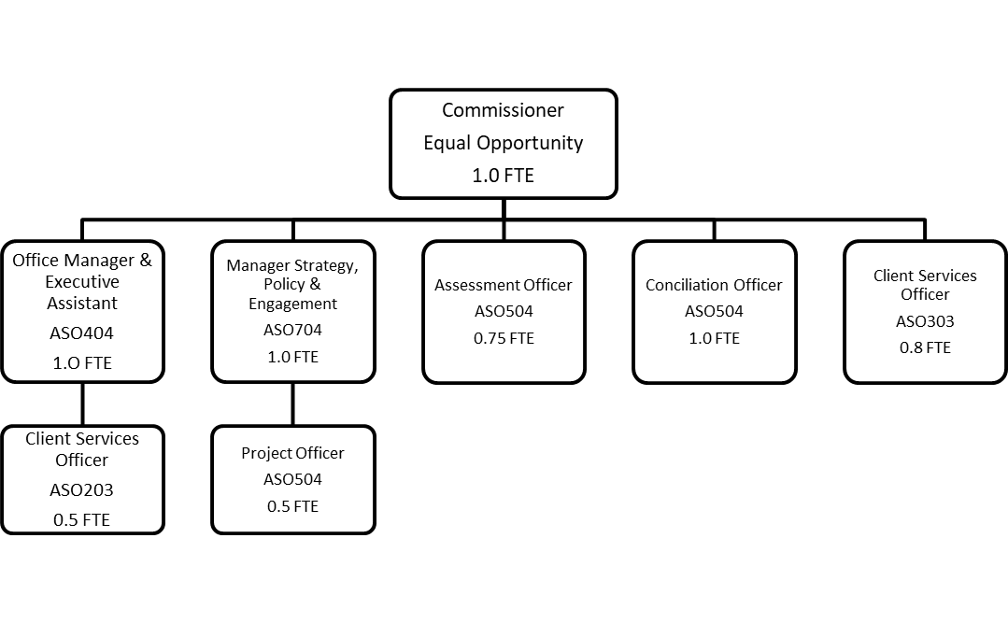

## 3.2. Core-funded team for 2019-20

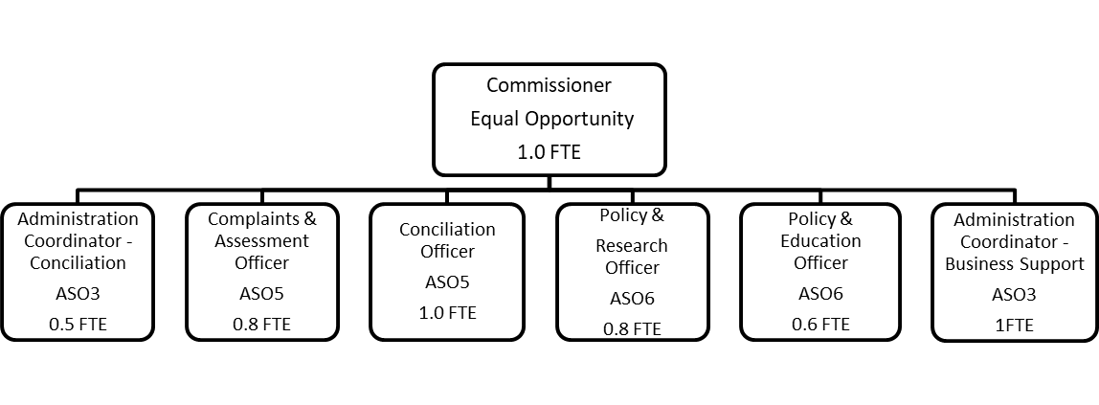

Note: Additional contract positions in the Commission are funded through fee-for-service consulting activity and not through the core budget provided by the Attorney General’s Department.

## 3.2. Executive employment in the Commission

None – The Commissioner is a statutory appointment.

## 3.3 Core funding for the Commission

Table 1 shows the core funding allocations provided by the Attorney General’s Department in 2009-10 compared with the period 2015-16-2018-19, and then forward allocations for the coming four years. As can be seen from the comparison of budget allocations for 2009-10 and 2019-20, there has been a 54.5% decrease in core funding overall (with a 51.2% decrease in salaries) over this 10 years – with additional decreases allocated over the next three years. In contrast, complaint numbers over the period 2009-10 to 2018-19 fell by 26.6%[1].

In 2018-19 core funding provided for 6.9 full time equivalent (FTE) staff (including the Commissioner). This compares with 20.2 [2] FTE in 2009-10. In 2019-20 core funding will provide for 5.7 FTE – with additional decreases in FTE over the forward estimates.

Table 1: Core budget allocation comparisons for the Equal Opportunity Commission



### 3.3.1. Interstate comparisons

As Table 2 below shows, the SA Commission’s core budget (i.e. that which is provided by the Attorney General’s Department) for 2018-19 was the lowest of any state in Australia[3].

Table 2: Comparisons of funding for Equal Opportunity Commissions & Anti-Discrimination Boards in Australia (organised by size of population)

|  |  |  |  |  |
| --- | --- | --- | --- | --- |
| STATE/TERRITORY | 17-18 BUDGET $ | 18-19 BUDGET $ | FTE STAFF NO. | COMMUNITY SIZE (2016) |
| NSW | 3,500,000 | [4] | 30 | 7.9 million |
| VIC |  | 6,506,000 | 49.8 | 6.4 million |
| QLD |  | 5,747,00 | 35 | 4.7 million |
| WA |  | 3,802,000 | 19 | 2.5 million |
| SA |  | 1,189,000[5] | 6.9[6] | 1.7 million |
| TAS | - | 1,314,727 | 11.3 | 518,500 |

## 3.4. Risks associated with decline in funding for the Commission

The following summarises the SA Commissioner for Equal Opportunity’s view of the main risks to the SA community associated with the further decline in funding for the Commission:

1. A reversal of the substantial service efficiency improvements delivered over the last two years and a return to long delays in complaint assessment and resolution, and in responding to public enquiries.

2. A reduction in the rate of successful conciliation due to time delays in complaint handling – this will see a greater number of matters referred to the Tribunal.

3. Missed opportunities to make recommendations at both state and national levels as to legislative and policy reforms that will further the objects of the Act.

4. Ongoing lack of capacity to develop and issue educational materials, including Practice Guidelines on matters relating to the Act.

5. Ongoing lack of capacity to respond to data and policy enquiries and requests from the community and government agencies.

6. Lack of capacity to undertake a much-needed data project to enhance reporting capabilities by developing new methods and metrics that better reflect current work flow patterns.

7. Inability to fulfil existing work requirements during periods of unplanned staff leave.

8. Increased complaints about the Commission services and greater time required to respond to these.

9. Lack of career and professional development opportunities for the Commission team.

The Commissioner is currently working at well over a full-time load (having taken over the Senior Conciliation Officer’s role – including undertaking conciliation training and conciliation of some complaints - when the contract could not be extended from December 2018 due to lack of funding). In addition, the tiny size of the Commission’s team and its limited budget mean there are no opportunities for career development within the team and professional development opportunities are restricted.

Morale in the team is understandably impacted when the expectations of the community in terms of service provision and support cannot be met – even after very substantial business performance improvements and innovative strategic partnerships have been implemented.

It is disturbing that some of the Commissioner’s core functions under the Act are now delivered substantially through an external consulting service she established in early 2017 and partnerships she established in 2018 with the University of Adelaide for a free legal clinic and a PhD researcher program.

# Section 4: Function 1

# Fostering and encouraging informed and unprejudiced attitudes with a view to eliminating discrimination

## 4.1 Activities funded by the Attorney General’s Department

### 4.1.1 Discrimination enquiries and complaints

One of the core functions of the Equal Opportunity Commission (the Commission) is to help people resolve complaints about unlawful discrimination, sexual harassment and victimisation under the *Equal Opportunity Act 1984* (SA) (the Act). This work is central to the Commission’s role in protecting and promoting equality of opportunity and preventing discrimination in South Australia. This work complements our education and consultancy services.

The number and type of complaints we receive often highlights issues of systemic discrimination in areas under the Act and helps to identify priorities for project, policy and educational work at the Commission.

A summary of the main enquiry and complaint statistics are provided in this section and more detailed statistics can be found in Appendix A.

#### *4.1.1.1 Enquiries*

The Commission provides a free, impartial and confidential enquiry service to educate the community about their rights and responsibilities under equal opportunity law. Details of enquiries are recorded to understand the types of discrimination reported by members of the community and their informational needs to better target the delivery of educational information, resources and training.

In 2018/19 566 enquiries were received - a 1% decline in enquiries from the previous financial year. The past three years show comparable number of enquiries (see Chart 1) with a significant reduction from the number reported in 2014/15. This is in part attributable to an increase in customer usage of self-service information and resources made available through the Commission’s website, as evidenced by the increasing number of website visits over the last 10 years.

Chart 1: Enquiries to the Commission

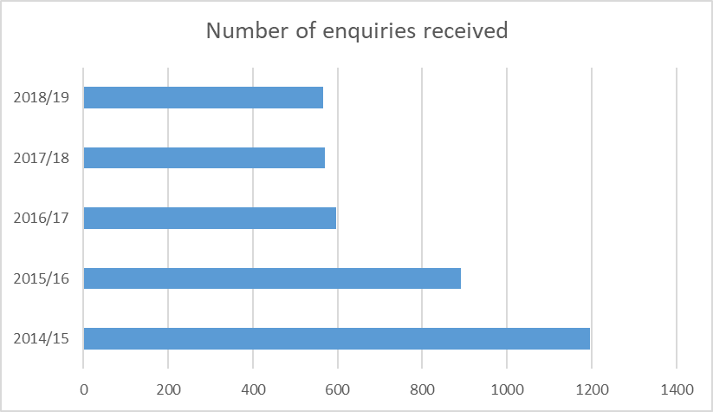

#### *4.1.1.2. Complaints*

In the 2018/19 financial year, 179 complaints were lodged with the Equal Opportunity Commission. Chart 2 below shows how this compares with the previous four years.

When a complaint is lodged with the Equal Opportunity Commission as a possible breach of the Act, it is assessed against the Act by the Commissioner who decides whether it can be accepted as a complaint and dealt with under the Act, or not accepted as a complaint because it falls outside the scope of the Act.

If a person alleges that they have been discriminated against on one or more grounds set out in the Act, and in one of the areas under the Act, then those allegations may be accepted by the Commissioner as a complaint. Some grounds do not apply to some areas and both a ground and area must be present for a complaint to be accepted under the Act. Where a complainant has not clearly identified a ground and/or area of complaint, they are supplied with information about what constitutes unlawful discrimination under the Act and asked to further clarify their complaint for assessment purposes.

Should the Commissioner decide to decline the complaint under section 95A of the Act then the complainant has the right to have the matter referred to the South Australian Employment Tribunal[7] for determination.

The Commission has implemented business performance improvements in complaint-handling over the past three years to streamline the complaint-handling process, reduce administrative duplication and workload, and improve the timeliness and efficiency of complaints management. The efficiencies enabled the Commission to clear the significant backlog of complaints that were on file from previous financial years. The number of open complaints carried over to the 2019/20 financial year has consequently significantly reduced compared with carryovers in previous financial years (see Chart 2).

More rigorous complaint assessment processes were also introduced into the Commission in 2017/18 as part of the business performance improvements. This has led to a 23% decrease in the proportion of complaints accepted over the last two years – down to 51% in the last two years from an average of 74% in the previous three years (see Chart 2 below).

Chart 2: Complaint activity

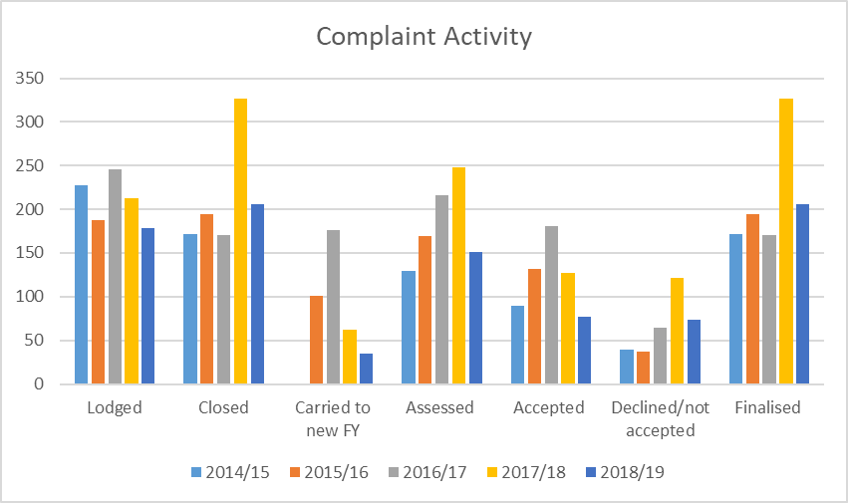

Charts 3 and 4 show the average complaint assessment time and the average time taken to finalise complaints in 2018-19 compared to previous years. The average complaint assessment time has reduced by 44% and the average complaint finalisation time has reduced by 27% in 2018/19 when compared to the average over previous years.

Chart 3: Complaint assessment time

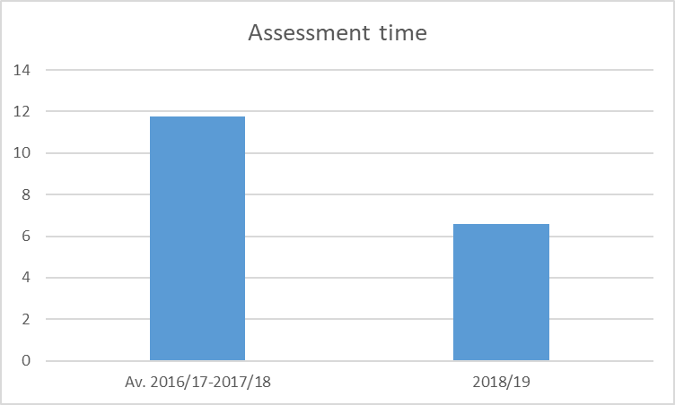

Chart 4: Complaint finalisation time

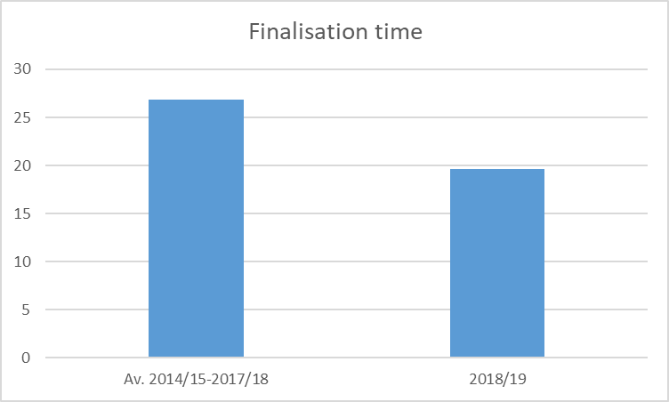

Chart 5 shows the grounds for complaints accepted in 2018-19 as a percentage of the total number of grounds. Disability discrimination continued to be the most prevalent ground for complaint, followed by sexual harassment and sex discrimination.

Chart 5: Accepted complaints by ground as a percentage of total

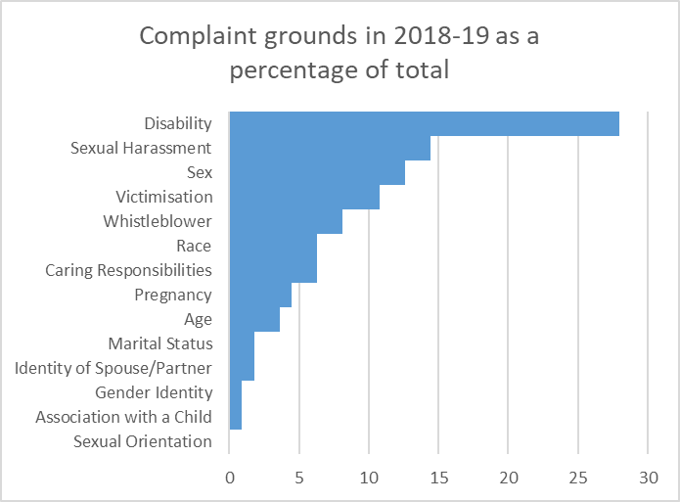

Chart 6 shows the grounds in accepted complaints in 2018-19 compared with accepted complaints over the previous four years. The number of whistle-blower complaints was higher in 2018-19 than the average over the previous four years, as was the number of complaints on the grounds of sex, pregnancy and identity of spouse or partner. The number of complaints on the ground of caring responsibilities in 2018-19 was the same as the average for this ground over the previous four years. Complaint numbers in relation to all other grounds were lower in 2018-19 than the average over the previous four years.

Chart 7 shows the areas for complaints accepted in 2018-19 as a percentage of the total. Employment continued to be the most prevalent area for complaint, but education and training overtook goods and services as the second most prevalent area in which complaints arose in 2018-19.

Chart 6: Accepted complaints by ground

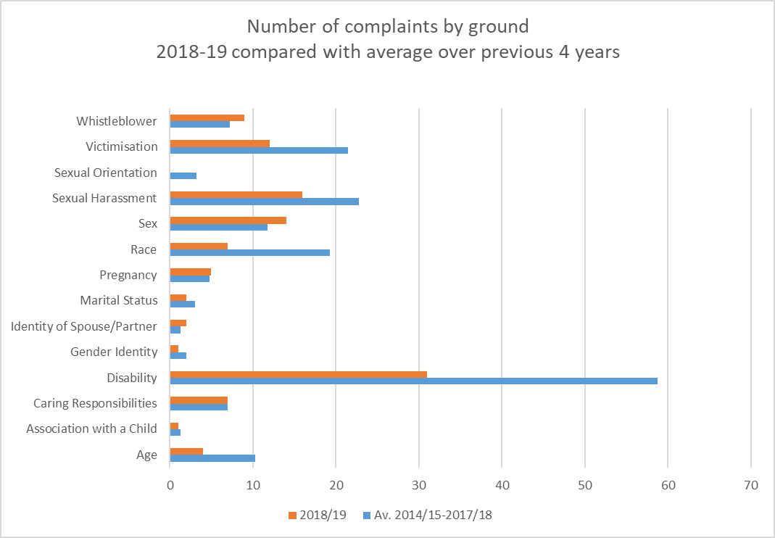

Chart 7: Accepted complaints by area

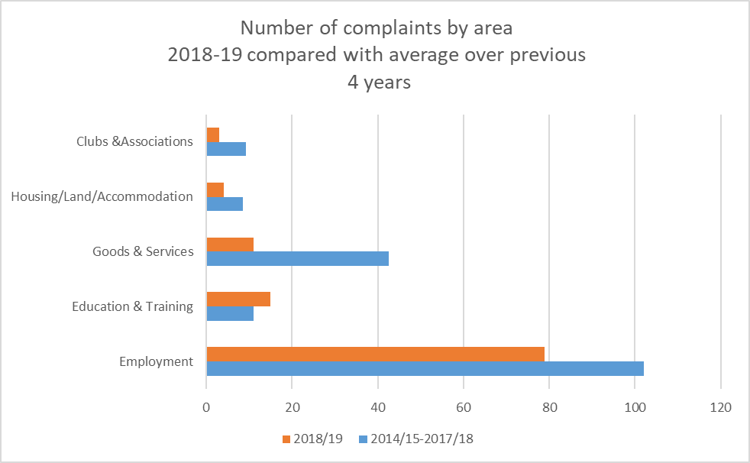

Chart 8 shows the outcomes of accepted complaints finalised in 2018/19 compared to the average of the previous four years. It can be seen that the number of accepted complaints finalised is slightly down from the average over the previous four years (from an average of 105 in 2014/15-2017/18 to 100 in 2018/19), more complaints were declined by the Commissioner after conciliation in 2018/19 compared with the average of the previous four years (26 compared with an average of 16 respectively) and the Commissioner referred a smaller number of complaints to the Tribunal when compared with the average of the previous four years (20 compared to an average of 33 respectively). Chart 8 also shows that the percentage of complaints successfully conciliated in 2018/19 was slightly higher than the average over the previous four years (54% compared to an average of 53% respectively).

Chart 8: Outcomes of accepted complaints

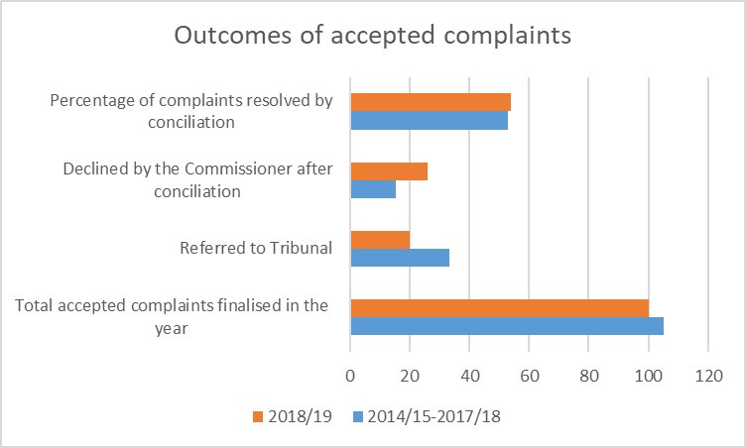

Of the complaints resolved by conciliation in 2018/19 (excluding the 16 cases where a private agreement was reached after conciliation) the issuing of an apology (22 cases) and financial compensation (17 cases) and were the most common outcomes. The average sum paid out per agreement was almost $725.00 higher than the average per agreement in the last four years – as can be seen from Chart 9.

Chart 9: Financial payments in conciliated settlement agreements

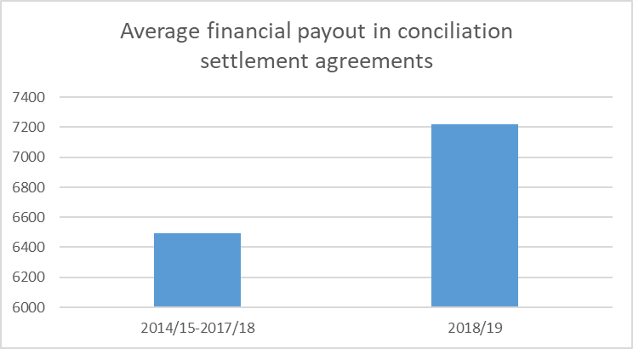

#### *4.1.1.3. Customer satisfaction*

Customer satisfaction surveys are emailed or posted to complainants and respondents following conciliation finalisation. A total of 33 evaluation surveys sent to parties were returned from complainants (14) and respondents (19) in the 2018/19 reporting period. Survey results indicated a high level of overall satisfaction with complaint-handling services from complainants (95%) and from respondents (94%) in 2018/19.

#### *4.1.1.4. Assistance to parties before the Tribunal*

Subject to section 95C subsection (2) of the Equal Opportunity Act (1984), the Commissioner may, at the request of the complainant or respondent, provide representation for them in proceedings before the Tribunal at public expense. The Commissioner must apply available public funds judiciously, so before providing representation, the Commissioner considers a range of factors including:

• The capacity of the complainant or respondent to represent himself or herself or provide his or her own representation;

• The nature and circumstances of the alleged contravention of the Act;

• Whether the case has good prospects of success (if it becomes apparent that prospects of success are not good, funding will cease);

• Whether the complainant or respondent can afford to pay for representation without hardship;

• Any other matter considered relevant by the Commissioner.

In the 2018/19 financial year, the Commissioner agreed to initially fund five complainants for assessment by a lawyer to determine the prospects of success for their case before the Tribunal. Of these to date, one has been fully funded for legal representation before the Tribunal and three were finalised as partial funding only.

#### *4.1.1.5. Complainant demographics*

In 2018/19, 56% of accepted complaints were lodged by a person who identified as female and 44% by a person who identified as male. There were no accepted complaints from people who identified as other than female or male. Chart 10 shows the age of complainants (accepted complaints).

Chart 10: The age of complainants in 2018/19 (accepted complaints)

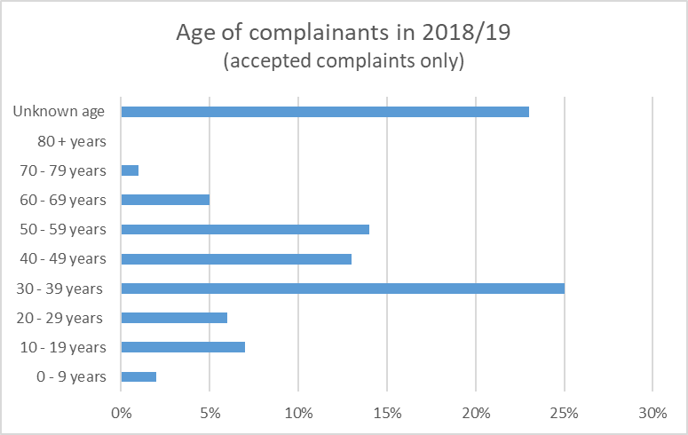

### 4.1.2. Other initiatives aimed at fostering and encouraging informed and unprejudiced attitudes with a view to eliminating discrimination

#### *4.1.2.1. Stop Racism Taskforce*

The Commission convened a Stop Racism Taskforce 4 times in 2018-19. The Taskforce is a group of 24 South Australian peak bodies, government agencies, academics and social justice advocates. Members of the Taskforce come together to share information about their work and identify and promote good practice initiatives to prevent and reduce racism in workplaces and the broader community.

#### *4.2.1.2. Inclusive School Uniform Policies in Independent and Faith Based Schools*

The Commissioner met with independent and faith based school associations in Adelaide and wrote to school principals and their board chairs on 23 May 2018 urging them to consider more inclusive and non-discriminatory school uniform policies that consider students’ gender, disability, religious dress requirements and cultural diversity. Current research shows that girls wearing dresses to school is a restrictive factor in their play and activity and directly results in them engaging in less physical activity. The Commissioner encouraged schools to provide girls with a pant or short offering, as well as traditional dress options, to allow greater freedom of movement and gender expression. The Commissioner advised that failing to address these issues may give rise to a complaint of discrimination under equal opportunity laws. This engagement was followed by a media release on the topic on 27 May 2018 which sparked quite a number of stories across print, radio, television and online media.

In 2018-19 a complaint of sex and disability discrimination in regard to school uniform restrictions was lodged with the Commissioner. This matter was successfully resolved within 17 days.

A subsequent media release went out in early 2019-20.

#### *4.2.1.3. Training and Public Education*

The Commission provides education and training services to employers, employees and community groups to help achieve compliance with the *Equal Opportunity Act 1984* (SA), embed best practice, and support cultural change on equal opportunity. These services include in-house training courses and customised training for organisations and workplaces.

In 2018-19, the Equal Opportunity Commission developed a Training Referral Program (TRP) pilot with the assistance of the Crown Solicitor’s Office and Attorney General’s Department procurement team. A panel of five training providers was established to support and extend the Equal Opportunity Commission’s capacity to deliver equal opportunity training. Following an application and assessment process from May to June 2018, the five training providers selected were:

* Perks People Solutions (trainers Cecilia White and Sarah Hills)
* Face to Face Communications (trainer David Hawke)
* YWCA Australia (trainers Michelle Tatyzo, Mason Somerville and Jemma Taylor)
* Diversity Inclusion (trainer Lucinda Hewitson)
* Leed Consulting (trainer Anna Lee)

The TRP pilot was operational from 1 July 2018 to 31 August 2019 enabling the Equal Opportunity Commission to understand and assess how a large-scale referral program would work in practice and to inform a future TRP.

Equal opportunity training promotes diversity and inclusion and encourages compliance with the *Equal Opportunity Act 1984* (SA). Training topics included within the scope of the TRP pilot are:

* The Contact Officer – roles and responsibilities;
* Refresher for the Contact Officer role;
* Prevention of workplace bullying, discrimination and harassment (for the individual or workforce);
* Managers - Prevention and resolving complaints of workplace bullying, discrimination and harassment;
* Bystander awareness;
* Unconscious bias
* Diversity and inclusion leadership.
* Customised training in the areas of ‘Disability and Inclusion in the Workplace - Responsibilities of Managers and Supervisors’ and ‘Disability Discrimination’

For the period 1 July 2018 to 30 June 2019, the TRP pilot delivered 19 training sessions with 274 participants (Table 4). A decrease in training delivery has been noted and will be monitored. While this decrease has our attention, the feedback from clients indicate high levels of satisfaction with the quality of training.

It has been learnt through the Australian Council of Human Rights Authorities ‘Human Rights Education and Training Network’ that decreases in training delivery have been experienced in other jurisdictions, including Western Australia, Tasmania and new South Wales.

Table 4: Number of in-house and customised training sessions and participants (time series)

|  |  |  |  |
| --- | --- | --- | --- |
|  | 2016/17 | 2017/18 | 2018/19 |
| Customised training: | | | |
| participant nos. | 908* | 598 ^ | 274^ |
| training sessions nos. | 22 | 29 | 19 |
| In-house training program: | | | |
| participant nos. | 86 | 144 | 128 |
| training sessions nos. | 14 | 15 | 12 |
| total - participants | 1016* | 742 | 302 |
| total - sessions | 36 | 44 | 31 |

* Includes 640 community education participants

^ Community education participant numbers no longer collected

#### 4.2.1.4. Commissioner’s public education activity (speeches and media)

The Commissioner delivered regular presentations to a range of community and business groups, industry associations, peak bodies, government and non-government organisations, and unions with a view to informing and engaging on equal opportunity and anti-discrimination issues and promoting the work of the Commission. In 2018/19, the Commissioner spoke at 49 events (see details in Table 5 below) reaching more than 6,200 people.

The Commissioner also proactively engages with radio, online and print media as a platform to help educate the community about their rights and responsibilities under equal opportunity law, and to draw community attention to systemic issues of discrimination. In 2018-19, the Commissioner’s media activities included 17 radio interviews, 2 opinion editorials, 28 print and online news articles, 2 industry magazine articles, 1 magazine feature, 1 regional media article, 2 podcasts and 3 television interviews.

Topics discussed in public speaking and media engagements included flexible working for men, parental leave, gender equity and the gender pay gap, sexual harassment and discrimination in the workplace, gender neutral school uniforms, diversity and inclusion in education, race discrimination, disability access in the arts, and disability discrimination in employment.

|  |  |
| --- | --- |
| Table 5: The COMMISSIONER’S SPEECHES 2018-19 | |
| July 18 | 2018 Mitchell Oration at the Adelaide Festival of Ideas – ‘Lauded and vilified: The highs and lows of leadership in human rights’. Commissioner in conversation with Professor Gillian Triggs, former President of the Australian Human Rights Commission |
|  | Adelaide Festival of Ideas – ‘Where to from #MeToo’ – Commissioner in conversation with Jane Caro and Nina Funnell |
|  | Governor’s Leadership Foundation speech - Leading a Cohesive Society |
| August 18 | National Association for Women in Construction (NAWIC) - Panel discussion on how having women in senior positions can positively impact the industry |
|  | Commissioner gave keynote to launch Tutti’s SALA exhibition by artists with an intellectual disability |
|  | Speech to Adelaide University post graduate law students on Discrimination Law and the Equal Opportunity Commission |
|  | CPD meeting Law Society of SA – ‘Discrimination Law in SA’ |
|  | Lecture to Adelaide University undergraduate law students on Discrimination law and the Equal Opportunity Commission |
| September 18 | Presentation to the Commission to Women in Leadership Journey (20 participants from Vietnam) |
|  | BPW Adelaide – speech on the work of the EO Commission (followed by dinner) |
|  | Presentation to staff at the Office of the Small Business Commissioner - to discuss Commissioner role, responsibilities and current projects |
|  | BizLinks presentation for Office of the Small Business Commissioner |
|  | General Practice Training and Education Conference 2018 - keynote by Commissioner in collaboration with Stacey Copas |
|  | Defence Science Technology Group - Gender Equality in the workplace |
|  | Speech at Race Relations Youth Forum at Salisbury |
|  | Women Kind Book Launch – Commissioner in Conversation with authors Dr Kirstin Ferguson and Catherine Fox |
|  | Keynote and panel for the Planning Institute of Australia – ‘Gender diversity and inclusion in leadership’ |
| October 18 | LGBTIQ Leadership and Advocacy Training for Human Rights Law Centre- Adaptive Leadership session |
|  | University of Adelaide panel – Gender Gap – Progress for 2018 and beyond – An Integrative discussion on Gender Equity in Australian Society, Economics & STEM |
|  | Presentation to Adelaide University Board on report by Commission |
|  | Keynote speaker at SHINE SA Annual General Meeting |
|  | Commissioner moderated Personal Injury Education Foundation Conference panel on ‘Mainstreaming Disability’. |
|  | BPW Event to celebrate 125 years of Women’s Suffrage in SA - How to get more diversity in Parliament – Commissioner facilitated panel discussion with MPs |
|  | CEDA – Women and Leadership – gender equality – have we stalled? Chiefs for Gender Equity presented with Commissioner on panel |
|  | CEDA Trustee event – Commissioner presented on ‘Promoting diversity and inclusion in SA: Equal Opportunity and beyond’. |
| november 18 | Commissioner keynote speaker on leadership at Kangaroo Island Leadership Program Awards dinner (with Brian Cunningham) |
|  | Judicial Development Day – ‘Sexual harassment in the #MeToo era’ – keynote address and panel discussion with Chief Judges and Chief Magistrate. |
|  | Commissioner presented award to recipients at the Gladys Elphick Awards |
|  | Spence Club – Keynote speaker on leadership |
| december 18 | Adelaide University - - Diversity and Inclusion education workshop |
| march 19 | Keynote and panel speaker at Commonwealth Bank of Australia’s ‘Women in Focus’ International Women's Day event |
|  | Commissioner panel speaker at YWCA International Women’s Day event |
|  | Speech on ‘Discrimination and Equal Opportunity’ at Apprentice Employment Network’s SA Members Forum |
|  | Keynote address at Campbelltown City Council International Women’s Day event |
|  | Prince Alfred College – International Women’s Day Luncheon. Commissioner led debating team. |
|  | Commissioner spoke on ‘Equal Opportunity and Gender Equality’ for UniSA Human Resources Management Program Group from PNG |
|  | Presentation to Defence, Science and Technology (DST) Group on ‘Increasing the Diversity in the Workforce at DST’ |
| april19 | Metropolitan Fire Service all-staff discussion session with MFS Chief about the Commission’s Report. |
|  | ACHRA Conference – Sydney (Chaired two-day conference) |
|  | Delivered paper entitled ‘The Ruddock Review: Impact on South Australian Anti-Discrimination Law’ at Queensland University School of Law Conference: Religious Freedom after Ruddock (in collaboration with Jacquie Rochow, Commission Law Intern) |
|  | Keynote to Public Sector Network’s Diversity and Inclusivity Roadshow 2019 |
| may 19 | Commissioner on Panel for Women in Media SA discussing the #metoo backlash |
|  | Keynote address to open the annual conference for Soroptimist International Australia – ‘Gender equality and the work of the Equal Opportunity Commission’ |
|  | Westland Shopping Centre Whyalla – Tenant and staff session on discrimination |
|  | Heart of the Matter (Heart Foundation Annual Business Breakfast) – Commissioner MC for the whole event and in conversation with Kristen Hilton, Commissioner for Human Rights and Equal Opportunity, Victoria. |
|  | Guest Speaker at Uni SA MBA course, Leadership for Growth |
|  | Guest speaker at WSP VIBE launch for IDAHOBIT |
| june 19 | MCBI Podcast with Dr Niki Vincent on leadership in equal opportunity |
|  | Commissioner in conversation with journalist and author of ‘On Freedom’ Tory Shepherd to launch book at the Hawke Centre |

In 2018-19 the Commission spent $15,570.00 in engaging a highly experienced media and public relations consultant to facilitate its public education work through the mainstream media and through social media. This consultancy (which was put in place for the first time in 2017-18) saw public education activities through the media increase from 5 media interviews in 2016-17 to 38 in 2017-18 and to 55 media interviews in 2018-19 (see Chart 11 below)[8].

Chart 11: The Commissioner’s public education activity 2016-17 to 2018-19

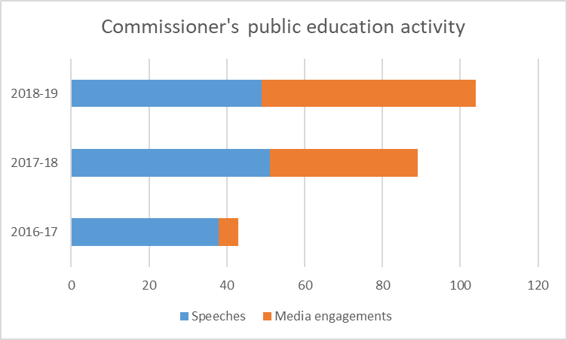

#### 4.2.1.5. Website and Social Media

The Commission’s website (www.eoc.sa.gov.au) forms an integral part of its community information service and delivers access to a range of information and educational resources, including publications, factsheets, policies, procedures, case studies, training videos, online courses and quizzes. It also enables people to lodge complaints of discrimination online, view the Commission’s training calendar, and enrol for in-house equal opportunity training programs.

The Commission’s website is one part of a broader communication strategy employed by the Commission. In 2018/19 the website was visited over 200,500 times. This exceeded the estimated result and was in keeping with 2017-18 figures.

The Commission also continues to grow its social media presence on Facebook and Twitter, amplifying the reach and impact of its work. The Equal Opportunity Commission has seen a 9% increase in followers from 937 to 1025 through Facebook for the 2018-19 financial year.

The Commissioner has her own Facebook page that has seen an increase in followers to 1740. There was a similar increase in the Commissioner’s Twitter followers (now at 1850). The Commissioner also has over 9600 followers on LinkedIn. The Chiefs for Gender Equity Facebook page has had a 100%+ increase in its followers, from 512 to 1049. The Chiefs Twitter account now has 807 followers and their LinkedIn page has 305 followers.

## 4.2 Initiatives developed through partnerships with other organisations

### 4.2.1 Free Legal Advice Clinic – Adelaide University Law School

In January 2018, the Commission established a free legal advice clinic in partnership with the University of Adelaide to improve access to justice for members of the community. The clinic is based at the offices of the Commission. It provides legal advice to any individual who believes that they have been unlawfully discriminated against, sexually harassed or victimised. While the clinic is available to all, it is particularly helpful in supporting people who are disadvantaged or ill-equipped to cope with the challenges of legal process. It is staffed by final year law students from the University. Qualified legal practitioners supervise the service and all advice provided by the service is checked by an experienced lawyer. The clinic can work with people to identify equal opportunity and discrimination issues and can advise and support people through the entire complaints process. This includes drafting and lodging complaints, providing referrals to other resources and supports, preparing documents, and preparing for Tribunal hearings.

The clinic also provides important legal training for our future lawyers by exposing students to the practical application of the law.

The clinic was expanded to two days per week in January 2019 in order to better meet the demand for its services. However this is being reduced back to one day per week from July 2019 as the University of Adelaide was asked to take over the free legal clinic provided by the now-defunded Welfare Rights Centre at the Administrative Appeals Tribunal within its existing resources.

Between 1 July 2018 and 30 June 2019, the clinic has assisted 85 people.

## 4.3 Initiatives funded through fee-for-service consulting or membership fees

### 4.3.1 Chiefs for Gender Equity

The Chiefs for Gender Equity are a group of South Australian organisational leaders working together with the common aim of achieving gender equality. Collectively, the group represents a broad range of sectors, with all members committed to informing and influencing all levels of South Australian business and government on the importance of gender equality and driving change within the organisations they lead, their industries and the South Australian community.

The Chiefs were established by the South Australian Equal Opportunity Commission in 2012. Initially modelled on the national Male Champions of Change, 2017 saw the group expand to include women. The Commissioner for Equal Opportunity, Dr Niki Vincent, convenes the group.

Each Chief pays a $5000 annual membership fee. These fees are used to fund all the Chiefs activities, including administrative support and a media consultant.

Throughout 2018-19, the Chiefs for Gender Equity were featured in, or mentioned, in 19 media stories. The Chiefs for Gender Equity Facebook page has 1049 followers (a 100%+ increase in 12 months) their Twitter account now has 807 followers and their Linked In page has 305 followers.

The membership of the group includes:

* Ms Chris Barnesby, General Manager, Olympic Dam, BHP
* Mr Hamilton Calder, State Director SA/NT, Committee for Economic Development of Australia
* Mr Kim Cheater, Partner, PwC
* Mr Tony D’Alessandro, CEO Statewide Super
* Ms Victoria MacKirdy, CEO, City of Victor Harbor
* Dr Neil McGoran, Director, Catholic Education SA
* Professor Caroline McMillen, Chief Scientist SA
* Mr Jake Parkinson, CEO, South Australian National Football League (SANFL)
* Ms Jane Pickering, CEO, Eldercare
* Mr Matthew Salisbury, SA & NT Regional Director, WSP
* Ms Catherine Sayer, CEO, Food South Australia
* Mr Grant Stevens APM, Commissioner, South Australia Police
* Mr Ian Stone, Group Managing Director, RAA
* Ms Karen Thomas, Managing Partner, Fisher Jeffries
* Mr Roger Zammit, CEO, Badge Group

The Chiefs vision is that by 2030, South Australia is achieving economic growth and prosperity through the equal representation and recognition of women and men across all aspects of community, work and family life. The Chiefs’ current plan of action focuses on the following six areas:

* Our Leadership Shadow – making sure we walk the talk and model the behaviour we expect to see from our employees and peers. This includes taking a public stand, such as honouring the ‘panel pledge’ and refusing to speak at events where there are no women speakers;
* Flexible work – ensuring that our employees, men and women, have access to working arrangements that enable them to manage their work and life responsibilities. Workplace flexibility is critical to continuing to increase women’s workforce participation and to enabling men and women to increasingly ‘share the care’;
* Reducing unconscious bias – businesses need to find ways to eliminate entrenched biases in recruitment and leadership decisions. Not only is this fair, but in attracting and retaining diverse, high-quality talent, South Australian businesses can meet the social and economic challenges of the future;
* Accountability – each Chief is developing a reporting matrix that enables their organisation to gain insight into emerging issues, helps to monitor progress and strengthens public accountability;
* Working to address the gender pay gap to promote gender equity and women’s financial security and independence across their lifetime; and
* The need for workplace responses to domestic violence. The Chiefs recognise that workplaces are key environments where preventative action can be undertaken to reduce violence against women and to support those experiencing or escaping violence.

Commencing in the second half of 2019, the SA Chiefs for Gender Equity are undertaking a project to better understand how SA small businesses are performing on gender equality and what support they may need to improve.

### 4.3.2 Workplace Equality and Respect (WER) Project

The Equal Opportunity Commission has been funded by the Senior Management Council (the CE’s of every state government department) to deliver the whole-of-government Workplace Equality and Respect (WER) Project over three years.

The project commenced in January 2018 and aims to strengthen gender equality and promote safe and respectful workplace cultures across the public sector. It will contribute to the state government’s efforts to prevent violence against women by addressing, through the workplace, the underlying drivers or causes of gendered violence. The project builds upon the White Ribbon Workplace Accreditation Program that the Equal Opportunity Commission led from 2015 - 2017, where 19 State Government agencies achieved White Ribbon Workplace Accreditation.

Through the WER Project, 24 State Government agencies will develop and implement a Gender Equality and Respect Action Plan that aligns with Our Watch’s best practice Workplace Equality and Respect Standards. All agencies participating in the WER Project will also seek reaccreditation with White Ribbon. The Equal Opportunity Commission will coordinate a whole-of-government process for White Ribbon reaccreditation, with agencies commencing in July 2019 and completing end June 2020.

The WER Project positions the State Government as a national leader in workplace prevention of violence against women.

### 4.3.4 South Australia Police Monitoring Program

The Commission was invited by South Australia Police (SAPOL) to conduct an Independent Review into the nature and extent of sex discrimination and sexual harassment, including predatory behaviour, within SAPOL (the ‘Independent Review’). The final report was released in December 2016 and included 38 recommendations to combat sex discrimination, sexual harassment and predatory behaviour and improve the safety and wellbeing of SAPOL staff.

Six key areas covered in the recommendations included:

* Leadership
* Workforce management
* Training and development
* Flexible workplace cultures
* Dispute resolution and complaints
* Wellbeing and support services.

All recommendations were accepted for implementation by SAPOL and the Equal Opportunity Commission was engaged to independently monitor and report on SAPOL’s progress in implementing these and to evaluate whether a change in culture is being achieved.

The Commission’s SAPOL Monitoring Project commenced in May 2017. It concludes February 2020 and is funded by SAPOL. The Commission completed three progress reports for SAPOL from January 2018 to May 2019:

* Report 1 (delivered January 2018) focused on the extent to which SAPOL had set a foundation for positive cultural change and noted seven areas for improvement on the issues of change management, change leadership and immediate actions for cultural change.
* Report 2 (delivered September 2018) focused on an assessment of the policies, processes and systems that contribute to the desired culture and noted six areas for improvement for flexible working options for specialist roles, gender equality reporting, target setting and employee exit management processes.
* Report 3 (delivered May 2019) focused on an assessment of SAPOL’s supervisors’ and managers’ capacity and willingness to support cultural change, and the capacity of the Diversity and Inclusion Branch to fulfil its purpose and objectives. Seven areas for improvement were noted.

The progress reports can be viewed by the public on the Equal Opportunity Commission’s website.

The fourth and final SAPOL monitoring report will focus on evidence of change in practices that support gender equality and a sustainable culture of gender equality. It is due to be released in February 2020.

### 4.3.4 Strengthening Responses to Sexual Assault and Harassment at the University of Adelaide

In June 2017, the University of Adelaide commissioned the Commission to undertake an audit of its systems and structures that prevent and respond to incidents of sexual harassment and sexual assault. One of the key recommendations made by the Commission was that the University undertake a review of student residential accommodation facilities (University owned and independently operated) to examine ways they can work collectively to address sexual violence.

The Commission was subsequently engaged to undertake this review from May to August 2018. The review sought to gain a deeper understanding of the effectiveness of policies, systems and resources that address sexual harassment and sexual assault at participating University Residential Colleges and Accommodation Services from the perspective of staff members employed by these facilities.

The review found that despite the positive role residential colleges play in many students experience of university, there are significant challenges that require an understanding of the complexities of residential life and a commitment by all involved to addressing sexual harassment and sexual assault in these settings. The Commission made 26 recommendations that covered eight key areas:

* complaints data
* complaints and reporting processes
* policies and procedures
* child protection
* staff perceptions of student culture
* staff and organisational culture
* social media
* document management and data collection systems.

The University has taken significant steps in addressing the prevalence of sexual harassment and sexual assault on its own grounds. In partnership with the Residential Colleges and in addressing the recommendations stated in the review, even further progress will be made.

# Section 5 - Function 2

# Research, data collection and the dissemination of information relating to discrimination

## 5.1. Activities funded by the Attorney General’s Department

Note that information relating to discrimination is disseminated through the Commissioner’s public speaking engagements and media activities (see section 4.2.1.4) as well as via this annual report.

## 5.2. Activities developed in collaboration with other organisations

### 5.2.1. The University of Adelaide PhD Program

The Commission has launched a PhD program with the University of Adelaide to deliver research into key workplace and cultural equity issues facing South Australia. The PhD program includes a stipend scholarship funded by the University for up to four years, as well as an internship with the Commission. The Commissioner provides academic supervision and guidance in collaboration with an in-house university supervisor.

Students with a strong academic record in fields such as psychology, law, economics, social sciences, business or management are eligible for the scholarships. Scholarships were offered through the University of Adelaide’s regular major round PhD scholarship cycle in September 2017. Five applications were received and two applicants secured a scholarship. Current research topics include men’s uptake of flexible working arrangements, and best practice for dispute resolution between school authorities and students with disability who are represented by their parents. This unique internship and industry experience will be offered again in the next major round of the PhD scholarship cycle in October 2019.

### 5.2.2. University of Adelaide’s Law and Justice Internship Program

In November 2018 the Equal Opportunity Commission agreed to be a host organisation for students enrolled in the University of Adelaide Law and Justice Internship Program. Students undertaking the internship are able to gain an appreciation for the practical operation of equal opportunity law by undertaking a 22 – 25 day placement at the Equal Opportunity Commission, either part-time over a semester while studying, or full-time for five weeks over summer. During the internship, students are encouraged to analyse the impact of law from a policy perspective and in the context of social and cultural diversity.

Students are selected based on their results in the public law core courses, their overall grade point average (GPA) and a statement on why they are passionate about public law.

The Equal Opportunity Commission hosted its first student, Jacquie Rochow, in Semester 2 of 2018. As part of her internship, the Jacquie conducted an internal review of the Equal Opportunity Act and presented recommendations to the Commissioner for Equal Opportunity on legislative amendments that would bring greater efficiency and effectiveness to complaint-handling processes. She also completed a research paper considering reform to the Equal Opportunity Act in view of recommendations from the federal Religious Freedom Review.

The Equal Opportunity Commission is hosting a second student in Semester 2 of 2019. This student will be analysing and assessing the accessibility and relevance of our state’s equal opportunity laws for Aboriginal and Torres Strait Islander people.

# Section 6 – Function 3

# Recommendations for reforms that will advance equal opportunity and prevent discrimination in South Australia

## 6.1 Submissions to the SA Attorney General

### 6.1.1 Legislative provisions for access to surrogacy services for single people

Submission to the SA Law Reform Institute on 19 July, 2018 for the ‘Surrogacy: A legislative framework Reference’.

The submission drew attention to the legislative provisions in South Australia which prevent single people from accessing surrogacy services and argued that this restriction was discriminatory. It noted that single people have legislative provision to access assisted reproductive treatment (e.g. In Vitro Fertilisation) and are protected from discrimination by those offering these services under the *Equal Opportunity Act 1984* (SA). Single women are also to be recognised as the parents of a child born as a result of assisted reproductive treatment under the Family Relationships Act 1975 (SA). Dr Vincent argued that there was no good reason why surrogacy was not also accessible for singles, that South Australia and Western Australia were the only states where a person’s relationship status affected their eligibility to access surrogacy arrangements, and strongly urged the pursuit of legislative reform in South Australia to ensure that single people have equal access to surrogacy arrangements.

On 8 August 2018, the Commissioner for Equal Opportunity wrote to the SA Attorney General to draw her attention to these issues.

In October 2018, SALRI published its report ‘Surrogacy: A Legislative Framework’. The report included 29 recommendations to the SA Parliament in relation to this reform. [SALRI Surrogacy Report October 2018](https://law.adelaide.edu.au/system/files/media/documents/2019-02/salri_surrogacy_report_oct_2018_0.pdf).

In February 2019, the Commissioner wrote to Ms Joanna Martin, Executive Director Legal and Legislative Services, Attorney-General’s Department regarding the proposed Bill currently before parliament to amend the Family relationships Act, 1975.

She drew attention to new legislative requirements under the proposed Bill that stipulated the intending parent(s) must provide human reproductive material so that there is a genetic link to the child. The Commissioner expressed concerns that the necessity for a genetic link to the child was inequitable for those who cannot contribute genetic material, and discriminatory as the use of donated embryos is already accepted in other assisted reproductive treatments (i.e. IVF) in South Australia.

She urged that the current Bill be amended to align with SALRI’s Recommendation 27 to ensure that intending parents who cannot contribute their own reproductive material will not be restricted from accessing surrogacy services. While providing safeguards to address concerns about the use of donor embryos, such as the right for a child to know their genetic history.

She also raised concerns that the current Bill specified that the surrogate mother and intending parent(s) must be 25 years of age or older at the time the lawful surrogacy agreement is entered. She noted that restricting the age was too simplistic as it presumed that a person’s age defined their maturity level. Echoing the concerns of those consulted in the SALRI review that parties to a lawful surrogacy agreement could have the sufficient maturity to enter a surrogacy arrangement and may well have chosen to start their family at a younger age (under 25 years) if not for their medical circumstances.

She urged that the Bill be amended to allow for exceptional circumstances in keeping with Recommendations 23 and 24 of SALRI’s review, in accordance with other state models to ensure equitable access to surrogacy arrangements for young people, individuals and couples.

### 6.1.2 Draft Statutes Amendment (SACAT) Bill 2019

On 4 April 2019, the Commissioner for Equal Opportunity made a submission to the Attorney-General about the ‘Draft Statutes Amendment (SACAT) Bill 2019’. The Bill proposed to transfer jurisdiction for the determination of Equal Opportunity matters from the South Australian Employment Tribunal (SAET) to the South Australian Civil and Administrative Tribunal (SACAT). Of significance, this would bring South Australia in line with other Australian jurisdictions.

The Commissioner supported the bill but sought an amendment so that the Commissioner for Equal Opportunity would continue to be provided with the power to refer matters to the South Australian Employment Tribunal (SAET) where there is a live workers compensation matter on foot in the SAET.

Section 95B(ba) of the *Equal Opportunity Act 1984* (SA) gave the Commissioner the ability to refer matters to the SAET where she was of the opinion that the matter should be referred there (whether or not conciliation has been attempted). The effect of Part 11 Clause 80 of the Statutes Amendment (SACAT) Bill 2019 (the bill) as proposed replaced the SAET with SACAT. This would have the effect of removing the power of the Commissioner to refer matters to the SAET directly while the Commissioner had carriage of the complaint. The Commissioner pointed out that she had, and continued to, routinely exercise this power where a complainant made it known that they had a related workers compensation claim on foot at the SAET. She argued that by removing the ability to refer matters to the SAET complainants and respondents would be impacted by additional administrative delays as a result of matters needing to be referred to the SACAT in the first instance.

In addition, the Commissioner raised a concern that the SACAT be able to conduct internal reviews of Equal Opportunity matters. She pointed out that Sections 66 and 67 of the South Australian Employment Tribunal Act 2014 enabled internal reviews and appeals of decisions of the Tribunal. She noted that a number of Equal Opportunity matters that had been referred to the SAET by her had been appealed internally with the SAET and heard by internal review or the Full Bench.

The Attorney-General supported the Commissioner’s proposed amendment relating to the referral of matters to SAET where there is a live workers compensation claim on foot. The Commissioner’s proposed amendment to allow SACAT to internally review Equal Opportunity matters was not accepted. However, the Commissioner understands that Senior Members of the SACAT will be appointed to hear Equal Opportunity matters and a right of appeal lies with the Supreme Court. The Bill passed, incorporating these amendments on 4 July 2019. It was assented to on 11 July 2019 and came into effect on 2 September 2019.

### 6.1.3 Complaints of discrimination on the ground of ‘religious dress’

On 20 May 2019, the Commissioner for Equal Opportunity provided a briefing to the Attorney General in relation to a request for information from her about data on the number and nature of discrimination complaints received at the Equal Opportunity Commission on the grounds of religious appearance or dress over the ten year period from 2009 to the end of April 2019.

The briefing noted that in the ten year period since 2009, the Commission had received a total of 19 complaints on the ground of religious appearance or dress. Of these 19 complaints, 16 were accepted within the jurisdiction of the Equal Opportunity Act in the area of employment. Of the latter, 4 were conciliated, 1 was declined, 9 were withdrawn and 2 were referred to the Tribunal. Both complaints referred to Tribunal were later withdrawn as parties reached a private settlement agreement. Three complaints were not initiated as they were outside the jurisdiction or did not meet threshold requirements.

### 6.1.4 Proposed amendments to the South Australian *Equal Opportunity Act 1984* that would strengthen the powers of the Commissioner for Equal Opportunity to investigate alleged contraventions of the Act

On 30 May 2019, the Commissioner for Equal Opportunity made a submission to the Attorney General in relation to proposed amendments to the South Australian *Equal Opportunity Act 1984* that would strengthen the powers of the Commissioner for Equal Opportunity to investigate alleged contraventions of the Act in circumstances where a whistle-blower, not personally aggrieved by the act of discrimination, has witnessed and reported discrimination that would be deemed unlawful.

In order to investigate a breach of this nature under current equal opportunity law, the Commissioner must first obtain the consent of the Attorney General, as Minister, to apply to the Tribunal for an order that she may conduct an investigation. In making this application to the Tribunal, the person who is alleged to have committed the breach must be notified of the application. They have an opportunity to be heard at the application hearing and may provide evidence about the alleged breach that may persuade the Tribunal to either grant or dismiss the Commissioner’s application.

The Equal Opportunity Act does not currently empower the Commissioner to require a response from the person or organisation who is alleged to have committed the breach prior to the application hearing. It is therefore difficult for the Commissioner to assess thoroughly whether a breach of the Act may have occurred and thus, whether an application to Tribunal is warranted.

Where the Tribunal authorises the Commissioner to conduct an investigation, the Act then limits her to requiring “the production of books, papers or other documents” from the respondent in order to undertake that investigation. This information alone would rarely provide sufficient detail for the Commissioner to come to a view as to whether discrimination had occurred.

There is also a concern that the requirement to obtain consent of the Minister, before applying to the Tribunal for an order to conduct an investigation of this nature, undermines the statutory independence of the Commissioner in relation to the complaint function. Under section 10 of the Act, the intent of the legislation is to limit Ministerial direction in relation to the manner in which action should be taken on a particular complaint. Ordinarily, a matter would progress through investigation without approval of the Minister or Tribunal, when pursued by a complainant personally aggrieved by the act of discrimination.

In her submission, the Commissioner considered two options for legislative reform that would strengthen her powers to investigate alleged contraventions of the Act in circumstances where a whistle-blower, not personally aggrieved by the act of discrimination, has witnessed and reported discrimination that would be deemed unlawful.

Option 1

Maintain current arrangements for the institution of inquiries under section 93A(1) of the Act, including the requirement for the Commissioner to seek Ministerial consent to apply to the Tribunal for an order to permit an investigation. However, to better enable the Commissioner to institute an inquiry, Dr Vincent recommended reforming the Act to grant the Commissioner powers to require a response from the person or organisation who is alleged to have committed the breach, prior to the application hearing. This power would allow the Commissioner to thoroughly assess whether a breach of the Act may have occurred and whether an application to Tribunal is warranted.

Where the Tribunal authorises the Commissioner to conduct an investigation, the Commissioner also recommended reforming section 94(2a) of the Act to expand the scope and nature of information that the Commissioner may require of any party in relation to an investigation. Rather than limiting the Commissioner to requiring ‘“the production of books, papers or other documents” from the respondent in order to undertake the investigation, the Commissioner recommend expanding this requirement to “any information that is reasonably necessary for the purposes of conducting the investigation”. This would enable the Commissioner to obtain sufficient detail to determine whether the complaint should be referred to the Tribunal. The Commissioner also recommended retaining exclusions stipulated in sections 94(2b), 94(3), 94(4)(a)-(b), 94(5), 94(6), 94(7)(a)-(b).

Option 2

The second option would be to follow a similar legislative approach to the Tasmanian Anti-Discrimination Act 1998 (see Part 6, Division 1A Section 60(2)). In the Tasmanian legislation, the Commissioner is granted legislative power to investigate any discrimination or prohibited conduct without the lodgement of a complaint, if satisfied that there are reasonable grounds for doing so.

However, if we were to repeal section 93A of the Equal Opportunity Act and replace it with such a provision, there would need to be a process that would enable the Commissioner to undertake such an investigation. In line with the Tasmanian approach, granting the Commissioner the power to pursue the complaint as if the Commissioner were the complainant could be a solution (see Part 6, Division 1A Section 60(5)(c) of the Tasmanian Anti-Discrimination Act 1998).

Where the Commissioner acts as the complainant, there would need to be provision in the legislation to enable the Commissioner to refer the matter directly to Tribunal following investigation, as the need for procedural fairness would prohibit the Commissioner from conducting conciliation on a matter in which she is also the complainant.

The Commissioner noted that if the Attorney General decided to pursue this option she would still recommend granting the Commissioner powers to require a response from the person or organisation who is alleged to have committed the breach, and expanding the scope and nature of information that the Commissioner may require of any party in relation to the investigation.

Finally, the Commissioner noted that the key distinction between these two legislative options is the presence or absence of a requirement for the Commissioner to obtain Ministerial consent and a referral from the Tribunal to conduct an investigation. Her only caution in relation to option 1 is that it may undermine the statutory independence of the Commissioner in relation to the complaint function. Despite this caution, the Commissioner stated that she would support either option providing consideration was given to:

a) Granting the Commissioner powers to require a response from the person or organisation who is alleged to have committed the breach; and

b) Expanding the scope and nature of information that the Commissioner may require of any party in relation to an investigation.

The Commissioner noted that while obtaining Ministerial consent does not necessarily obstruct the Commissioner’s ability to investigate matters of this nature, the Commissioner’s current lack of power to obtain sufficient details of the matter, to come to a view as to whether discrimination has occurred, is problematic.

## 6.2 Other submissions

### 6.2.1 Letter to the Hon Stephen Knoll, Minister for Transport, Infrastructure and Local Government regarding the South Australian government’s decision to withdraw financial support for the Overland train service. Dated 13 November 2018

The Commissioner wrote to the Minister about the South Australian government’s decision to end its financial support for the Overland train service between Adelaide and Melbourne and the uncertainty of the service’s future operation which, noting the potential impact of this decision on people who cannot utilise other transport services because of their disability or age,

The letter highlighted that the service was a vital transport link for these people living in rural and regional locations who are unable to access services in the major cities and who are not near airports.

The Commissioner also identified that the state government may open itself up to possible complaints of discrimination if alternative modes of transport are not fully accessible to people with a disability or with accessibility issues.

### 6.2.2 Submission to Australian Human Rights Commission consultation paper: Protecting the Human Rights of People Born with Variations in Sex Characteristics in the context of Medical Interventions. Submitted on 9 August 2018.

In this submission, the Commissioner for Equal Opportunity argued that preserving the rights of the child should mean that parents are generally not authorised to consent to medical procedures related to variations in sex characteristics. Such decisions that are irreversible and deferrable should be deferred until the child reaches adulthood, or is sufficiently mature to provide their own informed consent. Where medical procedures are required for the health and wellbeing of the child, and the procedure cannot reasonably be deferred until adulthood, the parents should be supported by a multi-disciplinary team of medical, human rights and psychological supporters.

The submission noted concern to ensure appropriate levels of psychological support for parents and for children facing medical interventions. Research shows families are often more concerned with psycho-social standards and ‘norms’ relating to medical intervention, than they are about medical necessities. If adequately supported by psychologists who are experts in the field, parents and children may feel less social pressure and stigma to ‘normalise’ sex variations. Psychological support should start in childhood and extend into adulthood.

The submission supported previous recommendations made by the IHRA that legal oversight mechanisms should include specific national legislation to ensure consistency in all jurisdictions, and establishment of a specialist Tribunal comprised of experts, including people with lived experience. Noting the rapid changes in technology and medical procedures, any mechanisms for legal oversight should be subject to review at least once every three years.

If specific legislation were to be developed, this should be done in consultation with medical experts as well as those with lived experience to ensure enough flexibility to adequately cover different interventions and variations. Additionally, any legislation should be subject to review at least once every three years.

Capacity of a child to consent is commensurate with their age and maturity, and this is recognised in rights of the child conventions and treaties. Any specialist Tribunal established for the purpose of determining applications for medical interventions should be guided by these principles. Psychological support at all levels for all children is also imperative. This should support children’s rights to information about their own bodies in a manner that is appropriate for their age and maturity level with the aim of eliminating stigma associated with variations in sex characteristics, and supporting the child to understand their options and consequences of these options. The SA Commissioner noted awareness of practices that have occurred in the recent past that empowered parents to make decisions about medical interventions while keeping information from the child. Anecdotal evidence suggests this still occurs to some degree. In one case recently reported to the Commissioner, the patient was sixteen-years-old when she underwent a gonadectomy, yet she was not told the truth about her procedure. This had serious ramifications upon her psychologically, and should be an unacceptable practice. Children should have the right to information about their own bodies and medical procedures proposed, with that information delivered by psychological professionals in a manner appropriate to their age and maturity.

There should also be different processes for children and for adults who lack legal capacity. Adults who lack legal capacity usually do so because of an intellectual disability, which means that they have limited ability to understand and consent to a procedure. Additional support in the form of people trained in supported decision making for adults with disability may be required, because recent work in disability supports the position that capacity is fluid, it can change from day to day. Capacity to understand and provide consent should be assumed and the person with disability supported to exercise that decision-making capacity wherever possible. The two situations are different and require specialist approaches for each.

The submission supported development of a legal definition of medical necessity to ensure the best interests of the patient, and to remove ambiguity and inconsistency in decisions made by medical professionals and courts. The argued that the definition should be developed by the medical community, in consultation with intersex experts and those with lived experience. The definition should be subject to extensive consultation prior to finalisation. Again, any legal definition should be subject to regular review that is in step with advances in medical technology.

The submission supported legislation that regulates the use of non-emergency/deferrable medical interventions. This legislation should be flexible, rather than blunt, to allow application to the courts to take individual circumstances into account, rather than provide blanket bans. Studies have found rates of gender assignment rejection among intersex children ranging from 5 to 40 percent, depending on the condition. Irreversible surgery may leave children with bodies that don’t match their identities and this in turn can result in trauma, poor mental health and increased risk of suicide. For this reason, deferral is preferred.

The submission also argued that criminal sanctions would be appropriate over civil legislation because civil legislation may place a child in the position of needing to take legal action against a parent. This could discourage individuals from enforcing their human rights. Setting out state expectations in a similar manner to the criminalisation of female genital mutilation would seem to provide the more effective regulatory mechanism. Any such legislation should be subject to review at least once every three years.

The submission supported submissions made in the Shadow Report submission to the Committee on the Rights of Persons with Disabilities on the situation of intersex people in Australia. The submission made by IHRA raises the possibility of national guidelines to preserve and support human rights in medical intervention procedures. The guidelines should be developed by medical professionals within a human rights framework, informed by extensive consultation with stakeholders including expert organisations, the intersex community and those with lived experience. The guidelines should be subject to review in the same manner at least once every three years. The guidelines should have the force of law, otherwise they are mere guidelines which cannot be enforced nor guarantee protection of human rights. Each jurisdiction should ensure oversight through equal opportunity and human rights bodies.

Various legislative provisions relate to the length of time for which medical records should be maintained, and to an individual’s right to access their own medical records. The Commissioner contended that where medical records relate to interventions related to sex characteristics, records should be maintained for the lifetime of the patient (or a significantly long period, such as 80 years), and the patient should have an automatic right to access those records.

To ensure everyone who is the subject of a medical intervention related to sex characteristic variations receives full and appropriate information about their bodies and proposed medical procedures, there should be a requirement at law of disclosure of information to children. This disclosure should be carried out with the support of psychologists who are experts in the field to minimise any risk of trauma and support the child to receive full knowledge that is appropriate to their age and level of maturity.

Expert peer groups have highlighted the importance of adequate psychological and peer support for people born with sex characteristics variation, and for their families and carers. It should therefore be a priority of government to put measures in place that facilitate this support.

Statistics from the National LGBTI Health Alliance show that people aged over 16 years with variations in sex characteristics are six times more likely than the general population to attempt suicide. They are also three times more likely to attempt self-harm with 26% of people with an Intersex variation having self-harmed on the basis of issues related to having a congenital sex variation, while 42% have had thoughts about self-harm. People with an Intersex variation are nearly twice as likely to be diagnosed with depression as people in the general population and are twice as likely to be diagnosed with anxiety in their lifetime. For many, there is also a negative impact on wellbeing as a result of having undergone medical interventions including having undergone a traumatising or unwanted surgery, beginning hormone therapies and feeling emotionally impacted or unlike themselves. For these reasons, it is important that adequate focus is directed towards providing psychological support at all stages to pre-empt and avoid emotional trauma, and support patients and their families to live mentally healthy lives.

The submission noted the barriers to connecting individuals to support services and individuals accessing support services. These include:

* lack of awareness by the medical profession, individuals and families
* pressure from medical professionals for parents to consent to ‘normalising’ surgeries performed on babies and children
* few support services available due to lack of funding
* cost of accessing psychological support and lack of resources
* lack of services in rural and remote areas
* stigma preventing those with variations in sexual characteristics from seeking support

The submission argued for Australian governments to commit to national reform which will prioritise resource funding for support services in every jurisdiction. Research and submissions from expert groups highlight the importance of adequate support services for people with variations in sex characteristics, as well as their families and carers. This is a human rights and health issue, and the government should commit to the provision of funding and support to ensure adequate resources and high visibility in the community. The statistics quoted above highlight the enormous cost to mental health that results from social stigma, unwanted surgeries and lack of proper support.

Removal of stigma in accessing support services should also be a government priority. Much has been achieved in recent decades tackling stigma attached to mental illnesses, such as depression, and the same should be tackled for stigma attached to variations in sex conditions. Changing community attitudes to ensure inclusion and access is as important as the provision of support services.

The submission argued for a comprehensive national policy that addresses all of the points raised.

### 6.2.3 Feedback on Draft SA Health Equity & Access in Health Care Policy Directive. Submitted 1 August 2018.

The Commission provided feedback on SA Health’s Draft Equity & Access in Health Care Policy. The Commission’s feedback included adding ‘physical’ as a possible form of elder abuse, re-wording the definition of ‘Gender and Sexual Diversity’ to refer to “all the diversities of sex characteristics, sexual orientations and gender identities, including lesbian, gay, bisexual, transgender, intersex, non-binary, gender-fluid and many more”, and rewording the definition of ‘Trans and Gender Diverse’ to correctly say “A person who lives, or wishes to live, as a different gender from the biological sex they were assigned at birth, and who identifies themselves as transgender or gender diverse. The term ‘transgender’ may also encompass people who identify their gender as male and female, neither male nor female, or genderless. There is no relation between gender identity and sexual orientation; a transgender person may identify as any sexual orientation.”

### 6.2.4 Letter to Mr Tony Braxton-Smith, Chief Executive, Department of Planning, Transport and Infrastructure in relation to the Disability Standards for Accessible Public Transport 2002 – dated 7 November 2018

This letter noted that the Disability Standards for Accessible Public Transport 2002 require all modes of public transport in Australia to be accessible by 2022 and have minimum compliance milestones to be met every five years for existing and new transport conveyances, infrastructure, services and facilities, and requested an update on the percentage of the South Australian public bus fleet that is currently accessible to people with disability, and whether it was expected that all South Australian public transport would be accessible by 2022.

### 6.2.5 Submission to the Australian Human Rights Commission’s National Inquiry into Workplace Sexual Harassment in January 2019.

The National Inquiry will provide an account of the extent, nature and impacts of sexual harassment in the workplace. Equally, it seeks to identify the challenges faced by employers, and identify, with them, evidence-based strategies and practices for addressing these challenges.

In mid-2018 the Commissioner received a survey data request from the Australian Human Rights Commission for the National Inquiry into Sexual Harassment it is undertaking. The Equal Opportunity Commission (SA) submitted the requested survey and data response in January 2019.

### 6.2.6 Letter to the Gender Reassignment Board, Department of Justice, Government of Western Australia on 12 April 2019

The Commissioner wrote in support of a transgender woman who was born in WA (but living in SA) and her application to be legally recognised as a woman. This woman and her partner (also a transgender woman) had recently become engaged and wished to change their sex and gender identity on their birth certificates to ensure that when they marry, their new sex and gender identity was correctly recognised. However, because she was born in Western Australia, this woman faced significant barriers to the registration and legal recognition of her authentic gender identity, compared to her partner, who was born in South Australia. She was forced to endure hormone treatment and travel interstate for expensive and potentially dangerous gender reassignment surgery that was not available in Western Australia. In addition to these invasive requirements, she was required to get letters from three doctors and at least two or three people she knows such as family, friends and colleagues validating her new gender identity. These strict and intrusive requirements imposed under the Western Australian Gender Reassignment Act 2000 had a detrimental impact on her health and well-being.

In comparison, people born in South Australia, like her fiancé, no longer have to apply to a magistrate or provide evidence that they have undergone medical or surgical procedures to have their authentic gender identity legally recognised and registered on their birth certificate. A change in the law in 2016 saw the repeal of the South Australian Sexual Reassignment Act 1988 and the introduction of the Births, Deaths and Marriages Registration (Gender Identity) Amendment Act 2016, which empowered the SA Registrar to recognise a change of sex and gender identity without the requirement for a reassignment procedure. An application to change sex or gender identity now only requires a statement from a medical practitioner or psychologist certifying that the applicant has received or is receiving an appropriate clinical treatment in relation to their sex or gender identity, and this can include counselling only. New birth certificates issued also show only the altered record gender identity, and not the fact that this was changed.

Therefore, while the Commissioner strongly supported this woman’s application to be legally recognised as a woman, she also strongly encouraged the pursuit of law reform in Western Australia to remove discriminatory features of the Gender Reassignment Act 2000 that continue to pose risks to the health and safety of transgender people. She noted that the Western Australian Government was considering the recommendations of the Law Reform Commission of Western Australia’s Review of Western Australian legislation in relation to the recognition of a person’s sex, change of sex, or intersex status.

### 6.2.6 Submission to the South Australian Law Reform Institute for the ‘Abortion: A Review of South Australian Law and Practice’ review being undertaken. Submitted on 30 May 2019

The submission argued that South Australia should demonstrate its commitment to women’s health and equality by reforming the state’s outdated laws and bringing South Australian legislation into line with community standards and clinical practice. It asserted that the current criminalisation of abortion in South Australia is discriminatory to women, as only women need the procedure and can be prosecuted for doing so and noted that there is no other matter of health care, except for abortion, that is placed within the criminal code.

Women’s basic human rights to sexual and reproductive health, to be free from cruel, inhuman, or degrading treatment, to non-discrimination, to privacy and equality before the law, and to bodily autonomy are threatened by the current system under which they risk criminal prosecution for making medical decisions concerning their own body and health.

By having restrictive abortion laws and failing to ensure women have access to reproductive health services, women experience worse health outcomes - including being forced to carry an unwanted pregnancy to term, delays in obtaining needed health services, or resorting to unsafe abortion options. These risks are heightened for women whose circumstances make accessing health services more difficult, including young women and girls, women living remotely, women with a disability, Aboriginal and Torres Strait Islander women, women of culturally or linguistically diverse backgrounds and women who cannot afford to travel to jurisdictions with more liberal abortion laws.

The submission argued that barriers to safe and accessible abortion should be removed, including the removal of abortion from the Criminal Law Consolidation Act 1935 (SA) (except to punish unqualified persons from performing abortions on women and a person destroying or harming a woman’s foetus without her consent). Instead abortion should be addressed as a clinical health issue to be determined between a woman and her doctor without the fear of criminal prosecution, with regulation replicating the ACT or Victorian model. Any new abortion legislation should place the decision for having an abortion with the woman and not with the medical practitioner, and ensure that surgical and medical abortions are accessible to all South Australians.

Women should have the right to choose whether they have an abortion without needing to justify their decision or prove to a medical practitioner that their situation makes them eligible for an abortion, at least up to 24 weeks gestation as in Victorian legislation. This could include requiring the sign-off of just one medical practitioner or suitable health professional instead of two before having the procedure, and requiring medical practitioners or health professionals who have a conscientious objection to abortion to have to refer the woman onto another medical practitioner or health professional who is known to not have a conscientious objection. Those with a conscientious objection must perform, or assist in, the termination of pregnancy in cases of medical emergency, where an abortion is necessary to save a woman’s life or prevent serious physical harm. It could also mean expanding who is allowed to legally administer a medical abortion (e.g. to include pharmacists, nurses, midwives and Telehealth services to administer and counsel women on using abortion medication) as well as increasing funding to facilitate the expansion of the number of prescribed hospitals that are allowed to facilitate abortions, so that there are more appropriately qualified health professionals, in appropriate facilities able to assist women who consent to an abortion.

The submission noted also that South Australian law should provide for sensible and proportionate safe access zones around abortion clinics, which protect women trying to access abortion services from harm. Safe access zones should be set in law, apply at all times and prohibited behaviour should not include an intention element.

It also pointed out that it is important to ensure that any abortion law reform covers all people who could become pregnant. The traditional reference to “woman” as defined in the Criminal Law Consolidation Act 1935 (SA) as meaning “any female person of any age” should be simply replaced with “pregnant person” in any new abortion legislation, so as to be inclusive of all who may need access to reproductive health services, such as gender diverse people who do not identify as female or transgender men. This will ensure that South Australia’s abortion laws are fully inclusive to all South Australians, in keeping with Section 26(a) of the Acts Interpretation Act 1915 (SA) which stipulates that in every Act, “every word implying a particular gender will be construed as including every other gender”.

The Commissioner strongly urged the pursuit of legislative reform in South Australia to ensure that abortion law no longer discriminates against those seeking abortion procedures and instead supports a pregnant person’s right to access a health procedure free from fear and discrimination.

### 6.2.7 Submission to Multicultural Legislative Review of the South Australian Multicultural and Ethnic Affairs Commission Act 1980 on 30 May 2019.

The submission supported amending the Act to include the eight multicultural principles as listed in the associated Multicultural Legislative Review 2019 Discussion Paper. However, it noted that the first principle “diversity is an asset and a valuable resource benefiting the state” could be better written to focus less on the economic benefit of multiculturalism, to be more in line with Queensland and Victoria’s principles on diversity, such as “All South Australians come from diverse backgrounds and South Australia values the richness that such diversity brings to the community and encourages the full participation of people from diverse backgrounds in the cultural, economic, political and social life of South Australia to help build a prosperous state”.

The submission also supported amending the Act to include the requirement for the state Government to develop a state framework and/or action plan that lists actions and targets that government departments must take to achieve multicultural policy outcomes, plus what actions they are taking to ensure their services are accessible to people with diverse languages. A plan should include key performance indicators that department Chief Executive’s should have to meet and report on at the end of each financial year to the minister or South Australian Parliament.

The submission supported the updating of the Act to clearly define the responsibilities and activities of the South Australian Multicultural and Ethnic Affairs Commission (SAMEAC) – including the three functions as listed in the Discussion Paper, as well as suggesting that the Commission be given authority to work at the executive level with state government and peak bodies to collaborate and coordinate on policy and program initiatives to help drive and achieve the goals of a state action plan and to help identify the needs of diverse communities that these peak agencies represent.

Furthermore, the submission argued that the Act should be updated to ensure that there is at least one member of SAMEAC that is a youth representative (as in Victorian legislation) and include members that are from different parts of South Australia to represent the views of regional/rural communities.

The submission welcomed the review’s aim of contemporising the language of the Act, including the use of the term ‘intercultural’ as opposed to ‘multicultural’ to lead the way for state policy that encourages communities to develop relationships that have a deep understanding and respect for all other cultures, through the mutual exchange of ideas and cultural norms to enable communities to learn and grow together.

### 6.2.8 Letter to the Hon John Gardner, Minister for Education regarding the disadvantage of casual Department for Education female employees in comparison to Public Sector employees on 30 May 2019.

In this letter, the SA Commissioner for Equal Opportunity raised concerns regarding women who are employed on casual contracts by the Department for Education being subjected to discrimination for their caring responsibilities and who are at greater disadvantage in comparison to other women employed on casual contracts under the Public Sector Act 2009 (SA).

### 6.2.9 Submission to South Australian Office for Ageing Well on the draft ‘Ageing and Adult Safeguarding Regulations 2019’ (‘the Regulations’) on 3 April 2019.

Parliament passed the Office for the Ageing (Adult Safeguarding) Amendment Act 2018 in November 2018. The Act makes important changes to the Office for the Ageing Act 1995 to help ensure that the rights of older South Australians and other adults who may be vulnerable to abuse or neglect are upheld. The Office for Ageing Well (formerly Office for the Ageing) sought feedback to inform the development of Regulations to support the implementation of the new laws.

The submission noted the concern of the Equal Opportunity Commissioner with the way that the Office for the Ageing (Adult Safeguarding) Amendment Act 2018 defines a vulnerable adult. It argues that it is discriminatory to define vulnerability in terms of a personal characteristic such as age or disability. Vulnerability should not be linked to the personal characteristics of a person but linked instead to the circumstances in which someone may find themselves. For example a person is more vulnerable if they are fully dependent on another person for their personal care and support needs, financial management, transport services, or are socially isolated etc. These situational factors should be considered when identifying a vulnerable adult who needs intervention, rather than just assuming a person is vulnerable because of their disability or age.

The submission also questioned the exception made in s 24 of the Act not requiring the vulnerable adult’s consent before undertaking an assessment of a lodged report and asked what, in practice an assessment of a report would include, and why would the vulnerable adult to whom the report pertains to, not be asked for consent at this stage? It also queried how the decision-making capacity of a vulnerable adult would be assessed as impaired as there was no mention in the Act or the Regulations as to how and by whom this would be assessed.

In addition, the submission noted the Commissioner’s concern with the possibility for a person or body being able to refuse accepting a referral from the Adult Safeguarding Unit due to a lack of resources or capacity to accept the referral at the relevant time. When dealing with such a serious issue as the abuse and neglect of vulnerable adults, there should be a guaranteed service response from government.

Furthermore, a question was asked about at what point in the process a member of the Safeguarding Unit must notify South Australian Police (SAPOL) if a report is made alleging criminal activity, or if an investigation unveils criminal misconduct. As the Adult Safeguarding Unit is not intended to investigate abuse with a view to prosecute offenders, nor to substitute for a criminal justice response, then reporting and/or referral to SAPOL will at times be appropriate. The submission argued that such protocols should be made clear in the Regulations or Code of Practice so that there is certainty around how to promptly report criminal allegations to SAPOL, with the adult’s consent, when the agency has reasonable grounds to conclude that a person is at-risk.

Finally, the submission queried how this safeguarding legislation and the Adult Safeguarding Unit interface with the Federal Quality and Safeguarding Unit and asked if National Disability Insurance Scheme participants would are included under the legislation.

The Ageing and Adult Safeguarding Regulations 2019 were released on 20 June 2019.

# Section 7. Reporting of public complaints about the Commission’s service

## 7.1 Summary of complaints by subject

|  |  |
| --- | --- |
| Public complaints received by Equal Opportunity Commission | |
| Category of complaints by subject | NUMBER OF INSTANCES |
| Complaint regarding commission service provision | 4 |

Data for the past five years is available at: <https://data.sa.gov.au/data/organization/attorney-general-s-dept>

## 7.2 Complaint outcomes

|  |  |
| --- | --- |
| NATURE OF COMPLAINT/SUGGESTION | SERVICES IMPROVED/CHANGED AS A RESULT |
| Complaint about the unsatisfactory service provided by a Commission staff member when making an enquiry about alleged discrimination. | The person was provided with additional information and referred to the Australian Human Rights Commission – which was the more appropriate agency to assist them with their complaint. |
| Complaint to the Commission and subsequent complaint to the South Australian Ombudsman about the management of a complaint lodged with the Commission in early 2016.  The complaint centred on a significant delay in the complaint being assessed and the lack of communication with the complainant during this time by the staff member managing the complaint. | The Commissioner accepted that the delay in assessing this complaint was unreasonable and the level of communication provided to the complainant was unsatisfactory. A written apology was provided to the complainant acknowledging this.  Prior to this complaint being lodged with the Ombudsman in 2019, the Commission had already taken significant steps over the previous two years to improve organisational transparency and accountability in the management of complaints. This included, in particular, the process for assessing and monitoring the management of discrimination complaints, to ensure a more timely assessment of and communication with both complainants and respondents.  Since the implementation of these business improvements and in response to initial recommendations made by the Ombudsman the Commission has achieved a 44% reduction in assessment time and a 27% reduction in the overall time taken to resolve complaints when compared with the average over the previous four years. |
| Complaint alleging that a conciliation officer was biased during the conference and that the settlement agreement was not what the complainant wanted. | The matter was resolved after an internal review found that the complainant was treated fairly in conciliation. |
| Complaint about the release of the complainant’s contact details in documents sent to the respondents when a matter was referred to the South Australian employment Tribunal. | After an internal review it was found that Commission staff had followed the standard process for the referral of matters to the South Australian Employment Tribunal (SAET) to include the full contact details of both the complainant and respondent when referring matters to them.  However in response to the complaint the Commission provided a formal written apology to the complainant for the distress caused. It also amended its procedures to protect the personal contact details of vulnerable people when referring complaints to the SAET. |
| Second complaint about the same release of a complainants contact details in documents sent to the respondents when the matter was referred to the South Australian employment Tribunal. | As per above (although no written apology – Commissioner offered to meet with complainant but this offer was declined). |

# Section 8: Appendix (detailed enquiry and complaint data)

## 8.1 Enquiry Data

The Commission provides a free, impartial and confidential enquiry service to educate the community about their rights and responsibilities under equal opportunity law. Details of enquiries are recorded to understand the types of discrimination faced by members of the community and their informational needs to better target the delivery of educational information, resources and training.

There were 566 enquiries received in 2018/19 - a 1% decrease in enquiries from the previous financial year. The past three years show comparable number of enquiries (Table A1), with a significant reduction from the number reported in 2014/15. This is in part attributable to an increase in customer usage of self-service information and resources made available through the Commission’s website, as evidenced by the increasing number of website visits over the last ten years.

Table A1: Number of enquiries received

|  |  |  |  |  |  |
| --- | --- | --- | --- | --- | --- |
| Enquiries received | 2014/15 | 2015/16 | 2016/17 | 2017/18 | 2018/19 |
| No. of enquiries received | 1196 | 891 | 597 | 570* | 566* |
| % difference from previous year | -26% | -26% | -33% | -5% | -1% |

* Total does not include EO training enquiries - from middle of previous year, these calls divert to another Commission office number and are tracked elsewhere by the Commission.

Enquiries to the Commission can be made via a range of methods (Table A2). Seventy one percent of all enquiries were made by telephone in the 2018/19 financial year. There has been a steady increase in the use of the online incident form to make enquiries.

Table A2: Method enquiry received

|  |  |  |  |  |  |  |  |  |  |  |
| --- | --- | --- | --- | --- | --- | --- | --- | --- | --- | --- |
| Method enquiry received | 2014/15 | | 2015/16 | | 2016/17 | | 2017/18 | | 2018/19 | |
|  | No. | % | No. | % | No. | % | No. | % | No. | % |
| Telephone | 955 | 80 | 707 | 79 | 455 | 74 | 421 | 74 | 401 | 71 |
| Email | 164 | 14 | 106 | 12 | 109 | 18 | 83 | 15 | 85 | 15 |
| Online incident report | 30 | 3 | 39 | 4 | 25 | 4 | 35 | 6 | 59 | 10 |
| In person | 36 | 3 | 29 | 3 | 15 | 2 | 22 | 4 | 18 | 3 |
| Facebook | 2 | 0 | 3 | 0 | 6 | 1 | 0 | 0 | 0 | 0 |
| Letter | 9 | 1 | 7 | 1 | 5 | 1 | 4 | 1 | 3 | 1 |
| Total * | 1196 | 100 | 891 | 100 | 615 | 100 | 570 | 100 | 566 | 100 |

* 100% is the rounded value.

The Commission assisted enquirers in a number of ways (Table A3).

Table A3: Enquiry outcomes

| Enquiry Outcomes | 2013/14 | | 2014/15 | | 2015/16 | | 2016/17 | | 2017/18 | | 2018/19 | |
| --- | --- | --- | --- | --- | --- | --- | --- | --- | --- | --- | --- | --- |
|  | No. | % | No. | % | No. | % | No. | % | No. | % | No. | % |
| General information provided | 600 | 43 | 461 | 39 | 331 | 37 | 260 | 43 | 233 | 41 | 195 | 34 |
| Referred elsewhere (out of jurisdiction) | 209 | 15 | 212 | 18 | 159 | 18 | 75 | 13 | 101 | 18 | 164 | 29 |
| Referred to Commission’s electronic complaint form | 89 | 6 | 135 | 11 | 100 | 11 | 62 | 10 | 82 | 14 | 97 | 17 |
| Referred to Commission Website | 97 | 7 | 78 | 7 | 64 | 7 | 49 | 9 | 43 | 8 | 40 | 7 |
| Referred to advocate (to assist with EO/other Issue) | 146 | 10 | 68 | 6 | 63 | 7 | 48 | 9 | 34 | 6 | 21 | 4 |
| Complaint form and information package sent | 121 | 9 | 134 | 11 | 58 | 7 | 38 | 7 | 25 | 4 | 16 | 3 |
| No action required | 87 | 6 | 61 | 5 | 76 | 9 | 31 | 5 | 32 | 6 | 16 | 3 |
| Referred to Australian Human Rights Commission | 26 | 2 | 30 | 3 | 24 | 3 | 14 | 2 | 13 | 2 | 13 | 2 |
| Report or Publications provided/Media response provided/Presentation requested/Other | 11 | 1 | 7 | 1 | 11 | 1 | 19 | 3 | 5 | 1 | 1 | 0 |
| Appointment made for interview with Commission enquiry officer | 10 | 1 | 4 | 0 | 0 | 0 | 1 | 0 | 2 | 0 | 2 | 0 |
| Referred to SAET# | 9 | 1 | 5 | 0 | 1 | 0 | 0 | 0 | 0 | 0 | 1 | 0 |
| Total * | 1405 | 100 | 1195 | 100 | 887 | 100 | 597 | 100 | 570 | 100 | 566 | 100 |

* 100% is the rounded value

# SAET - South Australian Employment Tribunal

Disability and race were the most commonly reported grounds of discrimination by enquirers in the 2017/18 financial year, as they were for the previous five years (Table A4).

Table A4: Top seven grounds of discrimination identified by enquirers

|  |  |  |  |  |  |  |  |  |  |  |  |  |
| --- | --- | --- | --- | --- | --- | --- | --- | --- | --- | --- | --- | --- |
| Enquiries – Grounds | 2013/14 | | 2014/15 | | 2015/16 | | 2016/17 | | 2017/18 | | 2018/19 | |
| No. | % | No. | % | No. | % | No. | % | No. | % | No. | % |
| Disability | 370 | 23 | 315 | 22 | 235 | 23 | 167 | 25 | 128 | 21 | 163 | 27 |
| Race | 154 | 10 | 160 | 11 | 106 | 10 | 68 | 10 | 62 | 10 | 53 | 9 |
| Sex | 101 | 6 | 95 | 7 | 67 | 7 | 49 | 7 | 37 | 5 | 45 | 7 |
| Sexual Harassment | 67 | 4 | 63 | 4 | 53 | 5 | 26 | 5 | 33 | 5 | 35 | 6 |
| Age | 97 | 6 | 86 | 6 | 59 | 6 | 36 | 5 | 28 | 5 | 38 | 6 |
| Caring Responsibilities | 56 | 3 | 56 | 4 | 43 | 4 | 33 | 5 | 17 | 3 | 26 | 4 |
| Pregnancy | 42 | 3 | 34 | 2 | 28 | 3 | 13 | 2 | 15 | 2 | 15 | 2 |
| All other Enquiries | 732 | 45 | 597 | 42 | 429 | 42 | 268 | 41 | 300 | 48 | 236 | 39 |
| (includes bullying, victimisation, parental leave, sexual orientation, unfair dismissal, courts) |
| Total * # | 1619 | 100 | 1406 | 100 | 1020 | 100 | 660 | 100 | 620 | 100 | 611 | 100 |

* 100% is the rounded value

# There may be more than one issue per enquiry

The areas of employment and goods and services rank as the most commonly identified areas of discrimination by enquirers in 2018/19 (Table A5).

Table A5: Areas of discrimination identified by enquirers

|  |  |  |  |  |  |  |  |  |  |  |  |  |  |  |
| --- | --- | --- | --- | --- | --- | --- | --- | --- | --- | --- | --- | --- | --- | --- |
| Enquiries – Areas | 2012/13 | | 2013/14 | | 2014/15 | | 2015/16 | | 2016/17 | | 2017/18 | | 2018/19 | |
| No. | % | No. | % | No. | % | No. | % | No. | % | No. | % | No. | % |
| Employment | 826 | 59 | 688 | 56 | 615 | 57 | 467 | 59 | 290 | 58 | 283 | 56 | 278 | 53 |
| Goods and Services | 329 | 24 | 291 | 24 | 267 | 25 | 176 | 22 | 108 | 21 | 113 | 23 | 136 | 26 |
| Education /Training | 114 | 8 | 99 | 8 | 89 | 8 | 56 | 7 | 43 | 9 | 45 | 9 | 47 | 9 |
| Clubs and Associations | 43 | 3 | 69 | 6 | 48 | 4 | 48 | 6 | 29 | 6 | 31 | 6 | 28 | 5 |
| Housing / Land | 71 | 5 | 70 | 6 | 46 | 4 | 40 | 5 | 29 | 6 | 25 | 5 | 29 | 6 |
| Advertising | 6 | 0 | 4 | 0 | 12 | 1 | 9 | 1 | 3 | 1 | 3 | 1 | 4 | 1 |
| Qualification | 0 | 0 | 0 | 0 | 7 | 1 | 1 | 0 | 1 | 0 | 1 | 0 | 1 | 0 |
| Total * | 1389 | 100 | 1221 | 100 | 1084 | 100 | 797 | 100 | 503 | 100 | 501 | 100 | 523 | 100 |

* 100% is the rounded value

Note: Enquiry matters that fall outside the jurisdiction of the *Equal Opportunity Act 1984* (SA) are not included in this table

Where the gender identity of enquirers was recorded, more females than males made enquiries to the Commission in 2018/19 (Table A6).

Table A6: Gender identity of enquirers

|  |  |  |  |  |  |  |  |  |  |  |  |  |  |  |
| --- | --- | --- | --- | --- | --- | --- | --- | --- | --- | --- | --- | --- | --- | --- |
|  | 2012/13 | | 2013/14 | | 2014/15 | | 2015/16 | | 2016/17 | | 2017/18 | | 2018/19 | |
| Gender of Enquirers | No. | % | No. | % | No. | % | No. | % | No. | % | No. | % | No. | % |
| Female | 552 | 36 | 487 | 35 | 398 | 33 | 387 | 44 | 284 | 48 | 258 | 46 | 172 | 48 |
| Male | 425 | 28 | 477 | 34 | 316 | 26 | 310 | 35 | 199 | 33 | 210 | 37 | 140 | 39 |
| Trans-gender | 7 | 0 | 4 | 0 | 2 | 0 | 2 | 0 | 3 | 1 | 1 | 0 | 0 | 0 |
| Intersex | 0 | 0 | 0 | 0 | 1 | 0 | 1 | 0 | 1 | 0 | 0 | 0 | 0 | 0 |
| Unknown | 538 | 35 | 435 | 31 | 478 | 40 | 185 | 21 | 110 | 18 | 93 | 17 | 48 | 13 |
| Total* | 1522 | 100 | 1403 | 100 | 1195 | 100 | 885 | 100 | 597 | 100 | 562 | 100 | 360 | 100 |

* 100% is the rounded value

Note: Enquiry matters that fall outside the jurisdiction of the *Equal Opportunity Act 1984* (SA) are not included in this table

## 8.2 Complaint Data

The Commission implemented business performance improvements in complaint-handling over the past three years to streamline the complaint-handling process, reduce administrative duplication and workload, and improve the timeliness and efficiency of complaints management. The efficiencies gained enabled the Commission to clear the significant backlog of complaints that were on file from previous financial years, and as at the end of this financial year, that backlog is now cleared. The number of open complaints carried over to the 2019/20 financial year has consequently significantly reduced (35) compared with carryovers in previous financial years (Table A7).

In the 2018/19 financial year, 179 complaints were lodged, representing a 16% decrease from the previous year (Table A7).

Table A7: Number of complaints lodged, closed and carried forward

|  |  |  |  |  |  |
| --- | --- | --- | --- | --- | --- |
| All Complaints | 2014/15 | 2015/16 | 2016/17 | 2017/18 | 2018/19 |
| Complaints lodged in the financial year | 228 | 187 | 246 | 213 | 179 |
| Complaints closed in the financial year | 172 | 194 | 171 | 327 | 206 |
| Complaints carried to new financial year | - | 101 | 176 | 62 | 35 |

- Data not collected

### Complaint Assessment

More rigorous complaint assessment processes were introduced by the Commission in 2017/18 as part of the business performance improvements, and these processes continue to be improved. This led to a decrease in the number of complaints accepted in 2017-18 and 2018-19 when compared with previous years (Table A8).

Table A8: Number of complaints assessed and outcomes of assessment

|  |  |  |  |  |  |
| --- | --- | --- | --- | --- | --- |
| Complaint Assessments | 2014/15 | 2015/16 | 2016/17 | 2017/18 | 2018/19 |
| No. of complaints assessed | 129 | 169 | 245 | 248 | 151 |
| Complaints accepted at assessment in the year | 90  (70%) | 132  (78%) | 181  (74%) | 127  (51%) | 77  (51%) |
| Declined (at lodgement) | 7 | 19 | 36 | 62 | 26 |
| Not accepted | 32 | 18 | 28 | 59 | 48 |

In 2018/19, there was a substantial decrease in the average complaint assessment time (from 11.6 weeks in 2017-18 to 6.6 weeks in 2018-19). The assessment process can be delayed in instances where the assessor requires further information from the complainant or to seek advice from the Crown Solicitor.

Table A9: Complaint assessment times

|  |  |  |  |
| --- | --- | --- | --- |
| Complaint Assessment Times | 2016/17 | 2017/18 | 2018/19 |
| Average no. of weeks to assess complaint (in weeks) | 11.9 | 11.6 | 6.6 |

The time taken to finalise complaints has decreased in the 2018/19 financial year (Table A10).

Table A10: Finalisation times for all Complaints

|  |  |  |  |  |  |
| --- | --- | --- | --- | --- | --- |
| Finalisation Times of All Complaints | 2014/15 | 2015/16 | 2016/17+ | 2017/18 | 2018/19 |
| Finalised complaints | 172 | 194 | 171 | 327 | 206 |
| Average no. weeks to finalise all complaints | 18.3 | 29.2 | 26.4 | 33.3 | 19.6 |
| Median no. weeks to finalise all complaints | 15.2 | 28.3 | 21.7 | 23.9 | 11 |

Note: Complaints that are withdrawn are included in calculations

### Nature of Complaints

Disability was the most common ground of discrimination in accepted complaints, both for the 2018/19 financial year and in previous years (Table A11). Other common grounds identified were sexual harassment and sex discrimination.

Table A11 (3 parts): Complaints by ground and areas of discrimination for accepted complaints in the year (based on complaints that were assessed as accepted in the year)

|  |  |  |  |  |  |  |  |  |  |  |  |
| --- | --- | --- | --- | --- | --- | --- | --- | --- | --- | --- | --- |
| Grounds and Areas (Accepted Complaints) | Employment | | | | | Goods and Services | | | | | |
| 2014/15 | 2015/16 | 2016/17 | 2017/18 | 2018/19 | | 2014/15 | 2015/16 | 2016/17 | 2017/18 | 2018/19 |
| Age | 3 | 10 | 5 | 11 | 3 | | - | 4 | 3 | 1 | - |
| Association with a Child | - | - | - | - | 1 | | 1 | - | - | 1 | - |
| Caring Responsibilities | 3 | 10 | 4 | 5 | 5 | | 2 | - | 1 | - | 1 |
| Disability | 19 | 32 | 26 | 29 | 16 | | 12 | 30 | 37 | 7 | 2 |
| Gender Identity | - | - | - | - | 1 | | 2 | 2 | 1 | 1 | 1 |
| Identity of Spouse or Partner | 1 | - | 1 | 3 | 1 | | - | - | - | - | - |
| Marital Status | - | 3 | 1 | - | 2 | | - | 2 | - | - | - |
| Pregnancy | 5 | 3 | 2 | 5 | 5 | | - | - | - | - |  |
| Race | 4 | 7 | 13 | 6 | 3 | | 4 | 11 | 17 | 2 | 3 |
| Sex | - | 11 | 7 | 4 | 11 | | 1 | 2 | 7 | 2 | 2 |
| Sexual Harassment | 5 | 21 | 26 | 29 | 14 | | - | 1 | 7 | - | - |
| Sexual Orientation | - | 5 | 2 | 4 | - | | 2 | - | - | - | - |
| Victimisation | 11 | 19 | 24 | 9 | 9 | | 2 | - | 3 | - | 1 |
| Whistle-blower$ | 6 | 4 | 5 | 5 | 8 | | 1 | - | 1 | - | 1 |
| Total# | 60 | 125 | 116 | 110 | 79 | | 27 | 52 | 77 | 14 | 11 |

|  |  |  |  |  |  |  |  |  |  |  |  |
| --- | --- | --- | --- | --- | --- | --- | --- | --- | --- | --- | --- |
| Grounds and Areas (Accepted Complaints) | Housing/Land/Accommodation | | | | | Clubs and Associations | | | | | |
|  | **2014/15** | **2015/16** | **2016/17** | **2017/18** | **2018/19** | | **2014/15** | **2015/16** | **2016/17** | **2017/18** | **2018/19** |
| Age | - | - | - | - | 1 | | - | - | 2 | 1 | - |
| Association with a Child | - | 1 | - | - | - | | - | - | - | - | - |
| Caring Responsibilities | - | - | - | 1 | - | | - | - | - | 1 | - |
| Disability | 2 | 3 | 3 | 4 | 2 | | 3 | 4 | 4 | 1 | 2 |
| Gender Identity | - | - | - | 1 | - | | - | - | - | 1 | - |
| Identity of Spouse or Partner | - | - | - | - | - | | - | - | - | - | - |
| Marital Status | 1 | 2 | - | - | - | | - | - | - | - | - |
| Pregnancy | - | - | - | 1 | - | | - | - | - | - | - |
| Race | - | - | 7 | - | - | | - | - | 1 | - | - |
| Sex | 1 | 1 | - | - | - | | 1 | 1 | 5 | - | - |
| Sexual Harassment | - | - | - | - | 1 | | - | - | 2 | - | 1 |
| Sexual Orientation | - | - | - | - | - | | - | - | - | - | - |
| Victimisation | 2 | - | 1 | 1 | - | | 2 | 1 | 6 | - | - |
| Whistle-blower$ | - | - | 2 | - | - | | - | 1 | - | - | - |
| Total# | 6 | 7 | 13 | 8 | 4 | | 6 | 7 | 20 | 4 | 3 |

|  |  |  |  |  |  |  |  |  |  |  |
| --- | --- | --- | --- | --- | --- | --- | --- | --- | --- | --- |
| Grounds and Areas (Accepted Complaints) | Education/Training | | | | | Total Grounds | | | | |
| 2014/15 | 2015/16 | 2016/17 | 2017/18 | 2018/19 | 2014/15 | 2015/16 | 2016/17 | 2017/18 | 2018/19 |
| Age | 1 | - | - | - | - | 4 | 14 | 10 | 13 | 4 |
| Association with a Child | - | - | - | - | - | 1 | 1 | - | 3 | 1 |
| Caring Responsibilities | - | 1 | - | - | 1 | 5 | 10 | 5 | 8 | 7 |
| Disability | 7 | 4 | 13 | 5 | 9 | 33 | 65 | 85 | 52 | 31 |
| Gender Identity | - | - | - | - | - | 2 | 2 | 1 | 3 | 1 |
| Identity of Spouse or Partner | - | - | - | - | 1 | 1 | - | 1 | 3 | 2 |
| Marital Status | 1 | 1 | - | - | - | 2 | 8 | 2 | - | 2 |
| Pregnancy | - | - | - | - | - | 5 | 3 | 2 | 9 | 5 |
| Race | 1 | 1 | 1 | 2 | 1 | 9 | 19 | 39 | 10 | 7 |
| Sex | - | - | - | - | 1 | 3 | 15 | 23 | 6 | 14 |
| Sexual Harassment | - | - | 1 | - | - | 5 | 22 | 36 | 28 | 16 |
| Sexual Orientation | - | - | - | - | - | 2 | 5 | 2 | 4 | - |
| Victimisation | 2 | - | 2 | - | 2 | 19 | 20 | 35 | 12 | 12 |
| Whistle-blower$ | - | - | 1 | - | - | 7 | 5 | 9 | 8 | 9 |
| Total# | 12 | 7 | 18 | 7 | 15 | 101 | 189 | 250 | 159 | 111 |

- In a column means zero

+ This data inadvertently omitted in 2017/18 table 14a, and total grounds data now adjusted accordingly

$ Refers to complaints of victimisation under the Whistle-blowers Protection Act 1993 (SA)

# The following data are not reported in Table 14: Sex in Advertising - 1 in 2016/17; Race in Qualification - 1 in 2014/15, Pregnancy in Qualification – 1 in 2017/18 but are included in Totals for “Total Grounds”

Note: There may be more than one ground per complaint

Note: Data in Table 11 will vary slightly from year to year due to database corrections and changes during the period a complaint is open.

### Outcomes of Accepted Complaints

Under section 95 of the Equal Opportunity Act (1984), if the Commissioner believes a complaint may be resolved by conciliation (other than matters declined by the Commissioner under section 95A), then the Commissioner must make all reasonable endeavours to resolve the complaint by conciliation.

Conciliation is a flexible and responsive dispute resolution process that provides an alternative to the more formal legal proceedings in the South Australian Employment Tribunal.

Of the 100 accepted complaints finalised in the 2018/19 financial year, 54% were resolved at conciliation (Table A12).

Where conciliation does not achieve a resolution, the Commissioner may refer the complaint to the South Australian Employment Tribunal for hearing and determination, unless the complaint is declined by the Commissioner or withdrawn by the complainant.

Of those complaints that were unresolved, 20 were referred to the Tribunal in the 2018/19 financial year. The number of referrals to the Tribunal is significantly decreased from the previous year, when a large backlog of complaints were able to be finalised.

Table A12: Outcomes of accepted complaints

|  |  |  |  |  |  |
| --- | --- | --- | --- | --- | --- |
| Outcomes of accepted complaints | 2014/15 | 2015/16 | 2016/17 | 2017/18 | 2018/19 |
| Complaints resolved by conciliation | 30 | 58 | 71 | 66 | 54 |
| Percentage of complaints resolved by conciliation | 35% | 64% | 72% | 41% | 54% |
| Referred to South Australian Employment Tribunal | 36 | 18 | 13 | 66 | 20 |
| Declined by the Commissioner after conciliation | 3 | 14 | 15 | 30 | 26 |
| Total accepted complaints finalised in the year | 69 | 90 | 99 | 162* | 100 |

### Complaint outcomes resulting from settlement agreements

Of those settlement agreements that were not privately made, the issuing of financial compensation and an apology were the most common outcomes achieved in settlement agreements made in conciliation (Table A13). Settlement agreements can include more than one outcome and not all resolved conciliations involve a written agreement.

Table A13: Complaint outcomes resulting from settlement agreements

|  |  |  |  |  |  |
| --- | --- | --- | --- | --- | --- |
| Accepted Complaint Final Outcomes *  (Outcomes from Agreements) | 2014/15 | 2015/16 | 2016/17 | 2017/18 | 2018/19 |
| Access to Club Membership/Benefits | 1 | 2 | 4 | 1 | 0 |
| Access to Education/Training | 1 | 2 | 3 | 1 | 6 |
| Access To/Provision of Accommodation - Land | 0 | 1 | 1 | 1 | 1 |
| Alleged Perpetrator Relocates (in Employment Cases) | 0 | 0 | 1 | 0 | 0 |
| Apology | 13 | 19 | 31 | 20 | 22 |
| Complainant Satisfied with Response | 3 | 4 | 7 | 9 | 10 |
| Employment Options Improved (e.g. Job Offer) | 5 | 1 | 1 | 7 | 5 |
| Financial Compensation | 11 | 27 | 36 | 29 | 17 |
| Other | 6 | 17 | 20 | 10 | 5 |
| Other Access Achieved (e.g. Mobility) | 3 | 6 | 3 | 2 | 5 |
| Policy Change/Change in Practice | 6 | 8 | 9 | 7 | 6 |
| Private Agreement | 0 | 2 | 2 | 8 | 16 |
| Provision of Goods/Services/Facilities | 2 | 6 | 3 | 4 | 1 |
| Reasonable Adjustment | 0 | 3 | 2 | 2 | 4 |
| Reference Provided | 4 | 3 | 3 | 2 | 5 |
| Staff Training/Development Program | 8 | 10 | 9 | 14 | 4 |
| Undertaking to Cease an Action | 0 | 0 | 3 | 3 | 1 |

* There is one agreement per complaint, however there may be more than one outcome per agreement

Complaint outcomes resulting from settlement agreements – financial compensation

In some cases, financial compensation was agreed for damages, economic loss, or refunds as part of a settlement agreement.

Table A14: Financial component in settlement agreements

|  |  |  |  |  |  |
| --- | --- | --- | --- | --- | --- |
| Financial Compensation | 2014/15 | 2015/16 | 2016/17 | 2017/18 | 2018/19 |
| Total financial compensation payments | $52,000 | $68,503 | $217,643 | $139,317 | $122,726 |
| Average financial compensation payments | $5,778 | $4,030 | $10,364 | $5,805 | $7,219 |

### Complaint Lodgement Methods

A variety of methods are available for lodgement of complaints. Electronic methods, mostly by way of the online complaint form, continues to be the predominant method (Table A15). The use of email for complaint lodgement is the commonly used method for legal representatives, whereas individuals were more likely to lodge complaints via the online facility on the Commission’s website.

Table A15: Method of complaint lodgement

|  |  |  |  |  |  |
| --- | --- | --- | --- | --- | --- |
| Method of complaint lodgement | 2014/15 | 2015/16 | 2016/17 | 2017/18 | 2018/19 |
| Online complaint form | 49% | 62% | 55% | 58% | 63% |
| Email | 11% | 19% | 21% | 16% | 25% |
| Hardcopy complaint form/Letter | 38% | 17% | 24% | 25% | 11% |
| In Person, Telephone, Fax | 2% | 2% | 1% | 1% | 1% |

### 

### Complainant Demographic Information

The majority of complainants lodging matters with the Commission in the 2018/19 financial year were of working age (Table A16), and a higher proportion of complainants were female (Table A17).

Table A16: Age of all complainants in percentages

|  |  |  |  |  |  |
| --- | --- | --- | --- | --- | --- |
| Age of Complainants (Accepted Complaints)  Grouped | 2014/15 | 2015/16 | 2016/17 | 2017/18 | 2018/19 |
| 0 - 9 years | 0% | 0% | 0% | 2% | 2% |
| 10 - 19 years | 7% | 3% | 5% | 7% | 7% |
| 20 - 29 years | 12% | 15% | 12% | 15% | 6% |
| 30 - 39 years | 13% | 22% | 19% | 9% | 25% |
| 40 - 49 years | 7% | 15% | 15% | 23% | 13% |
| 50 - 59 years | 26% | 19% | 11% | 13% | 14% |
| 60 - 69 years | 7% | 5% | 14% | 9% | 5% |
| 70 - 79 years | 2% | 4% | 2% | 3% | 1% |
| 80 + years | 0% | 0% | 1% | 0% | 0% |
| Unknown age | 27% | 17% | 20% | 20% | 23% |
| Total * | 100% | 100% | 100% | 100% | 100% |

* 100% is the rounded value

Table A17: Gender identity of complainants in percentages

|  |  |  |  |  |  |
| --- | --- | --- | --- | --- | --- |
| Gender of Complainants (Accepted Complaints) | 2014/15 | 2015/16 | 2016/17 | 2017/18 | 2018/19 |
| Female | 44% | 50% | 59% | 61% | 56% |
| Male | 56% | 48% | 39% | 39% | 44% |
| Partners joined in one complaint | 0% | 0% | 1% | 0% | 0% |
| Transgender | 0% | 2% | 1% | 0% | 0% |
| Intersex | 0% | 0% | 0% | 0% | 0% |
| Total * | 100% | 100% | 100% | 100% | 100% |

* 100% is the rounded value

### 

### Customer Satisfaction with Complaint Handling Services

Customer satisfaction refers to how well the Commission’s complaint-handling services met or exceeded the expectations of complainants and respondents.

Customer satisfaction surveys are emailed or posted to complainants and respondents following conciliation finalisation. A total of 33 evaluation surveys sent to parties of accepted complaints were returned from complainants (14) and respondents (19) in the 2018/19 reporting period. Survey results indicated a high level of overall satisfaction with complaint-handling services from complainants (95%) and from respondents (94%) in 2018/19 (Table A18).

Table A18: Survey evaluation results of complaint-handling services

|  |  |  |
| --- | --- | --- |
| Service Evaluation Summary Results | Agree | |
| Complainant | Respondent |
| Questions: |
| The complaint process was well explained to me. | 93% | 95% |
| I was kept well informed throughout the complaint process. | 100% | 89% |
| I understood the information provided by Commission staff. | 100% | 100% |
| The documents provided were easy to understand & use. | 86% | 95% |
| Staff were professional, helpful and courteous in their manner. | 100% | 100% |
| I was treated fairly and impartially. | 93% | 89% |
| The other party was treated fairly and impartially. | 93% | 100% |
| I am satisfied with the time it took to resolve the complaint. | 100% | 84% |
| I am satisfied with the complaint outcome reached. | 93% | 95% |
| I am satisfied with the complaint handling process overall. | 93% | 89% |
| Overall Average Satisfaction | 95% | 94% |



## Office of the Commissioner for Equal Opportunity

## Level 17, 45 Pirie Street, Adelaide SA 5000

## GPO Box 464, Adelaide, SA 5001

## Phone 08 8207 1977

## www.eoc.sa.gov.au

1. Complaint (and enquiry) data are not satisfactory indicators for determining resource allocation for the Commission. One of our core functions is to undertake community education and other preventative work to foster and encourage informed and unprejudiced community attitudes. The work of the Commission over the last three years has been strategically focussed on this core function and the decreasing number of complaints is a strong indicator that this strategy has been successful. Preventative work requires consistent investment if we are not to see a reversal of these positive trends.
2. Commission Organisational Structure 2010 financial data collection
3. It is important to point out that the larger commissions should be more efficient due to economies of scale (an effective manager can supervise 10-12 people as effectively as 2-3 for example).
4. A figure for the NSW 2018-19 financial year budget is not available until publication of their annual report on 31 October 2019.
5. This figure includes temporary additional funding provided to the SA Commission to cover two redeployees from the closure of the Office of the Police Ombudsman for a period of this financial year.
6. This figure represents a 7.25 FTE for the first half year and 6.55 FTE for the second half of the financial year.
7. The Tribunal changed from the SA Employment Tribunal to the SA Civil and Administrative Tribunal from 2nd September 2019
8. In a letter dated 3 July, 2019, the Attorney General directed the Commissioner to cease this consultancy arrangement within 30 days.