

**Annual Report  
2013 - 2014**

**Equal Opportunity Commission**

G:\EOC\promotions and publications\layout resources\logos\EOC logos\official logo\eps\eoc_white_trans_horizontal.EPS

**Contents**

[Message from the Commissioner 4](#_Toc392171225)

[Highlights 5](file:///G:\EOC\annual%20planning%20and%20reporting\reporting\EOC%20Annual%20Report\Annual%20Report%2013%20-%2014\Annual%20Report%2013-14%20-%20in%20new%20template.docx#_Toc392171226)

[Complaints and Enquiries 5](file:///G:\EOC\annual%20planning%20and%20reporting\reporting\EOC%20Annual%20Report\Annual%20Report%2013%20-%2014\Annual%20Report%2013-14%20-%20in%20new%20template.docx#_Toc392171227)

[Programs 5](file:///G:\EOC\annual%20planning%20and%20reporting\reporting\EOC%20Annual%20Report\Annual%20Report%2013%20-%2014\Annual%20Report%2013-14%20-%20in%20new%20template.docx#_Toc392171228)

**2013 - 2014**

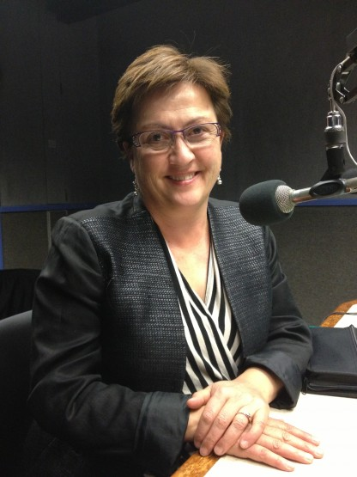Message from the Commissioner

I am pleased that Equal Opportunity Commission staff and I have been able to work across many diverse initiatives in the 2013-14 financial year. We have also held events such as the 2013 Mitchell Oration and hosted the Australian Council of Human Rights Authorities (ACHRA) meeting in Adelaide in April.

The Commission has continued to support the National Anti-Racism Strategy developed by the Australian Human Rights Commission and has had great success in building local support for the campaign ‘Racism. It Stops With Me’.

In particular, the Commission played a key role in achieving sign ups to the Anti-Racism campaign from the South Australian Government, the University of Adelaide, Flinders University, the University of South Australia, TAFE SA and the City of Charles Sturt, among others. The importance of building support for the campaign has certainly been highlighted by many publicised incidents of racism this year across Australia.

In another initiative focused on combatting racism and increasing inclusion, I became an official ambassador for the University of South Australia’s *Football United* Program this year. The Commission also continues to be a Program partner. This program does great work fostering social inclusion through sport (soccer) programs for young people from many cultural backgrounds.

More than half of the complaints lodged in 2013-14 related to work, including treatment at work, treatment during recruitment or discrimination-related dismissal. It is not

Commissioner Anne Gale speaking to Radio Adelaide’s   
Drop the DIS program

surprising then that much of the Commission’s work this year relates to employment.

In relation to gender equity in the workplace, I continue to work with the Chiefs for Gender Equity group. The aim of the Chiefs’ group, which you can read about later in the Annual Report, is to actively advance gender equity in the Chiefs’ respective sectors and our State.

Age discrimination in employment is another issue that the Commission regularly hears about. South Australia has the oldest population on mainland Australia, but relatively low levels of mature aged people in the workforce. In 2013-14, the Commission continued to work with other agencies to combat age discrimination at work.

The Age Matters project was finalised but the Commission commenced another project - the Greatest Asset - which aims to maximise employment opportunities for mature age workers and assist businesses in their workforce planning.

With an ageing population in Australia, and across the globe, there is a growing need to accommodate older workers wishing to transition to retirement and an ever increasing percentage of workers with caring responsibilities. With this in mind, and other factors such as the gender pay gap and issues with people returning to the workplace after parental leave, the Commission has also been working to improve flexibility in the workplace.

In 2013-14, the Commission continued working on the Flexible Workplace Futures Project - a cross-government initiative aimed at improving access to, and management of, flexible work in the South Australian public sector.

As always, one of our key goals is to assist businesses and organisations to manage equal opportunity issues by offering resources and training. Following on from the development last year of a new course in transgender issues, this year the Commission has developed Managing Age Diversity and Unconscious Bias courses. These, and other courses, can be delivered at workplaces on request.

In another key area, I am pleased to report that the Commission’s complaint conciliation rate was up 11% on last year, with 58% of complaints accepted under the Equal Opportunity Act being conciliated.

This leads me to acknowledge the quality services provided by the staff at the Commission. This is reflected in extremely high levels of client satisfaction, from both complainants and respondents in the complaint process, and from training participants. The Commission also continues to receive good feedback from people who attend our events, community education sessions, and those who use our websites and publications. I thank the team of highly skilled staff for their continued enthusiasm and commitment to achieving high service standards.

While I reflect on all of the Commission’s great work in 2013-14, I am also looking forward to a busy 2014-15. 20 December 2014 marks 30 years since the passing of the *Equal Opportunity Act 1984* (SA). To mark the 30-year anniversary of the Act, the Commission will be holding a Great Debate on Human Rights Day (10 December). Please check the Commission’s website, Facebook page or Twitter for information about this event and other upcoming Commission activities.

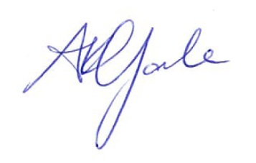

**ANNE GALE**

***Commissioner for Equal Opportunity***

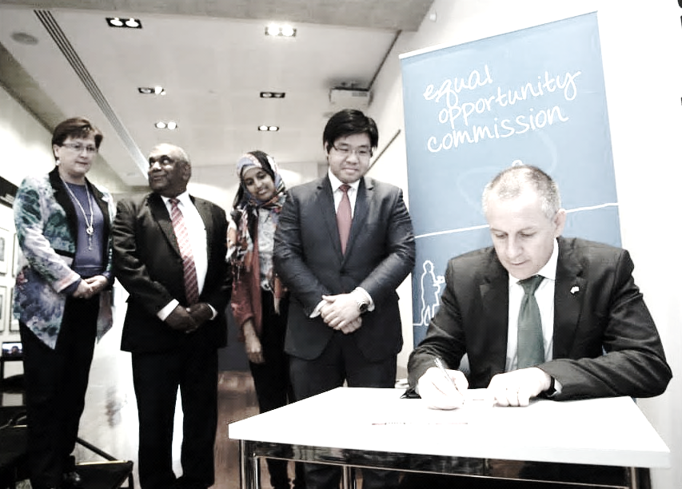

The Commissioner and the community 7

Australian Council of Human Rights Authorities Meeting 9

20th Mitchell Oration 11

National Anti-Racism Strategy in South Australia 12

Chiefs for Gender Equity 14

Policy Responses 15

Highlights

# The Commissioner and the community

**Highlights**

The Commissioner is asked to speak at many events during the year. Although the diversity of the audience and the subject varies, people are always interested to know about equal opportunity issues.

Here is a list of the events the Commissioner has spoken at, or participated in, this year:

* South Australian Government sign-up to the National Anti-Racism Campaign on Human Rights Day (photos pages 6 and 12)
* Leaders Institute of South Australia– Governor’s Leadership Foundation Social Justice Seminar – “*What does Social Justice mean to me*?”
* Institute of Public Administration Australia Series Mental Health and the Workplace – *Bullying and Harassment: Definitions, Reasons and Strategies*
* Football United (Fun) Ambassador - UniSA
* West Torrens Football United Refugee Week event
* Biennial Joint South Australian AEU/DECD Reconciliation Through Education Conference Let’s Walk the Talk - *"The role of policy and legislation in countering racism and racial vilification".*
* 2014 Walk for Justice – JusticeNet
* UniSA Forum – age friendly strategies
* Mentor Breakfast for students at Our Lady of the Sacred Heart College, Enfield
* Law Week 2014 event – held with Multicultural Communities Council of SA, Equal Opportunity Commission of SA and JusticeNet - *“Discrimination: Your Rights and Remedies”* for Culturally and Linguistically Diverse Communities.
* Hosted the national Australian Council of Human Rights Authorities Meeting
* Centre for Human Resources Management - Commissioner for Equal Opportunity Panel on Diversity and Employment
* “Disability Employment Kitchen Table” – Hosted by the Hon. Tony Piccolo MP, Minister for Disability

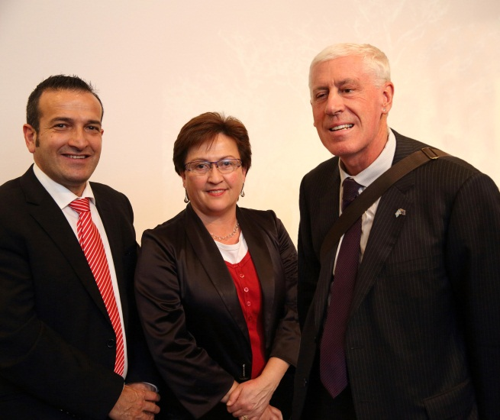

*Minister for Disability, Tony Piccolo, Commissioner Anne Gale, and Disability Discrimination Commissioner Graeme Innes*

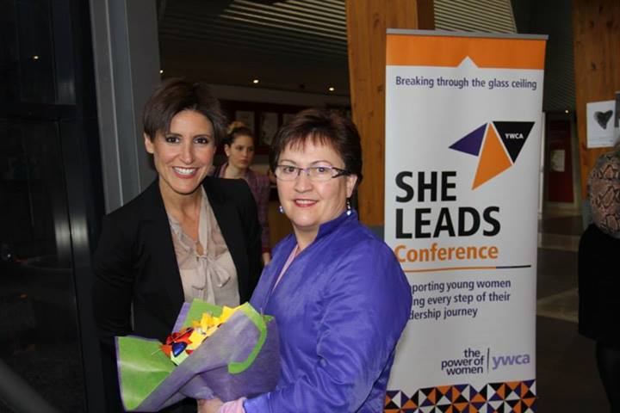

* YWCA Australia’s *“She Leads”* Conference – professional development program for early career young women
* Land Services Group (LSG) - *“Women in Leadership”* Forum
* SA Health Women in Leadership Steering Committee - *“Women inspired”*
* Met with Shelter SA Aboriginal Housing Group and spoke on Shelter SA’s *Housing Matters* show on Radio Adelaide about discrimination and racism particularly relating to indigenous groups
* Harmony Day 2013 celebrations – Morella Community Centre - *“Fair Go” and the role of the Equal Opportunity Commission*
* Centre for Equality - International Women’s Day event
* South Australian Multicultural and Ethnic Affairs Commission presentation on the Anti-Racism strategy
* State Aboriginal Women’s Gathering
* Mitchell Oration (as part of the Adelaide Festival of Ideas) - *Basic Instinct: The Heroic Project of Anti-discrimination Law*
* Office for Women - Launch of *Older Women Matter: Harnessing the talents of Australia’s older female workforce*.
* Office of Recreation and Sport’s *Sport and Women Conference - “Governance, Diversity and Opportunity: Are You on Board”*
* UniSA – *“It’s not fair!”* - inequities in sports participation
* Institute of Public Administration Australia (SA) – Transformational HR Conference. Mental Health and the Workplace Workshop Series - Flexible Working Arrangements
* SafeWork Week 2013 - *“Discrimination in the 21st Century - Are You Ready?”*
* Don’t Overlook Mature Employment (DOME)/SafeWork/DFEEST/EOC - *“What is it? – Age Discrimination”* - a Q&A Panel Discussion on age discrimination
* South Australian Public Sector Young Leaders Conference - *“Developing your personal brand”*
* Kaurna Walks – part of Reconciliation Week 2014

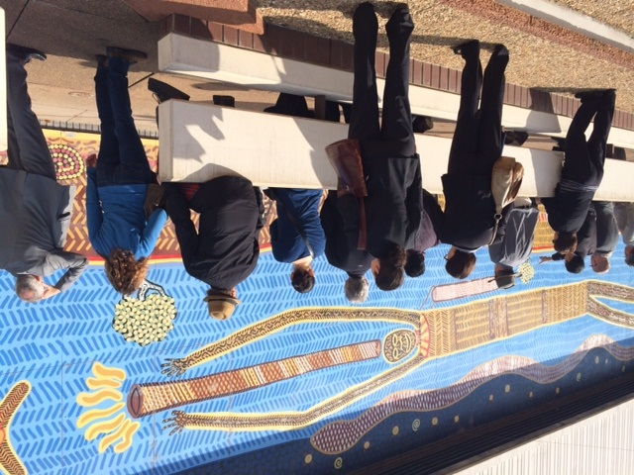

*Kaurna Walk ( conducted by Kaurna Elder Mr Frank Wanganeen)*

# Australian Council of Human Rights Authorities Meeting

The Australian Council of Human Rights Authorities (ACHRA) met in Adelaide on 16 and 17 April. ACHRA comprises state and territory statutory authorities with responsibility for discrimination, equal opportunity and human rights laws and the Australian Human Rights Commission.

At its meeting, ACHRA focused on issues of common concern and new developments relevant to their work. Key matters discussed included:

### Access to justice and equality before the law for people with disability

ACHRA urged all state governments to act on the Australian Human Rights Commission's recommendation to develop disability justice strategies to fulfil Australia's commitments under the *Convention on the Rights of Persons with Disability* to ensure access to justice and equality before the law for people with disability.

### Expunging records relating to historic homosexual offences

ACHRA noted the work done in South Australia, the commitment of the Victorian government, and work underway in Tasmania to expunge records relating to sexual conduct between consenting male adults. ACHRA urges all Australian jurisdictions to identify such records and implement mechanisms to expunge them.

### 

### Changes to Section 18C of the Racial Discrimination Act

**Highlights**

ACHRA indicated concern with the nature and breadth of the Federal Government’s proposed amendments to the Racial Discrimination Act and encouraged anyone concerned about racism in Australia to participate in the consultation. It commended the Victorian Equal Opportunity and Human Rights Commission on its submission. The submission is available at: [www.humanrightscommission.vic.gov.au/indexnews/item/778-submission-to-proposed-amendments-to-racial-discrimination-act](http://www.humanrightscommission.vic.gov.au/index.php/news-and-events/commission-news/item/778-submission-to-proposed-amendments-to-racial-discrimination-act%20) ).

ACHRA members subsequently made a submission to the Federal Attorney General calling for retention, with clarification, of the current provisions and endorsing the addition of effective incitement and intimidation prohibitions.

### Cyberbullying and young people

ACHRA welcomed the opportunity to discuss with the National Children and Youth Law Centre appropriate mechanisms for addressing cyberbullying and looked forward to future opportunities to work with state and federal governments to ensure that children and young people are protected from the enduring harm caused by cyberbullying.

### Workers returning to work from injury or illness

ACHRA met with the South Australian WorkCover Ombudsman. All members observed a consistent trend across the country of people experiencing discrimination on return to work from injury or illness. ACHRA noted that it is in the interests of workers compensation authorities, employers and employees to improve how returns to work are handled.

### Insurance and Older people

The Australian Human Rights Commission provided an update on work underway to improve the provision of insurance to older Australians. It was noted that this issue will become more important with mooted changes to the age pension eligibility age.

ACHRA was concerned that such changes highlight the need for state and territory governments and the Commonwealth to ensure access to workers compensation insurance protection and for private insurance providers to ensure access to income protection insurance for all workers irrespective of age.

### Conditions in and impacts of detention

ACHRA received reports on detention from ACT Commissioner Helen Watchirs and Australian Human Rights Commission President Professor Gillian Triggs.

Commissioner Watchirs' report on conditions of detention of women in the ACT highlighted the important work being done by the ACT to ensure its detention facilities meet international human rights standards.

Professor Triggs and Commissioner Mitchell reported on recent visits to immigration detention facilities to understand the situation of children being held in immigration detention.

### Supporting working parents: Pregnancy and Return to Work National Review

ACHRA received an update from the Australian Human Rights Commission on this national review. Of particular concern were the high levels of workplace discrimination experienced by both women during pregnancy and after the birth of their child and by fathers who have sought to take leave entitlements.

The Commission's headline data report is available at: [www.humanrights.gov.au/  
supporting-working-parents-pregnancy-and-return-work-national-review-0](http://www.humanrights.gov.au/supporting-working-parents-pregnancy-and-return-work-national-review-0)

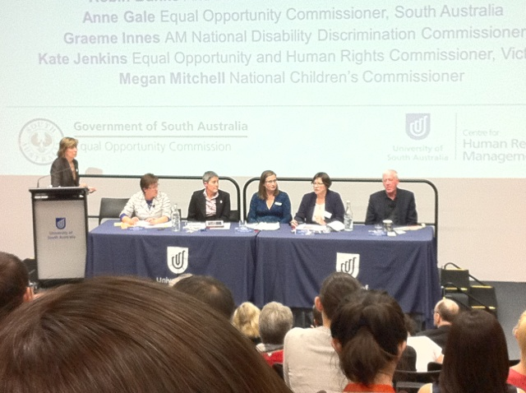

*ACHRA Commissioners participate in a   
University of South Australia panel event -   
Diversity and Employment: Going beyond Gender*

# 20th Mitchell Oration

**Highlights**

On 19 October 2013, the Equal Opportunity Commission hosted the 20th Dame Roma Mitchell Oration as part of the 2013 Adelaide Festival of Ideas. The Mitchell Oration is sponsored by the Equal Opportunity Commission to honour the work and lifelong achievements of Dame Roma Mitchell.

The orator was Professor Simon Rice, Director of Law Reform and Social Justice at the ANU Collage of Law, and his oration was titled, “Basic Instinct – The Heroic Project of Anti-Discrimination Law”.

The insightful and thought provoking presentation discussed the way in which Australia continues to rely on proscriptive laws to achieve non-discrimination and equality of opportunity in society, despite the fact that the model for those anti-discrimination laws has been largely unchanged for almost 40 years.

Professor Rice posed the question whether we have relied for too long on laws that go too far and too hard at an issue that has deep anthropological and cultural roots. Professor Rice later presented at the ACHRA Officers Conference.

Listen to, or read, the Mitchell Oration at:   
[www.eoc.sa.gov.au/eo-resources/events/  
mitchell-orations/mitchell-oration-2013](http://www.eoc.sa.gov.au/eo-resources/events/mitchell-orations/mitchell-oration-2013)

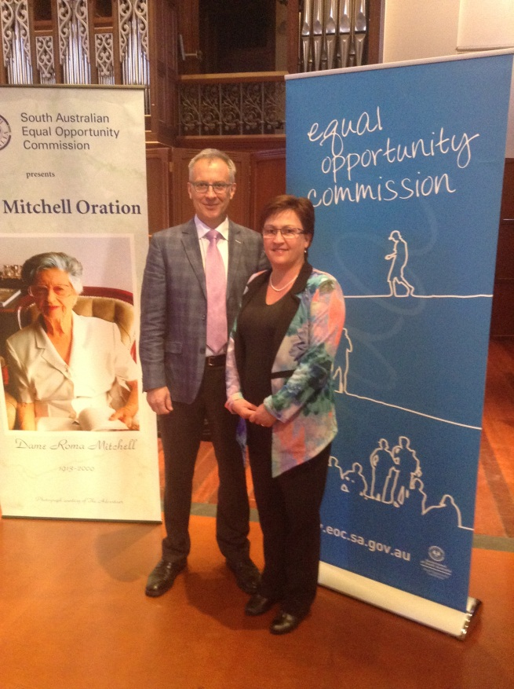

Professor Simon Rice and Commissioner Anne Gale

# National Anti-Racism Strategy in South Australia

**Highlights**

### South Australian Government Sign up

The Commission supports and implements the national anti-racism strategy in South Australia. The Commission has continued to build local support for the “Racism. It Stops With Me” campaign.

On 10 December 2013, World Human Rights Day, the South Australian Government committed to a whole of Government sign up to the Anti-Racism campaign. An event was hosted at the Bob Hawke Prime Ministerial Centre to celebrate the sign up by the State Government to the campaign. At the event, Dr Tim Soutphommasane, federal Race Discrimination Commissioner and the South Australian Premier, the Honourable Jay Weatherill co-signed a commitment to the campaign.

Following the event, all Chief Executives also signed up to the campaign. The Equal Opportunity Commission will host an implementation group with nominees from all Government departments which will meet quarterly to share ideas and encourage constructive action.

### Local Government

The Commission has also written to all local government Councils to seek their support for the campaign, and will seek to meet personally with some of the larger councils. The Equal Opportunity Commission has also secured commitments to sign up from a number of sporting organisations, all three of

Premier Jay Weatherill signs up to the Anti-Racism campaign

Adelaide’s major Universities, TAFE SA, Shelter SA and the Australian Hotels Association (SA).

A particular interest is in the northern area of Adelaide with a joint approach with the Commissioner for Aboriginal Engagement and Reconciliation SA, given the significant population of Aboriginal people in that area.

### Roundtables

The Commission continues to host roundtables with peak multicultural and Aboriginal bodies. Four roundtables have been held and there is ongoing commitment from members to continue these meetings.

The roundtable has identified a number of priority areas in order to counter racism effectively in South Australia. These priority areas align with those identified in the development of the National Anti-Racism Strategy. The Equal Opportunity Commission

has committed to hosting forums on these identified areas of interest in order to develop a better understanding of what can be done by organisations and agencies in this area.

### Roundtable Media Forum

The first area was the portrayal of cultural matters and racism in the media. In November 2013, two prominent journalists, Nance Haxton (ABC Radio Current Affairs Reporter) and Karen Ashford (SBS News and Current Affairs SA Correspondent), joined roundtable members for an open discussion about the role of media in tackling racism in the community, and to assist in developing some strategies for the roundtable to work in partnership with key media outlets in doing so.

One outcome of the Media Forum was the need for media training for community groups and leaders in order to increase knowledge and confidence in approaching and talking to the media, as well as in developing communication strategies.

The Commission, in partnership with the Commissioner for Aboriginal Engagement, will seek to establish and run a pilot training program focused on increasing community engagement with the media.

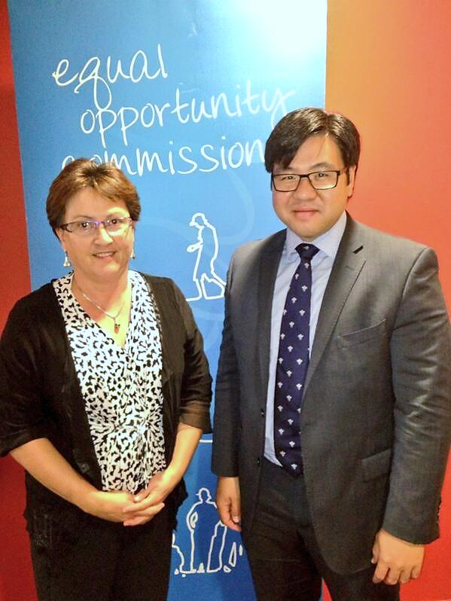

*Commissioner Anne Gale and national Race Discrimination Commissioner Dr Tim Soutphommasane*

# Chiefs for Gender Equity

**Highlights**

The Chiefs for Gender Equity group began in October 2011 as a group of South Australian male leaders committed to improving gender equity. The Chiefs, brought together by the Commissioner for Equal Opportunity, meet regularly to share ideas and initiatives, and work in their own business and in their industry sectors to improve gender equality.

In 2013-14, the group has explored issues including flexibility, job design, inclusion, and recruitment and retention.

The Chiefs participated in a CEDA Women in Leadership event in December 2013 and reported on issues and opportunities in their organisations and industries. The Chief Executive of ANZ Australia, member of the Male Champions for Change group attended and also addressed the forum.

The group has set priorities collectively and individually. Collectively they are exploring the gender wage gap and undertaking their own payroll analyses, as well as aiming to encourage others in their industry sectors to do so.

They continue to act as advocates for gender equity and incorporate their group work in individual speeches. Individual chiefs have supported the Women in Engineering Blueprint launch, Women in Agribusiness awards, and the recent Women in Sport conference.

This year, the Chiefs also produced a number of short videos to highlight some examples of best practice. These can be viewed at: [www.eoc.sa.gov.au/eo-resources/videos-and-ecourses/video-links/chiefs-gender-equity-videos](http://www.eoc.sa.gov.au/eo-resources/videos-and-ecourses/video-links/chiefs-gender-equity-videos%20)

Priorities for individuals include:

* Retention; flexibility and job design
  + Legal sector
  + Engineering sector
* Inclusion strategies
* Improving the pipeline for geology and engineering graduates

Find out more about the Chiefs for Gender Equity on the Equal Opportunity website: [www.eoc.sa.gov.au/eo-business/chiefs-gender-equity](file:///C:\Users\cxdal\AppData\Local\Temp\www.eoc.sa.gov.au\eo-business\chiefs-gender-equity).

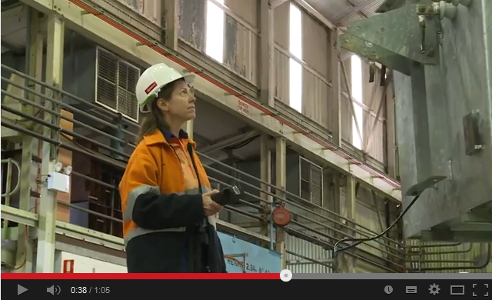

Chiefs of Gender Equity video - SA Power Networks

# Policy Responses

**Highlights**

The Commission lodged the following policy submissions in 2013-14:

### Submission to Draft South Australian Strategy for Safeguarding Older People

The submission drew on information collected through enquiries, complaints and anecdotal evidence. The submission welcomed the rights based approach taken by the strategy, and made recommendations relating to the right to work. It highlighted insurance and age discrimination as being possible barriers for older people wanting to remain in the workforce.

### Australian Health Practitioner Regulation Agency Review of English language skills registration standard

The submission drew on information collected through enquiries and complaints to provide comment on the barriers faced by practitioners seeking professional registration in Australia for the first time. The submission looked at issues with the current English language skills testing and supported changes to the current standard.

### Sentencing Advisory Council’s Discussion Paper considering the operation of Part 8A of the Criminal Law Act 1935 (SA)

This submission argued that in line with Equal Opportunity Act 1984 (SA), the Disability Discrimination Act 1992 (Cth), and the Convention on the Rights of Persons with Disabilities (CRPD), people with disabilities should be able to use and access the law in an equal manner, meaning that reasonable adjustments to services and facilities may be necessary. It made a number of suggestions including appropriate reduction in the number of psychiatric reports required, possible establishment of a Mental Health Review Tribunal, appropriate training on the human rights of people with a disability for all persons working within the judicial system, and the use of ‘Step-up - Step-down’ facilities.

### Review of the Mental Health Act 2009 (SA)

The submission outlined a number of issues raised in enquiries and complaints and also noted a number of human rights outlined in the Convention on the Rights of Persons with Disabilities. The submission supported training for police officers and treatment centre staff, mental health service provision on a voluntary basis where possible and any involuntary detention and treatment having appropriate and timely review, with appeal processes available. It also supported patients having timely access to community visitors on request.

### Submission on Supporting Working Parents: Pregnancy and Return to Work National Review

This submission highlighted enquiries and complaints in the area of employment related to pregnancy, breast-feeding, and caring responsibilities (with a focus on maternity leave-related matters) and included a number of case studies. The submission supported education, improved flexible work options, clear guidelines and policies, and changing discussions around caring responsibilities to a “whole of work issue” rather than a “women’s issue”.

### Review of the Whistleblowers Protection Act 1993 (SA) by the Independent Commissioner Against Corruption

The submission argued a need for greater clarity and guidance as to the practical application of the Act, as well as a simplification of the whistleblowing process and training and education on the operation of the Act. The submission focussed on the victimisation of whistleblowers, which is currently administered under the Equal Opportunity Act 1984 (SA). To encourage more disclosure, the submission also recommended the inclusion of a set of more robust safeguards to protect those who make the decision to blow the whistle.

### Australian Law Reform Commission Inquiry into Equality, Capacity and Disability in Commonwealth Laws

This submission included a number of case studies and addressed selected questions for consideration, offering suggestions for improvements in legislation or practice. Issues highlighted were tests for direct and indirect discrimination, interpretation of the terms ‘reasonable adjustments’ and ‘unjustifiable hardship’, issues in social security, financial services and superannuation, issues in the justice area for both victims and offenders, issues in banking and insurance, young people living in aged care, sterilisation of minors, use of restrictive practices, and access to education and support services for children with disability.

The Commissioner was approached by the Law Society of SA to write an article for the March edition of their journal, The Bulletin, based on the insurance section of the submission.

### Independent Review of Integrity in the Subclass 457 programme

This submission focussed on the areas of English language testing and support and information to employers and visa holders on their rights and obligations. The submission drew not only on complaint and enquiries but also on 2011 survey data gathered as part of the Commission’s previous Skilled Migrant Project. The survey indicated that despite skilled workers being granted 457 visas and having much needed skill sets, many of them struggle to find work, are underemployed, or treated badly by employers and colleagues.





Complaints and Enquiries

Enquiries 18

Complaints received 20

Whistleblowers 23

Complaint outcomes 24

Our service 26

The Equal Opportunity Tribunal 29

Complaints referred to the Tribunal 31

Tribunal decisions in 2013-14 34

# Enquiries

**Complaints**

An enquiry is often a first step prior to a formal complaint being lodged in writing. It is a useful opportunity for information to be exchanged and options to be explored.

The Commission receives a large number of telephone and email enquiries from individuals who believe they have been the victims of discrimination. It also receives enquiries from businesses, community organisations and equal opportunity contact persons seeking information about discrimination issues and equal opportunity.

In 2013-14, the Commission received 1,405 enquiries, slightly down on 1,522 enquiries in 2012-13. Enquiry numbers have steadily declined over the past decade as more people visit the Equal Opportunity Commission website to find the information they are looking for.

The graph below shows types of discrimination alleged or asked about in enquiries this year. Almost 13% of enquiries received related to issues that the Commission could not assist with as they did not fall within the *Equal Opportunity Act 1984* (SA). When issues fall outside of the Act, enquiry officers will generally refer enquirers to other complaint organisations, advocates or legal advice to assist.

Enquiries - types of discrimination (grounds)

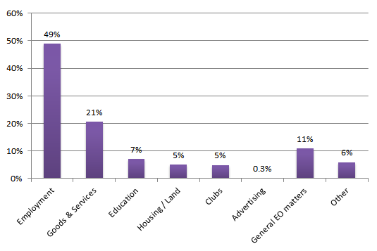

Enquiries - places of discrimination (areas)

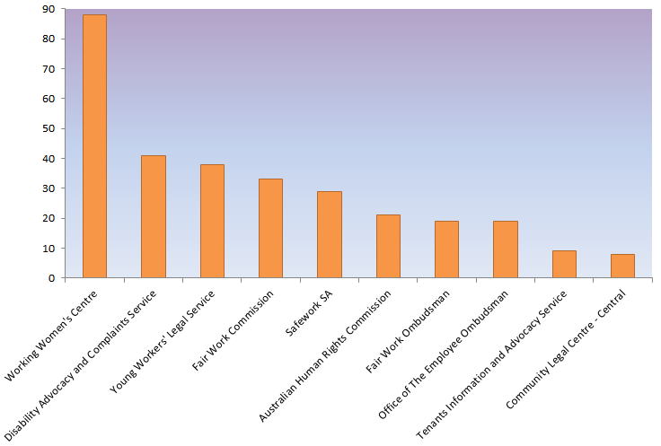

Top 10 agencies enquiries were referred to for support or additional assistance in 2013-14

# Complaints Received

People can make a complaint to the Commission if they believe they have been discriminated against. Complaints need to identify that the discrimination occurred for one of the reasons listed in the *Equal Opportunity Act 1984* (SA), such as age, race or disability. The discrimination must also occur in an area of public life, such as employment or goods and services.

In 2013-14, 201 complaints were received. While this is lower than the 253 complaints received in 2012-13, the number of complaints accepted under the Equal Opportunity Act (124) is almost the same as last year (127), with 62% of complaints falling under the Act. In 2013-14, 246 complaints were finalised.

Over 60 % of complaints are now received via the Commission’s online complaint form or via email. The online complaint form, as well as electronic versions that can be emailed, are available on our website.

As with previous years, the most common ground of discrimination was disability, followed by race discrimination. This year, 37% of all complaints were about disability discrimination (slightly down on last year’s 42%) and 18% were about race discrimination (same as 2012-13).

Some complaints include more than one ground of discrimination and the total number of grounds was 233. Of these, disability and race accounted for 32% and 16% respectively.

The majority of complaints received related to discrimination in employment. This includes treatment during recruitment and at work, and termination of employment. In 2013-14, 58% of complaints lodged related to employment. Of accepted complaints, 62% related to discrimination in employment.

**Complaints**

Some types of discrimination, such as religion, political opinion, criminal record and trade union activity are only dealt with by Federal law. Other types of discrimination are covered by both South Australian and Federal law. Where discrimination is covered by State and Federal law, complaints may be lodged with either the state or federal body, but not with both.

If someone lodges a complaint that falls outside of the Equal Opportunity Act, the Commission will refer them to other avenues that may be available to assist, including the Australian Human Rights Commission.

If someone witnesses discrimination, or doesn’t wish to lodge a complaint, the Commission’s website offers an Online Incident Report. The public can report an incident of discrimination they were affected by, whether they are a witness or the victim, and have the option to remain anonymous. The Incident Report is not a formal complaint but can help the Equal Opportunity Commission to better understand issues people are experiencing in South Australia and how to prevent them.

### Grounds and Areas of complaints lodged in 2013-14

|  |  |  |  |  |  |  |
| --- | --- | --- | --- | --- | --- | --- |
|  | **Employment** | **Goods and Services** | **Education** | **Clubs** | **Housing** | **Total** |
| Disability | 36 | 29 | 9 | 2 |  | 76 |
| Race | 21 | 11 | 5 |  |  | 37 |
| Sex | 14 | 5 | 1 | 1 |  | 21 |
| Age | 9 | 9 |  |  |  | 18 |
| Sexual Harassment | 17 | 1 |  |  |  | 18 |
| Whistleblower | 13 | 2 | 1 | 1 |  | 17 |
| Victimisation | 10 |  | 2 | 2 | 1 | 15 |
| Caring Responsibilities | 7 | 2 | 1 |  |  | 10 |
| Sexuality | 3 |  |  |  | 3 | 6 |
| Pregnancy | 4 | 1 |  |  |  | 5 |
| Identity of Spouse or Partner | 2 | 2 |  |  |  | 4 |
| Association with a Child |  | 2 |  |  | 1 | 3 |
| Chosen Gender |  |  |  |  | 2 | 2 |
| Aiding Unlawful Act |  |  | 1 |  |  | 1 |
| Marital Status |  |  |  |  |  | 0 |
| Religious Dress |  |  |  |  |  | 0 |
| **Grand Total** | **145** | **67** | **20** | **8** | **7** | **233\*** |

*\*Although there were 201 complaints lodged, some complaints of discrimination are lodged under more than one area or allege more than one ground of discrimination.*

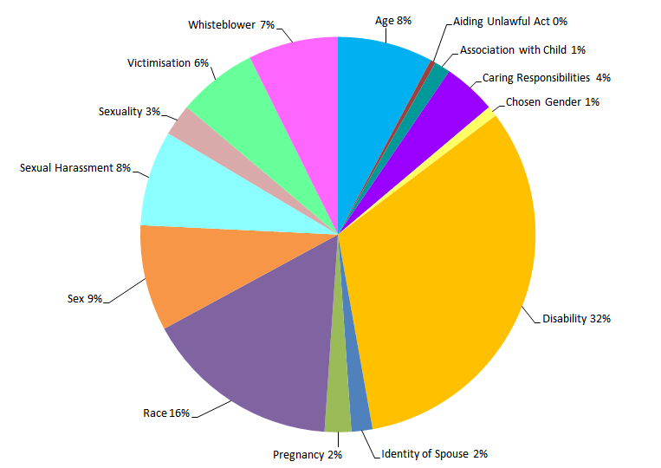 *Complaints lodged 2013-14: Types of discrimination*

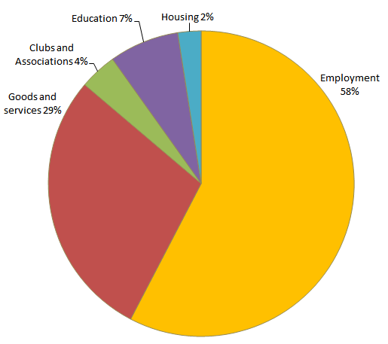

*Complaints lodged 2013-14: Places of discrimination*

Case Study: Disability discrimination in Goods and Services

Richard\* is vision impaired and, as a result, can't hold a drivers licence. Richard went to a phone company’s store to re-contract his mobile phone and they said they only accept drivers licences as ID. The salesperson refused to listen to him explain his situation. He then spoke to a manager who refused to accept his alternative ID including a certified birth certificate and photo ID. Richard had been with the company for 12 years and never had an issue. Richard was able to renew his contract with no photo ID by contacting the company’s phone service but it cost him $20 and an hour long phone call to have a new phone posted to him.

The complaint resolved via direct contact between the parties facilitated by the Commission. The phone company agreed to reimburse the postage cost, provide an apology, and take steps to ensure that an incident of this nature does not occur again.

Case Study: Disability discrimination in Employment

Carly\* is a nurse employed on a permanent part-time basis in a large hospital. She had been experiencing fainting spells but had recently been cleared to return to work on day and afternoon shifts by her Cardiologist. Carly said that her employer refused to allow her to return to work in any capacity until she was cleared to work all shifts, including night shift. Carly believed this was unfair and that her employer was failing to reasonably accommodate her return to work because of her medical condition.

A conciliation conference was held and an in principle agreement reached. The complaint was finalised post conference with Carly’s employer agreeing to pay economic loss to Carly of $18,000 and $6,000 compensation for injury to feeling. The employer also provided an apology.

Case Study: Disability discrimination in Education

Naveen\* has a disability action plan (DAP) as a student enrolled in a tertiary institution. Three of his four lecturers have accommodated his disability but Naveen said that one lecturer did not adhere to his DAP. Naveen also said that this lecturer was dismissive of him during meetings and did not respond to correspondence he had sent. The lecturer also did not include explanations or criteria for assessing an essay, when he graded it at 30%. Naveen also felt let down by the university's disability liaison officer, as he believed she did not support him to implement his DAP.

A conciliation conference was held. The complaint was settled with the institution acknowledging that Naveen had not been dealt with according to their expectations and agreeing to refund his fees for this subject. An assurance was provided that the lecturer involved had been reminded of expectations in regard to implementation of DAPs for students. The institution agreed to review relevant policies and procedures relating to DAPs and to implement "statements of the inherent requirements" of all subjects so students and staff are clear on expectations when accommodating DAPs.   
 \* names have been changed

# Whistleblowers

The *Whistleblowers Protection Act 1993* (SA) exists to facilitate the disclosure, in the public interest, of significant maladministration and waste in the public sector and corrupt or illegal conduct generally. It does this by providing a disclosure process and legal protection for those who make disclosures.

The *Whistleblowers Protection Act 1993* (SA) does not protect all disclosures of suspected misconduct, and not everyone who makes a disclosure is a whistleblower. Only a disclosure of ‘public interest information’ is protected. This means a disclosure of illegal activity, an irregular and unauthorised use of public money, substantial mismanagement of public resources or conduct that causes a substantial risk to public health, safety or the environment. Alternatively, public interest information can be maladministration by a public officer in performing official functions.

A disclosure is only protected if it is made to someone to whom it is reasonable to make the disclosure, such as an appropriate authority.

It is unlawful to treat a whistleblower less favourably because he or she has made a disclosure that is protected by the *Whistleblowers Protection Act 1993* (SA). This includes harm, intimidation, harassment, threats of reprisal or any other disadvantage.

If a whistleblower believes that they have been treated unfairly because they ‘blew the whistle’, they can either sue the person for damages in the civil courts or can make a complaint of victimisation to the Equal Opportunity Commission.

Over the past year, the Commission received 17 complaints from people who believed that they were whistleblowers protected by the *Whistleblowers Protection Act 1993* (SA) and who alleged victimisation after making disclosures. There were also 9 enquiries received in regard to the whistleblowers legislation. Twenty complaints alleging victimisation after making disclosures, including some received prior to July 2013, were accepted in 2013-14.

**Complaints**

Of the 20 complaints accepted under the Act, two have been conciliated, 11 have been referred to the Equal Opportunity Tribunal, 3 were withdrawn, and 4 complaints are still in the process of being resolved.



# Complaint outcomes

As required under the *Equal Opportunity Act 1984* (SA), the Commission will try to resolve most discrimination complaints through conciliation. This year, 58% of complaints that fell under the Act were resolved through conciliation - 11% more than last year.

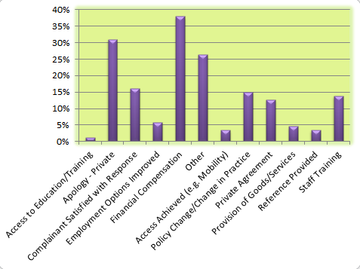A Conciliation Officer’s role is to remain impartial and encourage the parties to reach an agreement during a conciliation conference. A variety of outcomes can be negotiated and form a confidential agreement.

Many complaints are resolved simply by the opportunity to talk about what had happened or an apology. In 2013-14, 31% of conciliated complaints included an apology as part of the settlement agreement.

Other common outcomes include a change to practice that led to the complaint, such as an organisation creating new policies and procedures, or staff attending equal opportunity training. This can help to create workplace cultural change, increase awareness of discrimination issues, and help managers to deal with issues when they arise.

Sometimes people seek financial compensation for loss of wages, medical costs or for hurt and humiliation. Financial compensation is not always large or the main part of an agreement. In 2013-14, only 39% of conciliated complaints settled with a financial component. Four agreements were for amounts $10,000 or over and compensation amounts ranged from $80 to $24,000. The average settlement amount was just over $4,000.

In 2013-14, 11% of accepted complaints were withdrawn prior to being resolved, 3% were declined, and 28% were referred to the Equal Opportunity Tribunal for determination.

**Complaints**

*Conciliated complaint outcomes 2013-14*

Case Study: Pregnancy, race and marital status discrimination

Daisy\* was employed full time as a hairdresser. She alleged that her employer had discriminated against her because of her pregnancy, race and marital status. She said she was told off for becoming pregnant, had her hours reduced because she was going on maternity leave, and a number of derogatory comments were made about her being a single mother bringing up a "black baby". Her employment was terminated for alleged poor performance and insubordination. Daisy noted there were no problems with her performance before her pregnancy.

Daisy’s employer denied the discrimination saying that it was Daisy who would talk about her single parent status and joke about having a "black baby". Other staff thought it was okay to do so as well as she was saying these things herself. While she was a good hairdresser, she was difficult, angry and would ignore instructions. She would make inappropriate remarks to clients about her private life.

A conciliation conference was held and the employer agreed to settle the matter for the following: A Statement of Regret, Statement of Service, put in place Equal Opportunity policy and procedures in the workplace, attend Equal Opportunity training for Managers & Supervisors, Separation Certificate and make a donation to a charity nominated by Daisy of $1000.00.

Case Study: disability discrimination in insurance

Sophie\* made a complaint to the Equal Opportunity Commission after an insurance company refused her life insurance because of a disease she contracted as a child. This resulted in some minor physical incapacity but no impact on her life expectancy that Sophie is aware of. Refusal of insurance also means that there would be a record of refusal if she wanted to apply anywhere else.

A conciliation conference was held with the insurance company explaining its process and the reasons why Sophie’s insurance was refused. The company requested further information from Sophie regarding her condition which was provided as part of the conciliation conference.

After a follow up phone call, the company confirmed that it was able to provide Sophie with cover. Sophie accepted this and the complaint was considered resolved.

*\* names have been changed*

# Our Service

Every year, the Commission seeks feedback from both the people who lodge complaints and from the people who have been complained about.

Evaluation surveys look at performance indicators like the information we provide, how fast complaints are dealt with, impartiality and overall satisfaction with the process.

In 2013-14, the vast majority of both sides who returned an evaluation survey said they were satisfied with the Commission’s complaint handling overall - 85% of both complainants and people responding to complaints.

During the complaint process, the Commission provides information to assist both parties to understand what is happening. This includes providing fact sheets and general information, as well as keeping parties up to date. In addition, conciliation officers often spend time explaining complex discrimination issues to parties and answering queries about the process. Of those who filled in evaluations, 93% of both complainants and respondents agreed that they were well-informed throughout the process.

*[My conciliation officer] made this very clear and he made me feel he understood my complaint. He is very professional and I am pleased he helped me reach the final agreement. Many thanks.****- Complainant***

**Complaints**

Addressing the expectations of both sides and maintaining neutrality is also an important part of complaint handling at the Commission.

People who complain are sometimes surprised that the Commission does not act as their advocate, while respondents also often think that the Commission will be acting for the complainant. Fair treatment for all is paramount in our service. In 2013-14, 90% of complainants and 92% of respondents felt that the Commission’s complaint process was fair to both parties.

The majority of both complainants (81%) and respondents (85%) were satisfied with the timeliness of the Commission’s service.

*[Our conciliation officer] was fantastic. She kept me informed throughout, was always respectful of our position and the customers, and really pushed for a fair outcome for both sides, which was ultimately what was reached.***- Respondent**

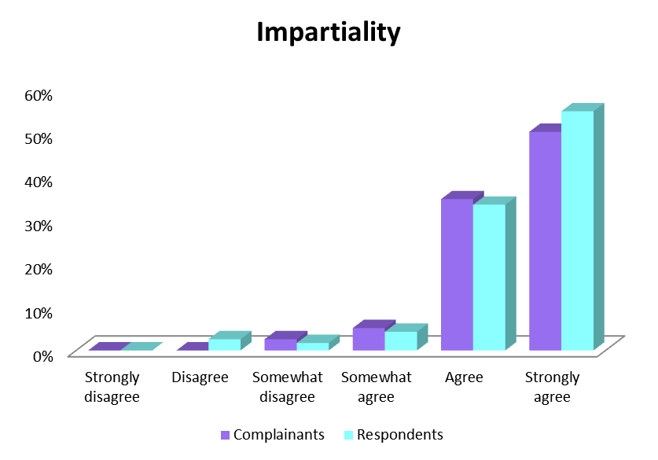

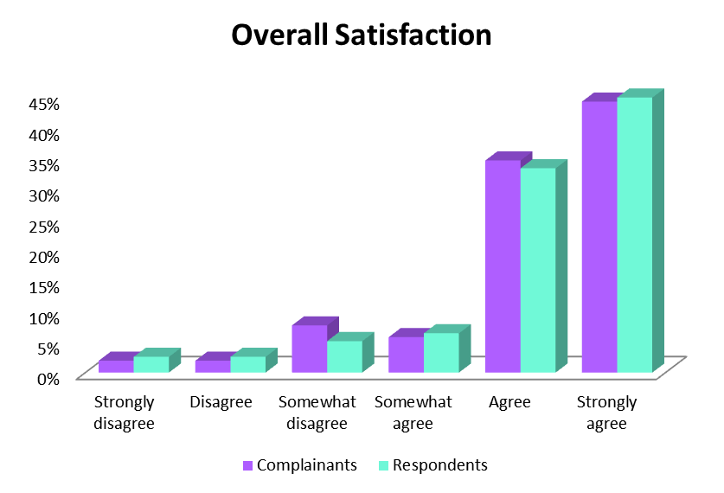

# The Equal Opportunity Tribunal

**Complaints**

The Equal Opportunity Tribunal has two main roles under the *Equal Opportunity Act 1984* (SA). It hears complaints referred to it by the Equal Opportunity Commissioner and applications for exemptions.

The Tribunal is a separate body from the Commission. It comprises a Presiding Member, who is a District Court Judge, and two assessors, who are lay people chosen for their skills and experience.

During the 2013-14 period, the Tribunal handed down six decisions and granted five exemptions. Details of Tribunal decisions and referrals are set out in the following pages. An appeal decision made by the Supreme Court in relation to a matter that had appeared before the Tribunal is also outlined.

### Exemptions from the Act

The *Equal Opportunity Act 1984* (SA) (‘the Act’) provides a way for organisations to apply to the Equal Opportunity Tribunal for a temporary exemption from the Act. The Tribunal can order an exemption of up to three years, and an organisation can lawfully discriminate according to the conditions of the exemption.

The Tribunal granted the following exemptions, including extensions to existing exemptions, in 2013-14:

**State of South Australia (Chief Executive, SA Health) DCCIV-13-1236 (25 July 2013)**

A three-year exemption was granted to the State of South Australia (Chief Executive, SA Health) and to members of the Aboriginal Health Council of SA Inc. (AHCSA) from Sections 52(1) and 103 of the Act to advertise for, and appoint, Aboriginal and/or Torres Strait Islander health workers in a number of specific roles.

**Minister for Education of South Australia [2013] SAEOT 12 (25 November 2013)**

The Minister applied for the renewal of an exemption from the provisions of the Act to allow for the continuation of the provision of a girls only secondary campus as part of a larger school (Roma Mitchell Secondary College).

The Tribunal noted that measures are taken at the girls only campus to address issues associated with disadvantage of many kinds, including those kinds of disadvantage which particularly affect girls. If the girls' campus was a separate school, it would be permitted to discriminate in favour of girls when accepting applications for enrolment under   
s 37(3) of the Act. The girls' campus operates much like a single sex school and, in addition, addresses some of the issues faced by socially disadvantaged girls.

The exemption was granted for a period of a further three years.

[[www.austlii.edu.au/au/cases/sa/SAEOT/2013/12.html](http://www.austlii.edu.au/au/cases/sa/SAEOT/2013/12.html)]

**Aboriginal Legal Rights Movement DCCIV-14-550 & 625 (24 June 2014)**

****The Aboriginal Legal Rights Movement applied for an extension to an existing exemption from section 52 of the Act (ground of race) to allow them to employ an Aboriginal or Torres Strait Islander person only as their Chief Executive Officer. The exemption was extended for a further 3 years.

The Aboriginal Legal Rights Movement also applied for an exemption from section 52 of the Act (ground of race) to allow them to employ only suitably qualified Aboriginal and/or Torres Strait Islanders as Aboriginal Field Officers (DCCV-14-625). The exemption was granted for 3 years.

**ASC Pty Ltd & Others [2014] SAEOT 2 (30 June 2014)**

ASC Pty Ltd, ASC Shipbuilding Pty Ltd and ASC Shipbuilding Pty Ltd applied for a renewal of their existing exemption from Section 52, 54 and 103 (1) (discrimination on the basis of nationality and country of origin) of *the Equal Opportunity Act 1984* (SA).

The Tribunal granted the exemption extension for a further three years, ordering the applicants to update their employment practices generally and their Equal Opportunity Exemption Order Policy and Procedure Manual, in particular, to reflect the terms of the renewal of the exemption and train relevant staff. The applicants are also required to provide a report to the Equal Opportunity Commission six months after the grant date of the exemption and then must report annually.

**Raytheon Australia Pty Limited DCCIV-14-594 (24 June 2014)**

Raytheon Australia Pty Limited applied for an extension to an existing exemption from sections 52 and 54 of the Act (ground of race). The exemption permits Raytheon to only employ Australian citizens in line with requirements imposed by United States legislation.

As with the previous exemption, Raytheon Australia is required to report six monthly to the Commissioner on its compliance to the exemption requirements and changes to its procedures. The exemption was extended for a further 3 years.

# Complaints referred to the Tribunal

**Complaints**

If parties fail to reach agreement through the Commission’s conciliation process, the Commissioner can either decline a complaint or refer it to the Tribunal. If the Commissioner refers a complaint to the Tribunal, the complainant can ask the Commissioner to provide them with legal assistance. The Commissioner can then decide whether or not to fund legal assistance for the complainant or respondent. The Commissioner can choose not to provide financial assistance if parties can afford their own legal representation or if the case is unlikely to be successful.

### Cases referred to the Tribunal with full or partial assistance

If legal assistance is provided, the Commissioner can opt to partially fund a complaint (complainant or respondent), rather than fully fund it. Situations where this may occur include where the Commissioner receives advice that the complaint is unlikely to be successful.

Two complainants had their cases partially or fully funded for complaints referred to the Tribunal in 2013-14.

**Simpson v Australian Health Practitioner Regulation Agency (AHPRA) and Nursing & Midwifery Board of Australia (NMBA) - DCCIV-14-296 (Partially funded)**

*- Race discrimination*

As at 30 June 2014, this case was awaiting scheduling at the Tribunal.

**Gordon v Department for Education and Child Development - DCCIV-13-1883 (Fully funded)**

*- Disability discrimination*

As at 30 June 2014, parties were in negotiation.

### Cases referred to the Tribunal without assistance

If the Commissioner declines a complaint, the complainant has a right under the Act to take their complaint to the Tribunal. In these cases, they do not receive financial assistance from the Commissioner and can either represent themselves or engage a lawyer to represent them.

In 2013-14, 32 complaints that were referred to the Tribunal and registered were not funded by the Commissioner. Note that a number of complaints made by one complainant may be registered as one Tribunal matter if they are related.

As at 30 June 2014, the following “unfunded” complaints were either waiting to be heard, or awaiting an outcome:

**Stephens v South Australia Police - DCCIV-13-2690**

*- Sex and disability discrimination*

The complainant did not appear at two scheduled hearings. The complaint was dismissed.

**Lynch v Department for Education and Child Development - DCCIV-13-414**

*- Disability discrimination*

Awaiting Tribunal hearing.

**Ragless v South Australian Field and Game Association - DCCIV-14-787**  
*- Disability discrimination*

Awaiting Tribunal hearing.

**Ragless v Brian Stokes - DCCIV-14-788**  
*- Whistleblower*

Awaiting Tribunal hearing.

**Ragless v South Australia Police -   
DCCIV-14-789**  
*- Whistleblower*

Awaiting Tribunal hearing.

**Ragless v Police Ombudsman - DCCIV-14-790**  
*- Whistleblower*

Awaiting Tribunal hearing.

**Ullrich v Adelaide Exchange Jewellers - DCCIV-13-2691**  
*- Disability discrimination*

Matter withdrawn by complainant.

**Lawler v Independent Pub Group Pty Ltd - DCCIV-13-2941**  
*- Caring responsibilities discrimination*

Matter withdrawn by complainant.

**Majok v Adelaide Resource Recovery Pty Ltd - DCCIV-13-2723**

*- Disability and race discrimination*

Matter withdrawn by complainant.

**Ingham v Department for Planning, Transport & Infrastructure, David Bernard, Judith Carr, Lino Di Lernia - DCCIV-13-2763**

*- Whistleblower and victimisation*

As at 30 June 2014, parties were awaiting preliminary hearing.

**Verney v Romeo’s Retail Group, Anthony Romeo, Harry Papas - DCCIV-13-2945**

*- Sexual harassment, sex discrimination, victimisation*

Matter withdrawn by complainant due to ill health.

**Ali v I-Sec Pty Ltd - DCCIV-14-785**

*- Race discrimination*

Parties failed to appear at a preliminary hearing in July 2014. Matter was subsequently withdrawn.

**Holmes v SA Prison Health Service - DCCIV-14-786**

*- Disability discrimination*

Matter withdrawn by complainant at preliminary hearing in July 2014 as his situation had changed.

**Marshall v SA Health - DCCIV-14-1024**

*- Disability discrimination*

Awaiting preliminary Tribunal hearing.

**Davidson v Department for Education and Child Development - DCCIV-14-1023**

*- Whistleblowing*

Awaiting Tribunal hearing.

**Colbung v Ceduna Koonibba Aboriginal Health Service Incorporated, Mavis Miller, Nina Spaan - DCCIV-13-2461**

*- Disability discrimination*

Matter withdrawn by complainant.

**Ingham v Department for Planning, Transport & Infrastructure, Rod Hook, David Bernard - DCCIV-14-250**

*- Whistleblower and victimisation*

Awaiting preliminary Tribunal hearing.

**Gordon v Uniting Communities - DCCIV-13-413**

*- Race discrimination*

Matter withdrawn by complainant.

**Pathi v Australia and New Zealand Banking Group Limited - DCCIV-14-442**

*- Race discrimination*

Matter withdrawn by complainant.

**Cowie v Central Adelaide Local Health Network (CALHN), Dr Peter Steele, Mr Michael Cursaro - DCCIV-14-623**

*- Disability discrimination and whistleblowing*

Awaiting preliminary Tribunal hearing.

**Bone-George v Department for Education and Child Development - DCCIV- 13-2905**

*- Disability discrimination*

Awaiting preliminary Tribunal hearing.

**Turnbull v Department for Communities and Social Inclusion - DCCIV-14-45**

*- Race discrimination*

The complainant did not appear at two scheduled hearings. The complaint was dismissed.

**Paterson v TAFE SA, Lawrence Udo-Ekpo - DCCIV-14-243**

*- Review of Commissioner’s decision*

As at 30 June, matter awaiting Tribunal hearing.

# Tribunal Decisions in 2013-14

**TSANAKAS v DEPARTMENT OF FURTHER EDUCATION, EMPLOYMENT, SCIENCE & TECHNOLOGY [2013] SAEOT 10 (31 July 2013)**

Mr Tsanakas alleged victimisation and disability discrimination by the Department of Further Education, Employment, Science and Technology (DFEEST) which was responsible for the college of Technical and Further Education (TAFE). On hearing submissions Mr Tsanakas indicated he would no longer pursue his complaint of victimisation and would continue only with his complaint of disability discrimination.

The respondent applied for the matter to be struck out as the matter was out of time. The Tribunal found that the complaint was out of time. The Tribunal did not consider that Mr  Tsanakas’ complaint had any prospect of success under the Act, as the Act does not require an educational authority to provide a student with a disability with precisely the kind of assistance he or she prefers or wants, even where a disability plan exists. The word ‘required’ in s66(d)(i) is to be interpreted objectively not subjectively. The complaint was dismissed.

Read the full judgement at:  
[www.austlii.edu.au/au/cases/sa/SAEOT/2013/10.html](http://www.austlii.edu.au/au/cases/sa/SAEOT/2013/10.html)

**Kossiedowski v Parvinder & Anor   
DCCIV-965 (9 September 2013)**

**Complaints**

Ms Kossiedowski was employed as an assistant in a small supermarket. She claimed that over a short period of time, she was sexually harassed by her employer, who asked her sexually explicit questions, patted her backside and deliberately brushed against her breasts.

She made a complaint to the Equal Opportunity Commission which did not resolve, and so the matter was referred to the Equal Opportunity Tribunal.

At the hearing, the Tribunal accepted Ms Kossiedowski’s account of the incidents, and rejected Mr Parvinder’s account. It held that there were three separate episodes of sexual harassment and awarded damages of $2,400 for lost wages and $1,000 for injury to feeling.

At the conclusion of her judgement, Her Honour Judge Cole issued a warning directly to Mr Parvinder that the conduct he engaged in was very concerning, and that ordinarily a higher award of damages would have been ordered in that regard. Judge Cole noted, however, that Mr Parvinder’s financial position was taken into account when awarding a lower amount of damages.

**SPYROU v THE STATE OF SOUTH AUSTRALIA (THE DEPARTMENT OF HEALTH AND AGEING) [2013] SAEOT 11 (6 November 2013)**

Ms Spyrou alleged that the respondent discriminated against her on the ground of caring responsibilities by denying her flexible working arrangements, harassing her to start work at an earlier start time and failing to discipline employees who discriminated against her.

The Tribunal found that the nature of the complainant’s particular position meant that it was reasonable that she could not commence work later than 9:30 am. The Tribunal also found that the failure to discipline allegation fell outside of the original complaint. The Tribunal did note, however, that the respondent’s actions appeared to have resulted in Ms Spyrou believing that she was entitled to a 10 o’clock start, and that this contributed to her perception of being harassed and bullied. The complaint was dismissed.

Read the full judgement at:  
[www.austlii.edu.au/au/cases/sa/SAEOT/2013/11.html](http://www.austlii.edu.au/au/cases/sa/SAEOT/2013/11.html)

**JACKSON v HOMESTART FINANCE & JACKSON v HOMESTART FINANCE [2013] SAEOT 13 (5 December 2013)**

A complaint was made by Mrs Jackson and her 31 year old son, Dean (who has a mild intellectual disability), following Homestart’s decision to decline their joint home loan application. Mrs Jackson had attended a meeting with a Homestart consultant, together with her son, to discuss a possible home loan. At the appointment Mrs Jackson did the bulk of the talking on behalf of her son who is by nature a shy and somewhat reserved individual.

Following that meeting, the Homestart consultant had concerns about Dean’s ability to understand the subject of the home loan. Shortly after, the Jacksons were advised that their loan application had been declined on the grounds of “unsuitability”. The Jacksons lodged a complaint with the Equal Opportunity Commission which did not resolve, and so the case was referred to the Equal Opportunity Tribunal.

The Tribunal held that Homestart had discriminated against both Mrs Jackson and Dean on the basis that the consultant and his manager formed an incorrect assumption, with very little ‘hard’ supporting information, that Dean’s loss of mental function prevented him from being able to understand the nature and impact of the loan.

Further, the Tribunal considered that it was unreasonable of Homestart to decline the loan on account of Dean’s disability without undertaking further investigations as to his capacity. Dean was awarded $2,500 in damages and Mrs Jackson $500. The Jacksons have appealed the quantum of damages awarded to the Supreme Court of SA.

Read the full judgement at:  
[www.austlii.edu.au/au/cases/sa/SAEOT/2013/13.html](http://www.austlii.edu.au/au/cases/sa/SAEOT/2013/13.html)

**RAMSTROM v BALDINO [2013] SAEOT 14 (20 December 2013)**

On 23 September 2010, Ms Ramstrom, a Magistrates’ clerk, made a complaint to the Equal Opportunity Commission in which she alleged that she had been sexually harassed by Mr Baldino, a magistrate for whom she worked. The complaint was unable to be conciliated and was referred to the Equal Opportunity Tribunal.

Alleged events were denied by the respondent and the Tribunal found that the complainant had not proven conduct by the respondent which constitutes sexual harassment under the Equal Opportunity Act 1984 on the balance of probabilities. The complaint was refused. The matter is currently on appeal to the Supreme Court of South Australia.

Read the full judgement at:  
[www.austlii.edu.au/au/cases/sa/SAEOT/2013/14.html](http://www.austlii.edu.au/au/cases/sa/SAEOT/2013/14.html)

**KOLUSOVSKI v COMMISSIONER FOR EQUAL OPPORTUNITY (25 March 2014)**

- *Review of Commissioner’s decision*

In August 2013, Mr Kolusovski lodged a race and age discrimination complaint with the Equal Opportunity Commission related to events that occurred in February 2012. The complaint was not initiated on the basis that it was out of time and the complainant was not able to provide any good reason for the delay. Mr Kolusovski lodged an appeal with the Equal Opportunity Tribunal.

The Equal Opportunity Tribunal dismissed Mr Kolusovski’s application and declined to reverse the Commissioner’s decision. Judge Cole found that there was no evidence to support “good reasons” or a case for an extension of time on the basis it was “just and equitable” within the meaning of s 93(2a). Judge Cole noted that Mr Kolusovski had become aware of an option to lodge with EOC in late 2012 after speaking to someone from Centrelink but had not lodged until August 2013. He had also failed to make out his case regarding why he had not lodged within time.

**WILLIAMS v INDEPENDENT PUB GROUP & WILLIAMS v STEPHENS (19 May 2014)**

Mr Williams attended a friend’s birthday party at a hotel owned by Independent Pub Group. Mr Williams had been asked by his friend to dress ‘in drag’, which she knew he did at times. Mr Williams went to use the female toilet and alleged that the barman, Mr Stephens, yelled from behind the bar that he was not to use the female toilets and that he had to use the male toilets. It was also alleged that he then approached Mr Williams and made derogatory comments about his clothes, laughed at him, and pulled up his shirt and played with his nipple in front of Mr Williams. Mr Williams also alleged that Mr Stephens sprayed him with water from the soft drink hose earlier in the evening.

Mr Williams felt intimidated and embarrassed. He claimed that Mr Stephens’ behaviour also drew the attention of other patrons, some of whom then also made unwanted comments.

The Tribunal found that Mr Williams had not established the factual basis for a claim for sexual harassment under the Act. As a result of inconsistencies between Mr Williams’ evidence and the substance of his complaint, together with contrary evidence from the respondents, the Tribunal was unable to be satisfied of the occurrence of any events which constituted sexual harassment under the Act. Further, the Tribunal could not uphold the claim for discrimination on the basis of chosen gender because Mr Williams was not, at the time of the incident, a person of chosen gender within the meaning of the Act.

Read the full judgement at:  
http://www.austlii.edu.au/au/cases/sa/SAEOT/2014/1.html

**SUPREME COURT DECISION**

**Rodgers v Revenue SA [2014] SASCFC 2 (23 January 2014)**

In March 2012, Ms Rodgers lodged a complaint with the Equal Opportunity Commission alleging sexual harassment by a fellow employee in 2003. She further alleged that her then employer was vicariously liable and that they had discriminated against her on the basis of her sex by exposing her to the harassment. She also alleged that she was subsequently victimised by other employees from 2004 to 2006, then from 2006 to 2010.

The complaint was declined by the Commission as the original sexual harassment complaint was out of time and the matter was then referred to the Equal Opportunity Tribunal. The Tribunal dismissed the complaint on the basis that it was out of time, that there was no power to extend time in respect of conduct before April 2009 (after which time amendments around extensions of time were made to the *Equal Opportunity Act 1984*), and that there was no reason to extend time because there was no explanation for the delay. Ms Rodgers appealed to the Supreme Court.

The Supreme Court found that the Tribunal did not err in its decision not to extend time. The Supreme Court decision also noted that the Commissioner has power under s 93(2a) of the *Equal Opportunity Act 1984* (SA) to extend time for lodging a complaint notwithstanding that the time limit had already expired before the enactment of that provision in 2009.

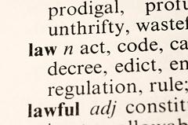

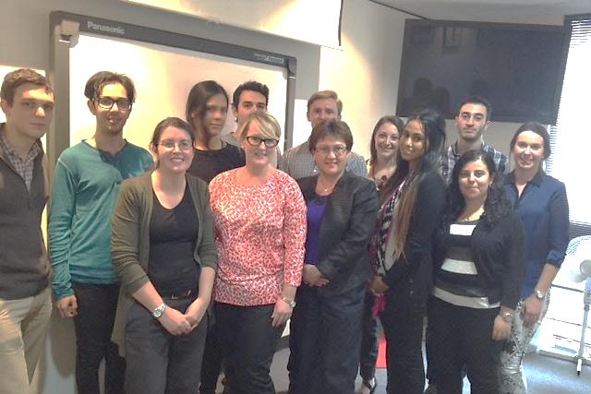

*Meeting with the Young Workers Legal Service*

Programs

Training and Community Education 39

Tailored Workplace Education 41

Football United (FUn) 43

Flexible Workplace Futures 44

Age Matters Project 45

Websites 47

Social Media 49

Story 1 20

Story 2 21

Story 3 22

Story 4 23

Story 5 24

Story 6 25

Story 7 26

# Training and Community Education

**Programs**

The Commission provides various education and training services. Services include:

* training courses for the general public
* customised training for organisations and workplaces
* education and information sessions for the community

### Training courses for the general public

A number of training courses and workshops are offered by the Commission throughout the year. Information about each of these courses is available on the Commission’s website under ‘current training courses.’ Training is held at the Commission’s office in Adelaide’s central business district. Training for contact officers and sessions on effectively managing workplace issues are the most popular public courses.

The Commission’s training programs continue to be very well received, generating positive feedback from attendees. In 2013-14, 83% of people attending training at the Commission rated courses as being excellent or very good, and 90% said they would recommend the training to others. Ninety-one percent of in-house training attendees rated the trainer’s presentation skills as very good or excellent.

### Training for organisations and workplaces

Customised training is also available and it can be tailored for individual workplaces. Commission training officers work closely with organisations to ensure their program is relevant and effective. The Commission offers workplace training:

* for individuals or groups
* for managers
* on specific topics

Training includes reviewing workplace policies and procedures, developing an equal opportunity plan, completing an assessment of the workplace culture and supporting organisations to conduct their own trainings in the future.

The Commission also offers e-Learning training programs to better suit the demands of the modern workforce.

In 2013-14, the Commission developed two new workshops, “Managing Age Diversity at Work” (designed for managers, supervisors and human resource professionals) and “Unconscious Bias in Recruitment – Challenging Your Stereotypes”. We also continued to assist organisations to better understand transgender issues, particularly how to support employees who are transitioning.

### G:\EOC\promotions and publications\photos\stock photos\iStock Photos\iStock 10475605 International students.jpgInformation for the community

The Commission presents information to the community regarding their rights through community education sessions. The Commission, for example, conducts regular sessions through TAFE’s Interlink program for new arrivals and the Football United partnership. Commission staff are also regular guests on Radio Adelaide and Coast FM discussing current issues of discrimination.

The Commission works with community organisations to raise awareness of equal opportunity and build the capacity of organisations to better manage issues around discrimination, diversity and equal opportunity. Organisations we worked with in 2013-14 include:

* Anglicare
* Australian Education Union - SA Branch
* Autism SA
* The Burundian Association of SA
* Centre for Equality
* Flinders University
* Shelter SA
* University of South Australia

# Tailored Workplace Education: Working as Partners

For many people in our community a large part of the day is spent at work, commuting to and from work, or thinking about work. In some cases inequality, discrimination and harassment still occurs at work and the costs to affected individuals and organisations can be considerable.

The Commission works in close partnership with local organisations and businesses to provide tailored education services to effectively tackle and prevent these issues. The Commission’s programs help staff and management better understand their rights and responsibilities and enable organisations to realise the benefits of implementing best practice.

Commissioner Anne Gale describes Wallis Cinemas as an excellent example of a proactive business, reaping the benefits of implementing best practice to prevent discrimination in the workplace.

Paul Besanko, Marketing Manager for Wallis Cinemas, believes that workplaces need to provide a safe environment for staff.

‘When staff feel comfortable and valued, the benefit for Wallis Cinemas is that our customers are more likely to have an exceptional experience at the movies.’ Mr Besanko said.

’EOC’s training not only helps Wallis as an organisation, but drives lasting change for our staff in their future careers, benefitting the community as a whole, as they implement these practices both professionally and personally.’

Our programs are high quality and thought-provoking, and are delivered by trainers who have significant expertise in how organisations can avoid discrimination, improve equal opportunity, and deal effectively with issues when they arise.

**Programs**



*Conciliation and Training Officer Robyn Dwight with Wallis Cinemas’ Marketing Manager Paul Besanko*

# Football United (FUn)

**Programs**

In May 2013, the Commission entered into a partnership with the University of South Australia to deliver the Football United Program. Football United aims to foster social inclusion through football (soccer) programs for youth at risk, particularly in areas with high proportions of refugees, culturally and linguistically diverse families, low socio-economic status and indigenous children, youth and families. The program promotes health, physical activity, community engagement and aspirations.

In 2013-14, the program was expanded to include 2 new programs and 5 new sites making up a total of 10 sites across the state, engaging approximately 400 participants and 67 Youth Leaders. Between September 2013 and June 2014, the program ran free, ongoing football activities for disadvantaged children in 4 primary schools, comprising Northfield, Salisbury North, Swallowcliffe and Elizabeth East/Elizabeth Park. The program included:

* Weekly soccer activities with trained youth leaders and qualified coaches
* A series of “United through Football” events comprising internal mini-tournaments and inter-site carnivals, and a youth leadership program
* Equal Opportunity Commission workshops on rights and equal opportunity
* A large-scale Harmony Day event
* A series of workshops in each site promoting mainstream services, health and well-being.

South Australia’s Commissioner for Equal Opportunity, Anne Gale became an official ambassador for Football United®-UniSA. As Ambassador, Commissioner Gale attended and spoke at the West Torrens Fun Launch, February 25 2014. Commissioner Gale and Mayor John Trainer, Mayor of West Torrens both had the privilege of jointly kicking the first goal of the season.

The Commission developed a short workshop which was delivered through the program to raise awareness of rights and equal opportunity among the participants.

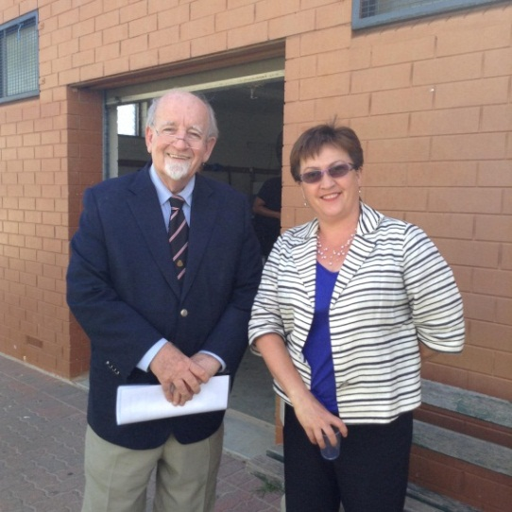

*Mayor of West Torrens, John Trainer,   
and Commissioner Anne Gale*

# Flexible Workplace Futures

**Programs**

In 2013-14, the Equal Opportunity Commission led the Flexible Workplace Futures Project. This was a cross-government initiative aimed at ensuring the South Australian public sector is a leader and adopts best practice in order to increase workforce participation rates (including participation rates of working parents); to prepare for an ageing population and increased caring responsibilities; to enable people to work longer; and to address changing workforce and sector requirements.

The project’s aims were to increase consistency and transparency in the implementation of flexible work practices, and to increase the consistency of decision making in response to requests for flexible work in the South Australian public sector. Currently, approaches across agencies vary and are often dependent on individual decision makers and the culture of a workplace rather than best and consistent practice. As a result, there are inequalities in the application process and in outcomes.

The project aims to educate, train and provide tools for key decision makers. All decisions must balance the needs of the business with that of the individual and when implemented well, flexible work practices can be productive for both employers and employees.



Deliverables from the project include an information package on flexible work, an updated Commissioner for Public Sector Guideline on Flexible work, new practical tools including a management ‘app’, e-application form and training.

The Flexible Workplace Futures project was a part of the SA Public Sector Renewal Program (“Change@SouthAustralia”).

A final report, and a presentation to the Change@SA team was delivered in January 2014.

The reference and pilot groups have agreed to continue to meet and share experiences and opportunities for change. Agencies involved in the group include:

* Department of the Premier and Cabinet
* Commission for Public Sector Employment
* Department of State Development
* Department of Correctional Services
* Department of Communities and Social Inclusion
* Department of Planning, Transport and Infrastructure
* South Australian Police
* Department of Health and Ageing

The Commission is currently working to disseminate information and tools developed through the project across the public sector to promote cultural change, as well as provision to the private sector.

Case Study: Caring Responsibilities in Employment

Emilio\* had his employment terminated because he is not able to work away from home due to his wife's illness and anxiety. Emilio had worked for the company for more than 5 years, but states that being asked to work away from home for several days at a time (and up to one week) meant he was basically asked to choose between his wife and his job.

Emilio’s employer denied discrimination, explaining that it was concerned that there were factors other than caring responsibilities that prevented him working away from home. It knew he had a second job, and felt that he had raised his wife's circumstances very late in the discussions.

A conciliation conference was held and the parties were able to discuss Emilio’s caring responsibilities in more detail. The complaint resolved with his ex-employer agreeing to provide financial compensation in the amount of $2,500, a statement of service and a telephone reference if requested.

*\* name has been changed*

# Age Matters Project

South Australia has the second oldest population in Australia, after Tasmania. Within 30 years, almost a quarter of the population will be aged over 65.

The aim of the Age Matters Project, completed in January 2014, was to optimise the workforce participation of mature age workers by addressing under-utilisation and discrimination that older workers experience in recruitment and employment.

The project worked with employers, mature age workers and jobseekers to demonstrate the business case for mature age employment, including good practice for retaining and retraining mature age workers

In 2011-12, Stage 1 of the project involved research into mature age productivity, development of an online e-course on age discrimination, public forums, and production of print and web resources to support mature age employment. Funding was provided by the Office for the Ageing.

Stage 2, which ended in December 2013, involved a number of awareness-raising strategies to address the under-utilisation and discrimination that mature age workers experience in recruitment and employment and to address some of the issues highlighted in Stage 1. These included public events, training and print and electronic resources.

Funding for Stage 2 was provided by the Department of Further Education, Employment, Science and Technology (DFEEST), as the lead agency for South Australia’s Strategic Plan 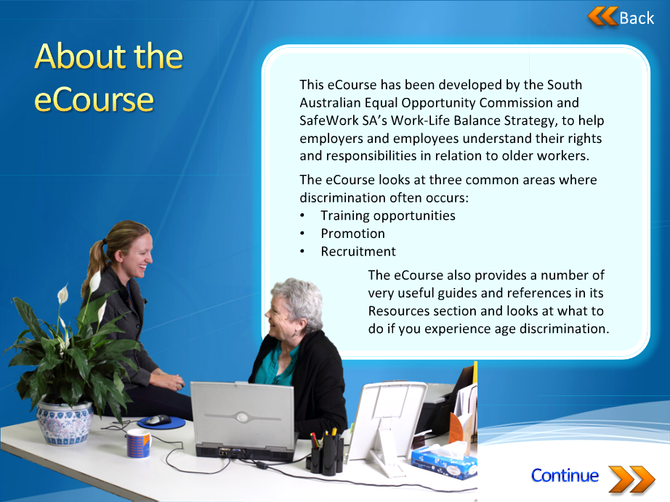

**Programs**

*Screenshot from the Age Matters free e-course available on the Commission’s website*

(SASP): Target 48 - Ageing workforce participation.

The Commission is continuing its work to ensure that the importance of mature age employment remains in the public focus not only by the Age Matters resources, but with a new project in 2014-15.

In support of *Prosperity through Longevity: South Australia’s Ageing Plan 2014 - 2019*, Office for the Ageing has funded the Commission to work with key employment industry groups, Australian Industry Group and Don’t Overlook Mature Expertise (DOME) to help combat age discrimination in employment.

The Greatest Asset Project aims to maximise employment opportunities for mature age workers through a range of strategies including a Workforce Planning Guide and tool for South Australian employers.

Case Study: Age and sex discrimination For Aged Care Worker

Chris\* is a male in his 50's who was employed as a carer for a large provider of residential aged care. Chris alleged that he was humiliated at a training course when the trainer used him and another male colleague in a training scenario. The scenario was about a new procedure for dealing with incontinence and she put him in the role of the client. She called him a “silly old man”, who had incontinence, and "skiddies in his pants" because he would not cooperate with carers in managing this.

The male colleague was placed in the role of a young inexperienced carer, while the only female in the scenario was the experienced capable carer. He was one of 2 males in a group of 28 participants - the rest were female.

He felt that he was targeted as the old man due to his age and because he was a male working in a female dominated environment. He says that the trainer only made demeaning comments and requests of him during the session. She did not treat the female participants like this.

A conciliation conference was held and agreement reached between parties. Chris’ employer agreed to apologise to Chris for the manner in which the trainer conducted the training and to counsel the trainer in regard to those aspects of the training that offended Chris.

Case Study: Age discrimination in Casual Work

Mai\* is 67 and worked as a tutor on a casual basis and wanted to continue to work for at least another year. A new manager was appointed and asked the receptionist about the retirement age. He was told that there was no set retirement age. He began to question Mai’s performance repeatedly and reduced her hours significantly as well. He constantly pulled her up for things she had allegedly done wrong which were generally very minor. Mai felt that he was trying to force her to leave due to her age. Mai tried to talk to him but he wouldn’t listen. She lodged a complaint of age discrimination with the Equal Opportunity Commission.

A conciliation conference was held and agreement reached between the parties. The manager provided Mai with a written apology at the conference. The manager agreed to develop a Human Resources Manual including guidelines for equal opportunity, bullying, harassment and discrimination, and grievance procedures for making a complaint. The manager would provide an opportunity for staff to provide feedback on the manual and also agreed to provide associated training for staff. The settlement also included paying for the reasonable cost of counselling for Mai and the sum of $5,000.00 as a general damages payment for hurt and humiliation. As part of the settlement, Mai agreed to resign her position.

*\* names have been changed*

# Websites

**Programs**

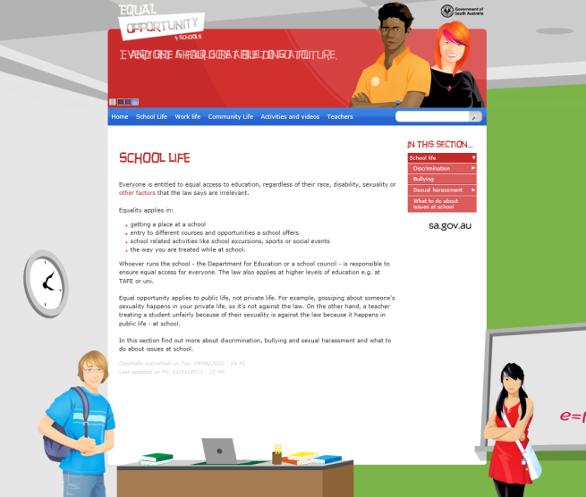The Commission has two websites - the main Equal Opportunity Commission website ([www.eoc.sa.gov.au](http://www.eoc.sa.gov.au)) and EO 4 Schools ([www.eo4schools.net.au/](http://www.eo4schools.net.au/)). EO 4 Schools contains equal opportunity and human rights information for students and includes online activities such as quizzes and crosswords.

In 2013-14, our websites were visited almost 244,000 times – over 660 times a day. There were 36,735 visits to the EO 4 schools website and over 207,000 visits to the EOC website.

Website visits have quadrupled over the past 9 years, with more and more people using online resources. There were over 100,00 downloads from our websites in 2013-14 - the 20 most popular files can be seen in the table below.

People visit our websites for a range of information including factsheets, policies and procedures, case studies, and training videos and quizzes. See our most popular pages and the top searches hitting our websites on the following page.

*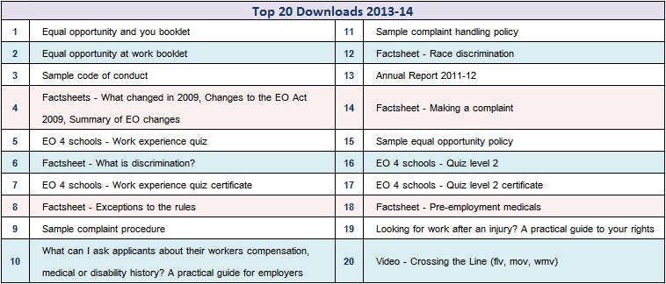*

*EO 4 Schools website*

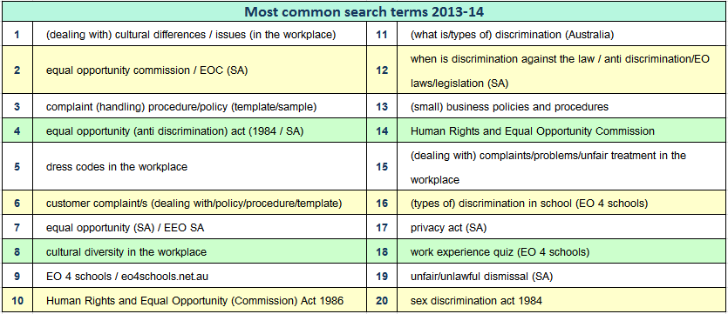 *The top 20 search terms hitting the EOC and EO 4 schools websites in 2013-14*

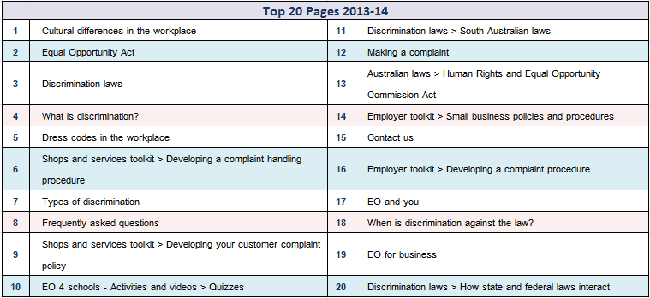

*The top 20 pages on the EOC and EO 4 schools websites in 2013-14*

# Social Media

**Programs**

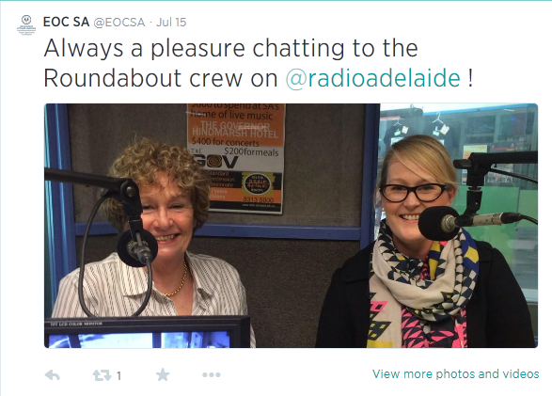Social media is an expedient and wide-reaching way to engage with organisations and the community. The Equal Opportunity Commission has a Facebook page and Twitter - both with a growing number of followers. Commissioner Anne Gale also has a Twitter account.

Through Facebook and Twitter, the Commission provides up to date information from a range of sources promoting equal opportunity, anti-discrimination, and human rights. We also use social media to inform the community about upcoming events - both ours and others.

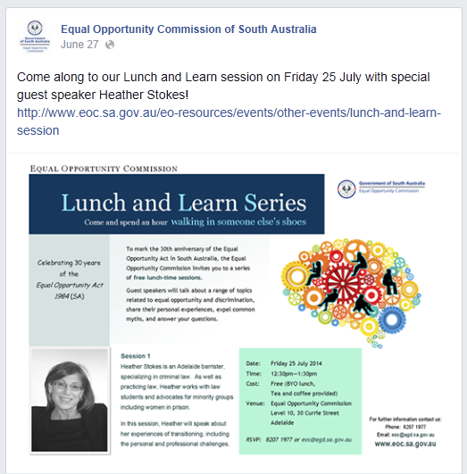In 2013-14, our Facebook and Twitter audiences grew to over 100 followers and are continuing to grow.

Follow the Equal Opportunity Commission on twitter ([twitter.com/eocsa](https://twitter.com/eocsa)) or like our [Facebook page](https://www.facebook.com/pages/Equal-Opportunity-Commission-of-South-Australia/325106495557) ([www.facebook.com/pages/Equal-  
Opportunity-Commission-of-South-Australia/325106495557](http://www.facebook.com/pages/Equal-Opportunity-Commission-of-South-Australia/325106495557)).

Follow Commissioner Anne Gale on Twitter - [twitter.com/galeanne15](https://twitter.com/galeanne15).



Address Level 17, 45 Pirie Street  
 Adelaide SA 5000

Phone (08) 8207 1977

E-mail eoc@agd.sa.gov.au

Website **www.eoc.sa.gov.au**

The Equal Opportunity Commission provides three main services in   
South Australia:

* Information
* Education
* Assessing and resolving complaints

You can phone, call into our office or   
make an appointment to see us if you   
have an enquiry.